|  |  |  |  |  |
| --- | --- | --- | --- | --- |
|  | | **Faculty of Design, Media and Management**  **Department of Computing** | | |
|  | | | | |
| **Final Report: Academic Year 2017 to 2018** | | | | |
| **Module Title:** | Project | | **Module Code:** | CO699 |
| **Assignment No/Title:** | Final Report (CW3) | | **Assessment Weighting:** | 60% |
| **Submission Date:** | Thursday 10th May 2018 Week 33 by 14:00 (Electronic and Physical Submission) | | **Feedback Date:** | + 3 Weeks |
| **M****odule Tutor:** | Justin Luker | | **Degree/Foundation:** | Degree |
| **Student ID:** | 21519352 | | **Student Name:** | Luke Foster |
| **1st Supervisor:** | Richard Bacon | | **2nd Supervisor:** | Rafid Al-Khannak |
| **Course:** | BSc. (Hons) Games Development | | | |

## Project Title

The project is going to be a third-person, single-player action role-playing game, based on the Greek God of time Chronos. The game will focus on the exploration and manipulation of time based mechanics to achieve certain goals/quests.

## Acknowledgments

I would like to take this moment to thank my friends and family who have motivated, supported and helped me throughout this project.

## Abstract

The Final report covers the aim of creating a prototype game that compares the four core time manipulation mechanics to determine which are more effective integrated into an action combat system, while using an agile methodology backed by supporting UML documentation. This aim is represented as a prototype game; it allows the player to compare the effectiveness of time mechanics through the main character Chronos’ abilities in different combat scenarios.

The artefact produced was designed from researching into requirements, agile methods and existing time mechanics in games. The design produced a brain storm from the requirements gathered; it also produced a backlog from the brainstorm and finally a sprint plan. The artefact was then developed leaving a few requirements to remain. Testing tables were produced providing evidence of issues solved in the artefact. The artefact was then analysed on how it could be implemented in the future and summarising the development process.

Table of Contents

Project Title 2

Acknowledgments 2

Abstract 2

Introduction 7

Background 8

Rationale 8

Aim 9

Objectives 9

Design (Completed by December 16th 2017) 9

Development (Completed by January 26th 2018) 9

Testing (Completed by April 20th 2018) 10

Implementation (Completed by June 20th 2018) 10

Risks 11

Literature Survey 12

Methodology 18

Comparing Waterfall and Agile 18

Agile in Relation to Roles and Stages of Development 19

Unified Modelling Language 20

Requirements 21

User Stories 21

Functional Requirements 23

Non-Functional Requirements 24

Design 25

Introduction 25

How Research has underpinned the Design 25

Design in relation to Objectives 27

Development 30

Introduction 30

Sprint 1 31

Sprint 2 33

Sprint 3 34

Sprint 4 35

Sprint 5 36

Sprint 6 38

Testing 39

Sprint 1 – Testing 39

Sprint 2 – Testing 40

Sprint 3 – Testing 41

Sprint 4 – Testing 42

Sprint 5 – Testing 42

Sprint 6 – Testing 44

Implementation 45

Development Summary 45

How the Prototype could be implemented into a Working Environment 45

Current Version Issues 46

Conclusions 47

Recommendations for Further Work 47

Glossary 48

**References** 48

Bibliography 57

Appendix A: Project Plan 58

Appendix B: Literature Review Research Scripts 61

Other Appendixes: Scripts 64

PlayerController 64

HealthManager 73

ChronosAbilityDetection 78

SlowTimeAbility 79

SpeedAbility 84

FreezeAbility 85

RewindAbility 88

AbilityTriggerDetection 91

HellMinotaurActive 94

HellHoundActive 96

HadesActive 98

MinotaurRewind 100

HoundRewind 102

HadesRewind 104

BasicStateDrivenBrain 106

BasicMove 109

BasicMelee 109

BasicRangedAttack 110

BasicBlock 111

HadesStateDrivenBrain 112

HadesMove 116

HadesMelee 116

HadesRangedAttack 117

HadesBlock 118

HadesDodge 119

HadesAbility 120

HoundStateDrivenBrain 121

HoundMove 122

HoundMelee 123

## Introduction

The project is going to be about how time within a game engine can be manipulated to achieve certain gameplay mechanics and features. There are many game engines to choose from for development of this project and they all have their pros and cons, some of the most powerful engines are Unity, Unreal Engine 4, Source 2 and CryENGINE (Pluralsight, 2015). The game engine that is going to be used for this project is unity, as it is very accessible for aspiring game developers and a free product to download. There are other various reasons which will be expanded on in the rationale (Pluralsight, 2015).

Time within games whether they’re video games or any other kind of game very much work the same as time in real life. When players commit to playing a game, they’re committing to spending a certain amount of time playing, time they will never get back (Teale, 2016). What unity allows for is working in real time like most video games or being unrealistic and giving you the tools to manipulate time to suit your needs. The way unity allows for this is by giving the developer a range of prerequisites to work from and tamper to their needs (Unity, 2017).

The first time manipulation mechanic to look at is slow motion, slow motion has been used as a feature for years to thrill the player or viewer in films and give them a different perspective on the current scenario, this also applies to the time mechanic of fast motion (Evans-Thirlwell, 2017). The next is time rewind, this mechanic is a useful feature in games for allowing the player to retry any step without having to restart the level, an example of this would be from the game Prince of Persia: The Forgotten Sands (Zarzecki, 2016). Finally freeze time, this feature for example in ‘Dishonoured’ allows you to stop time from using an ability, this will then make it easier for the player to target and kill their enemy (Sullivan, 2014). All these mechanics will be implemented into Chronos’ abilities for a better gameplay experience.

## Background

The inspiration for undertaking this project has come from the investigation into different mechanics in games. Initially a search started on google to seek out the best mechanics in video games and the main one to peak interest is the concept of time travel (E, 2015). Research was taken into finding out how to implement these mechanics and what they look like in a game engine, after some exploration on YouTube, a channel was found called Brackeys; within this channel were videos on how to program slow motion and time rewind into a unity project (Brackeys, 2017). This peaked interest and got ideas flowing even if the game wasn’t just going to be based on time.

An inspirational game for this project idea was Smite; Smite is a multiplayer battle arena game where you fight as Gods and Goddesses from a range of different pantheons (Jackson, 2014). From Smite the link to the Greek God of time, Chronos was inspired and the time mechanics research put together. Now a mechanic and theme were discovered a storyline could then be created from some further research into Greek mythology, this mythology allowed for a range of ideas for characters, scenery and a story (Gill, 2017).

A final exploration was needed to discover the gameplay for the idea. From some prior experience the best suited gameplay seemed to be similar to the Dark Souls games, which are an action role-playing single player and the combat system seems to fit in with an eerie theme quite well (NeuralFrights, 2017).

## Rationale

The game is going to focus on time within the game engine unity and how this software’s prerequisites allow for that (Unity, 2017). Time is being investigated because it’s a mechanism in games that is used regularly but most the time as more of a visual feature than a core element in the game (Evans-Thirlwell, 2017). Time mechanics has been touched on in previous modules lightly but it would be good to expand knowledge of the capabilities of unity.

This game will not only focus on time, but will also highlight a combination of combat systems such as smite and dark souls (Jackson, 2014) (NeuralFrights, 2017). The combat system will lead to advanced AI techniques, which will tie into the advanced AI programming module this year.

A key point is what is going to be used to produce the project, unity has been established as one, but a decision needs to be made on programming software. The main two that unity supports are monodevelop and visual studio, they both offer different positives and negatives, and for example visual studio offers more features whereas monodevelop has good compatibility (Cogswell, 2010).

The game is progressive and requires a fair amount of play time before retrieving all of Chronos’ relics. To demonstrate the project in the form of a prototype to the assessors, the prototype will need to be at a later point in the game. The player will have all of Chronos’ abilities which will demonstrate all of the mechanics being explored in this project.

## Aim

The aim of this project is to create a prototype game that compares the four core time manipulation mechanics to determine which are more effective integrated into an action combat system, while using an agile methodology backed by supporting UML documentation.

## Objectives

### Design (Completed by December 16th 2017)

1. Research to determine project requirements

(Completed by 20/11/17)

1. Create UML diagrams

(Completed by 01/12/17)

1. Create sprint plan

(Completed by 10/12/17)

1. Create back log

(Completed by 16/12/17)

### Development (Completed by January 26th 2018)

1. Develop pseudo code

(Completed by 18/12/17)

1. Develop movement system

(Completed by 22/12/17)

1. Develop time mechanic scripts

(Completed by 26/12/17)

1. Develop combat system

(Completed by 05/01/18)

1. Develop relevant Artificial Intelligence techniques

(Completed by 19/01/18)

1. Develop a method so time manipulation can affect Artificial Intelligent behaviour (Completed by 26/01/18)

### Testing (Completed by April 20th 2018)

1. Determine an expected outcome for the results of the test

(Completed by 20/04/18)

1. Test Requirements

(Completed by 27/04/18)

1. Record the actual outcome of the results of the test

(Completed by 27/04/18)

### Implementation (Completed by June 20th 2018)

1. Analyse Development Process

(Completed by 06/05/18)

1. Build Game for Xbox platform

(Completed by 15/05/18)

1. Protect Artefact Concept

(Completed by 10/06/18)

1. Pitch Idea to Games Companies

(Completed by 20/06/18)

## Risks

Risk Level Key: High ~~~~~~ Low

|  |  |
| --- | --- |
| **Risk Description** | The scope of the project could be increased; this would be because of extra requirements being added as they get discovered through the development process. An example of these extra requirements could be methods that need to be added to a script which weren’t anticipated for in the design stage. This risk would arise from a unprepared design plan for pseudo code. |
| **Level of Concern** | There is a high possibility of this risk occurring. |
| **Impact on Objectives** | This would impact the objectives by pushing back each individual objective set deadline and even creating a new objective as a whole if it’s detrimental to completing the aim. |
| **Contingency Action** | The action taken to avoid this risk would be when designing and planning the project make sure to anticipate the risk and allow extra time to complete it. |
| **Impact on Project Plan** | The impact it would have to the project would be the total time it would take to complete the project, this could be extended by 1 week. |

|  |  |
| --- | --- |
| **Risk Description** | When merging development work it could lead to a loss of information or a clash in content. Merging could lead to objects in the scene getting their position changed or scripts code not being cohesive with one another. These problems would arise from non-cohesive documents. |
| **Level of Concern** | The level of concern for this risk would be mediocre. |
| **Impact on Objectives** | The impact this would have on the objectives would be stalling the implementation and potentially the testing stages of the project. |
| **Contingency Action** | The contingency action to be taken here would be to target specifically what the issue is when merging, and then provide research on how to overcome this risk and then implement the solution. An example would be if a script stops working, you would then have to locate the specific code that’s broke and figure out how to fix it |
| **Impact on Project Plan** | The impact it would have to the project would be the total time it would take to complete the project, this could be extended by 2 weeks. |

## Literature Survey

In this section further research is going to be continued, this will include looking deeper into previous statements and to form more of an insight into the aim. Each piece of research will be followed by a review of what has been discussed and provided with a justification for why it is relevant to the project.

**Slow Motion**

Slow motion can be represented in different ways, but one of the main reasons slow motion became so popular was down to the film industry. The main blockbuster to make people aware of how thrilling slow motion could be was the Matrix; in this film in one scene the main character slows down time in order to dodge bullets. The creators of the matrix ‘Warner Bros’ decided this feature was so important that they ended up trademarking it as ‘Bullet Time’ (Travers, 1999). Films such as these would then lead to games companies producing similar slow motion effects. One of the most memorable games to do so was Max Payne, which allowed the player to activate a special power called bullet-time (IGN, 2001). Bullet-time slowed down time as the character dives to the side; while time is slowed down it allows the player to fire shots with more accuracy because the range of movement for the enemy had become a lot less (Porter, 2010).

The matrix was such a large film that it made bullet-time popular, this means that bullet-time has also become a valuable feature within the game industry. Bullet-time being a valuable feature was proven by the popularity of the game Max Payne and yet again proven more recently by the game super-hot (Barker, 2017). Bullet time isn’t as much a mechanic but more so a cinematic feature, but has led to games companies interpreting their own way and actually making it into a key feature in their games.

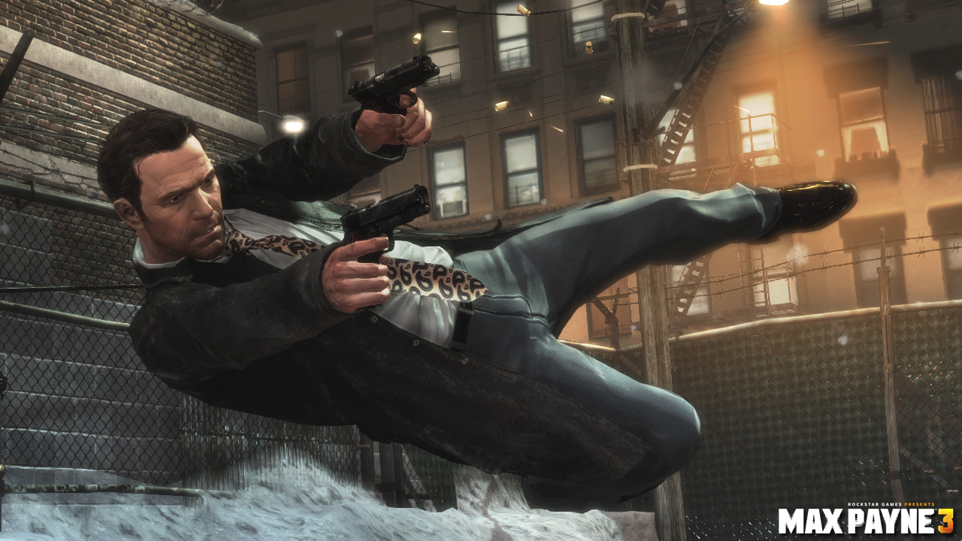

[1]

In relation to the project being undertaken bullets are not involved, but as many games have done, using bullet-time, you can interpret things in your own way. This is a feature for the game Smite; many of the characters have different types of slowing effects that can be applied to single or multiple enemies. A character to identify specifically would be Janus; this God has an ability called threshold which is a rift he creates, enemies who pass over the rift have their movement speed slowed (Hi-Rez Studios, 2014). This slow on the enemy will leave you as the player with an advantage of being able to kill them.

Following in other successful video games footsteps the project should interpret slow motion in its own way. This means taking knowledge of bullet-time to create a visually appealing feature but also taking notes from smite and superhot where they use slow motion as a mechanic. As in the example of Janus, Smite has only specifically targeted one variable to slow down whereas it could be more effective to slow down more. From this understanding it would be more useful for Chronos in the prototype to slow down all the variables on a specific enemy, giving the player an advantage for a short duration.

**Freeze Time**

Freezing time is the concept of making everything come to a halt in an instant, meaning if time was stopped zero seconds would be passing therefore nothing can travel faster than the speed of light so this would mean everything would be still (Barker, 2014). This concept has been touched on by a few existing video games such as ‘Quantum Break’ and ‘Prince of Persia: The Sand of Time’. In Prince of Persia the main character has an ability called power tank, which allows the player to freeze a single enemy in time, the enemy then turns grey for 10 seconds and can be chopped in halve with a couple of sword strikes (IGN, 2012). The game Quantum Break takes a different approach to freezing time; this is because instead of freezing a single enemy the player can dash with the main character in any direction, once the animation ends everything in the game freezes apart from the main character. The freezing style in Quantum Break is global and will allow the player a couple of seconds of frozen time to deal blows to an enemy of choice or multiple (Machkovech, 2016).

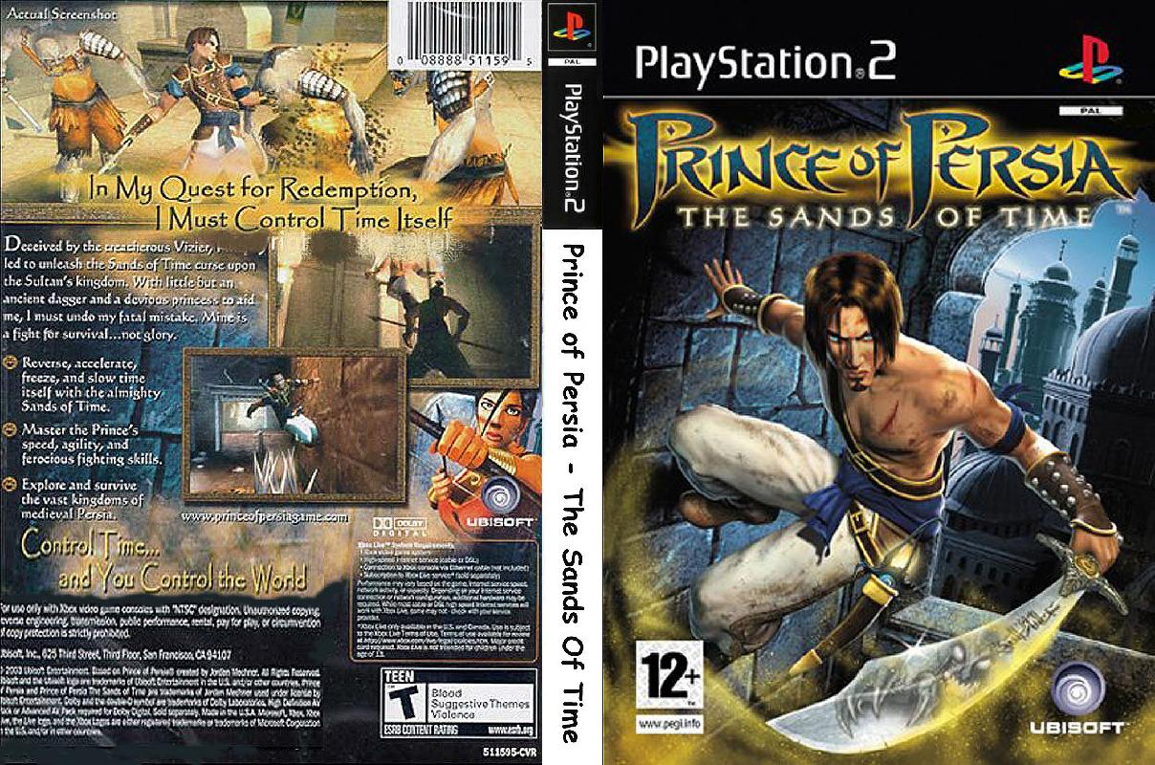

[2]

The game Prince of Persia specifically freezes time on a single target where as in Quantum Break it freezes time on multiple targets. In Prince of Persia when freezing one target the positive is that you can defeat that enemy with a lot more ease because they can’t return fire, but that doesn’t mean that other enemies can’t. This makes the game more difficult because you have to be more aware of your surroundings, instead of just focusing on the single enemy (IGN, 2012). In Quantum Break you freeze all the enemies, the positive with is that you can select the best enemy to kill, the negative is that the ability doesn’t seem balanced, as you don’t have to worry about taking any damage (Machkovech, 2016). From these comparisons it seems the best route to take would be to implement AOE ability, this ability would freeze enemies within a certain area. This would be beneficial in allowing the player to freeze multiple enemies or just one, but wouldn’t make the ability too powerful if other enemies not in the area can still target the player.

**Rewind Time**

Rewinding time is the idea of being able to visit past events so that you can relive them again up to the present, this will also allow you to make different decisions and correct past mistakes (Howell, 2013). Rewinding time or otherwise known as traveling back in time has been a concept questioned for a very long time, multiple theories have been created but most predominantly by Albert Einstein (Howell, 2013). Two games, already mentioned, include a time rewind feature, Smite and Prince of Persia. In Smite Chronos has the ability to rewind, which allows him to travel back through his own time zone to where he was 8 seconds before, this will revert him to the health and mana he had at that prior time (Hi-Rez Studios, 2013). In Prince of Persia: The Sand of Time the main character has the ‘Power of Revival’ which allows the player to rewind up to 10 seconds of gameplay, meaning the player can choose to stop rewinding time before the 10 seconds is over (IGN, 2012).

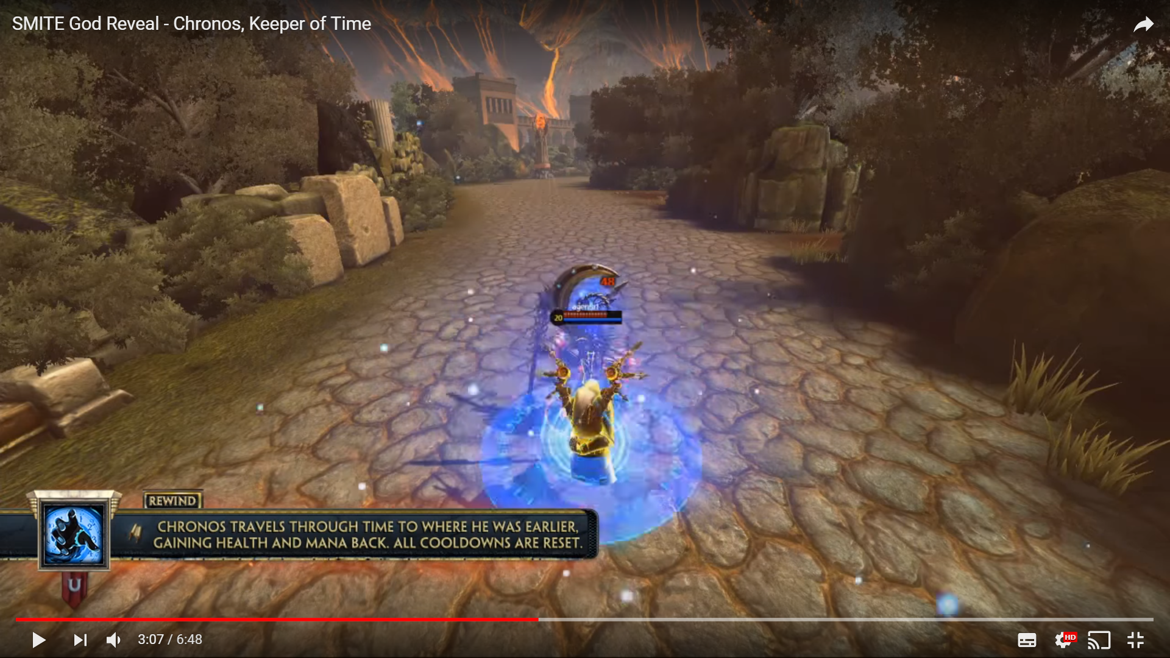

Comparing the two rewinding abilities demonstrated, they show two similar styles of rewinding time but are different in some ways. For Chronos, in Smite, the positive of his style of rewinding time is that it can be used to regain health, mana and will move his position if he is currently in danger. The negative is that the rewind in time only affects Chronos himself, meaning enemies can anticipate where he is going to be after the rewind (Hi-Rez Studios, 2013). In Prince of Persia a positive is that you can rewind after failing a puzzle or a jump, this means you can take multiple attempts at one activity. You can also choose the amount of time you get to rewind by, this allows the player to decide what the best point in time is to start again. A negative of this style of rewind is that if you choose the wrong time to rewind you could end up putting yourself in a situation where you constantly die (IGN, 2012). In conclusion the best approach to take for the project is to create a rewind system that lets the main character revert back to his original health. The project should allow the user to choose the amount of time they rewind by to prevent a paradox. Finally the rewind time in the project should affect the game globally so that enemies don’t get a tactical advantage when rewinding. Some further research was conducted into time rewind to find some existing scripts to use for the project; a package was found which creates a time machine effect in the game, this isn’t quite the same rewind needed in this project but could be used as a guideline for the mechanic (Altered Reality Entertainment LLC, 2015).

**Fast Motion**

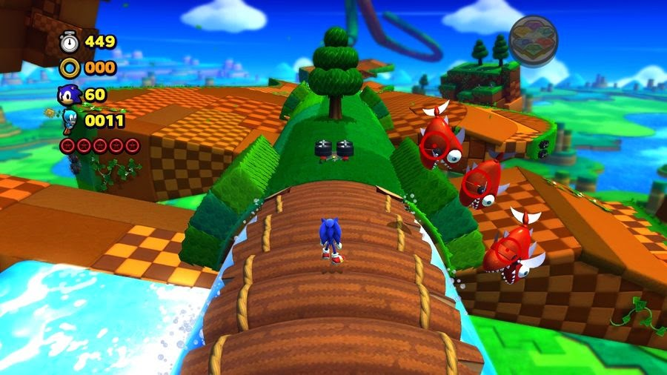Fast Motion in games can be represented in a range of ways, mostly considered as an objects motion between two points being increased to give players a sense of speed. This perception of speed in games is shown as your avatars motion relative to other objects in virtual space, so if you slow down everything else in the environment apart from one object, then it would seem like that object is moving really fast (Hill, 2014). Some games like Sonic the Hedgehog clock speeds of 767 miles per hour using his speed ability (Murray, 2017). Another example from the key background research into Smite is Chronos and his second ability Accelerate. This ability allows the Chronos to gain movement speed over time and also perform his basic attacks quicker (Hi-Rez Studios, 2013).

[4]

If you compare examples researched, you can see that these speed increases are measured in how fast a character moves over a period of time, but for the project there is no benefit to travelling at an incredibly high speed. In Sonic the Hedgehog he uses a personal speed dash; this is a positive because he can use it to dodge (Whitehead, 2008). In Smite Chronos’ ability has a positive of giving the player the advantage over the opponent by being able to move quicker and attack quicker (Hi-Rez Studios, 2013). In relation to the project Smite’s Chronos’ ability mechanic would suit the gameplay, so for the project a mechanic could be increasing the main characters movement speed and attacking stats for an advantage over the enemy (Hi-Rez Studios, 2013). For the project Chronos could use Sonics Dash in order to dodge enemy attacks (Whitehead, 2008).

**Primary Research**

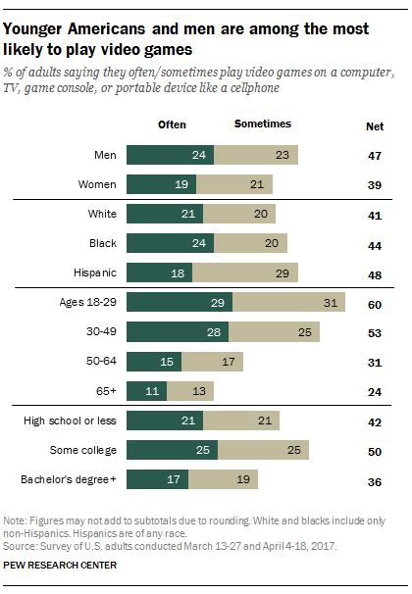A survey has been conducted to find out what market a time travel based game would tap into and also to distinguish what preferred time travel mechanic would be to a potential customer. Within the short survey four questions are asked. Firstly, the person’s age group, which time travel super power they prefer, their least favourite time travel super power and finally whether they would play a video game involving time travel. These questions are useful in helping to decide whether all the mechanics are relevant for the project, it also compares the mechanics to see which one is the best. The survey will also show what kind of audience the game should be targeted for by their age. Survey and Results have been posted in the appendix, which include results from 50 participants consisting of friends, family and a range of gamers. This survey was conducted to establish a target audience for the project so the general public were used for non-biased results.

[5]

If you compare the results from each question in the survey you can see there are some conclusions that can be drawn from them. The first question asks the participants for their age, this is to establish a target audience age range. The second question asks the participants for their favourite time travel super power, from these results you can see that the most favourable answer overall was to be able to rewind time, this showed a relation to the participant’s age being generally older. The fast motion super power had the fewest votes for this question; the results are showing that the older participants did not favour this super power. The third question asks what super power is the participant’s least desirable out of the selection; the results show that fast motion is the least favourite, which proves the second questions theory of being not a very popular super power. Slow motion was also a close contender in being the least desirable. The final question in the survey asks whether the participant would play a video game involving time travel, the results show that the majority of participants from the youngest age to forty years old would play the game, whereas from the age of forty one to the eldest participant they are less likely to buy a time travel game.

In conclusion the results from the primary research demonstrate that the target audience for the project should be any person below the age of fifty four, the reason for this instead of forty is because there are still people around the ages of 50 who would play this game. The last statement is proven by a study conducted in 2015 about the general ages of people who play videos and these results show that there are quite a respectable amount of participants around the age of fifty who do play video games sometimes or often (Brown, 2017). Based on the primary research, the project needs to focus on the time mechanics that are most popular and implementing the use of the most favourable ones.

## Methodology

### Comparing Waterfall and Agile

In this section the focus will be on what method is going to be used to create the project. There are two main methodologies to work from, one is the waterfall model and the other is agile. For waterfall it works off the basis that the products life cycle takes place in sequence. This sequence works in stages, it starts off by establishing the requirements, then moving onto designing the prototype, then implementing the design and finally verifying the implementation and maintaining the game (Stiller & Le Blanc, 2002, pp. 43-44). Nobody actually invented the waterfall model but rather it was inherited from other industries, these industries would not revisit stages of development in order to be more profitable but would result in a worse end product. (Bowes, 2014). The purpose of this model is to launch the product fast and rectify mistakes after release or in the next stage of development (Stiller & Le Blanc, 2002, p. 45). Another issue with the waterfall model is that if there are changes to requirements then there would need to be laborious change control procedures to go through, extra requirements is an issue established already in the risks section so using this method would result in taking even longer to overcome the risk (Bowes, 2014).

The other method to use would be agile development; agile uses a linear, sequential approach in favour of being incremental and iterative. Instead of planning and designing everything in the project up front, it allows for the project to change requirements over time by using cross functioning teams (Bowes, 2014). These teams work on successive iterations of the product over fixed periods of time; this is known as a sprint. The workload is organised into a backlog that is completed in hierarchy, this is based on the priority of the task. By the end of each iteration or sprint there should be a working product to present to the stakeholders of the company (Bowes, 2014). There are different types of agile approaches which include scrum, extreme programming, Kanban and crystal, but for this prototype the focus would need to be on using scrum, this is because the prototype is a solo project so this would mean the other approaches would be obsolete (Lacey, 2016, pp. 6-7).

In conclusion comparing these two project planning methodologies, the prototype being produced best suits the agile method. The reasoning behind this decision is based on what current games companies use, which is agile, whereas less and less use the waterfall method because it doesn’t allow for user or product owner input later into the project. FIFA 16 by EA games was successful off the back of agile development. For FIFA 16 sprints allowed testers to identify and fix bugs early in the process which saved the company time and money (Campbell, 2016). Scrum also endorses collecting frequent user feedback, so scrum accommodates for EA games being under constant pressure to add, amend and improve features (Campbell, 2016). If EA games can use a scrum agile approach, then so can this prototype, it’s justified to use this approach because it allows the project to overcome one of its risks. Agile will also allow the project to meet and improve set objectives, for example in the design a sprint plan and backlog need to be created. These two objectives being created are a standard for the methodology, but agile lets you create the backlog in priority hierarchical order which would improve this objective. The overall impact that agile would have is that it will create a better structure and plan for development.

### Agile in Relation to Roles and Stages of Development

Looking at agile in relation to the design, development, testing and implementation stages you can see that they are constructed in the product backlog. The product backlog in the scrum method consists of user stories created from different roles within the company. A user story describes functionality that is valuable to the product owner, developer or the users of the product. A story consists of a description of the functionality, justification for the need of the story and tests to determine whether the story is complete (Cohn, 2004, pp. 4-5). The product backlog can also be known as the requirements; these requirements will consist of tasks that need to be completed in priority order. Each story or requirement is completed using the development stages (design, development, testing and implementation), once the test of the story comes back successful it can then be merged into the working product. Before each sprint a meeting is held between the developers to determine what requirements are going to be put into the sprint backlog, the sprint backlog are tasks that need to be completed within the usual 2-4 weeks of a sprint (Ambler, 2012).

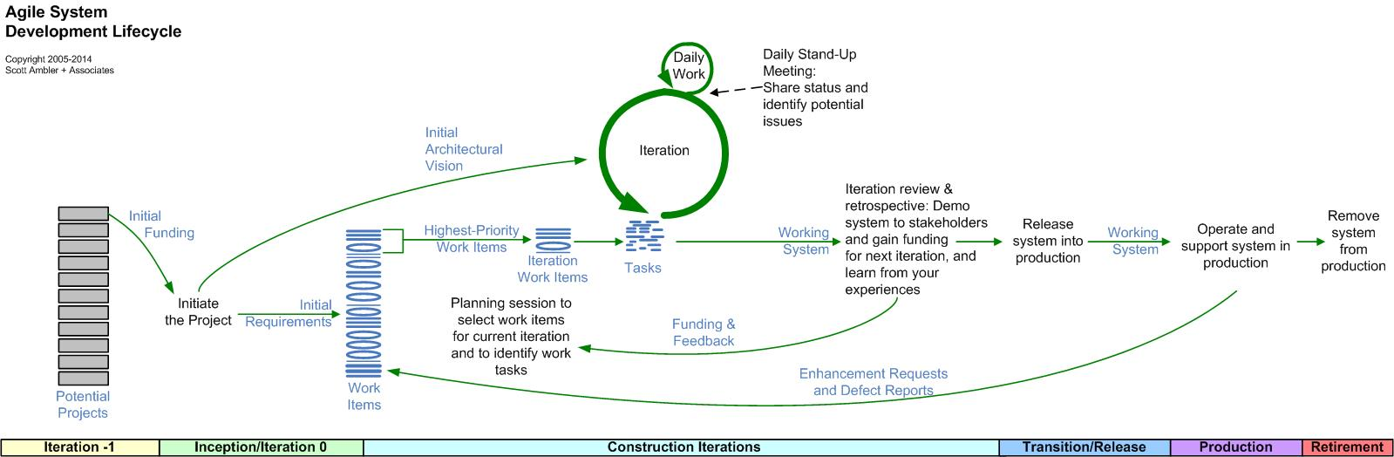

[6]

### Unified Modelling Language

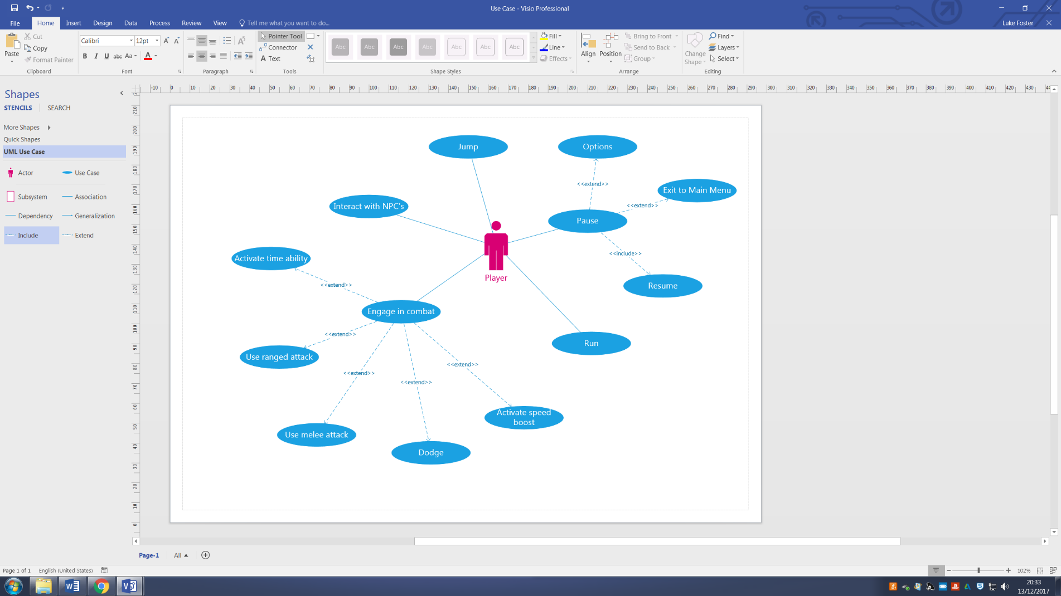The structure and plan would be created from using multiple UML diagrams, UML stands for unified modelling language. UML is a standard across the object oriented community; this standard was created in order to communicate and understand project systems with team members (Eriksson & Penker, 1998, pp. 1-3). The diagrams consist of, use case, state, sequence, collaboration, communication and activity (Eriksson & Penker, 1998, pp. 17-22). These diagrams are used to model parts of the prototype system for a better understanding of individual elements, for example an activity diagram could be created for the project for when Chronos needs to retrieve a relic. You would have to consider multiple factors for Chronos collecting these relics, like whether there are any decisions he would need to make on the way and also what conditions need to be met in order for him to get this relic. UML diagrams also help map out other systems within the project for example looking at the user interface. Creating UML diagrams also meets a design objective.

#### Use Case

Use case diagrams are usually referred to as behavior diagrams used to describe a set of actions (use cases) that some system or systems (subject) should or can perform in collaboration with one or more external users of the system (actors). Each use case should provide some observable and valuable result to the actors of the system (uml-diagrams.org, 2017). A use case diagram for the project has been created to represent the actions a player can take when playing the prototype.

#### Communication Diagram

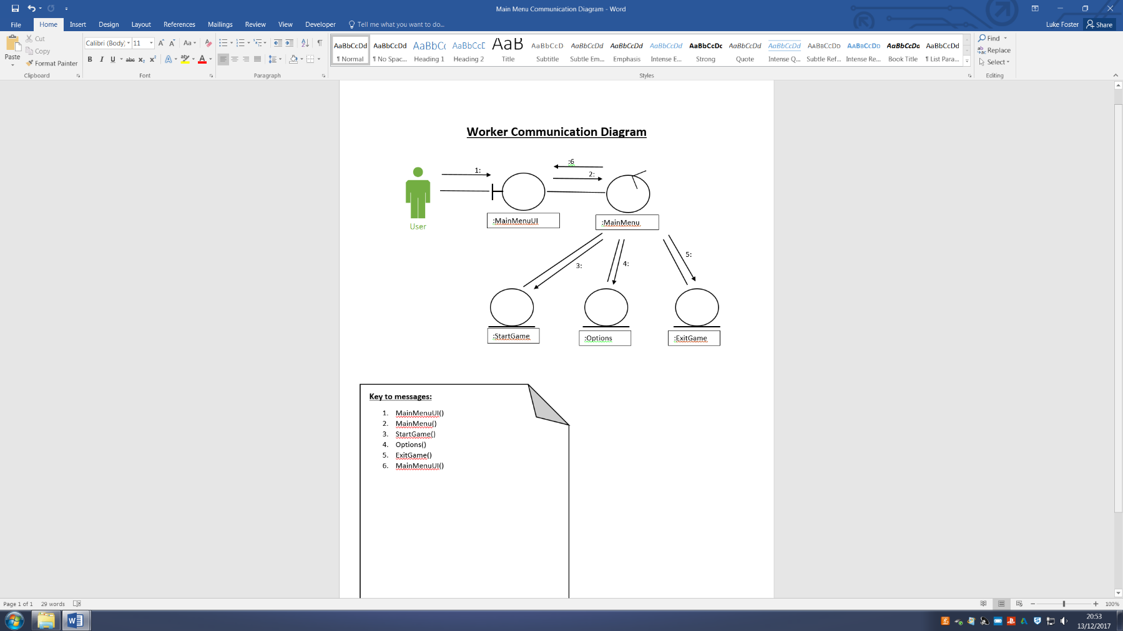Communication diagram is a kind of UML interaction diagram which shows interactions between objects and/or parts (represented as lifelines) using sequenced messages in a free-form arrangement (uml-diagrams.org, 2017). A communication diagram has been created to represent the main menu system and what paths the user can take.

## Requirements

### User Stories

|  |  |  |
| --- | --- | --- |
| **No.** | **User Story** | **Requirement** |
| **1.** | As a Player I want the game to have a 3rd person camera view so that I can see Chronos’ time travel abilities | Create a 3rd person camera for the main character |
| **2.** | As a Player I want ranged combat so that I can strafe to dodge enemy attacks | Create ranged basic attacks for Chronos and the AI |
| **3.** | As a Player I want combat to progress through the game so that Chronos becomes more powerful | Create progression system using XP |
| **4.** | As a Player I want combat to progress through the game so that enemies become more difficult towards the end | Increase enemies health and damage in correlation with Chronos’ progress |
| **5.** | As a Player I want Chronos to jump so that I can get over objects | Make it so Chronos can jump |
| **6.** | As a Player I want to play using an xbox controller so that it’s more of a comfortable gameplay experience | Implement an xbox controller for game controls |
| **7.** | As the Product Owner I want smooth animations so that the game is more visually pleasing | Create smooth animations by increasing animation frames per second |
| **8.** | As a Player I want a guide to help me reach quests so that I don’t waste time looking for them | Create quest guide who gives dialogue support to the player |
| **9.** | As a Player I want Chronos to dodge so that I can avoid enemy attacks | Create a dodge ability for Chronos |
| **10.** | As a Developer I want the AI to block so that they become more difficult to defeat | Add blocks for basic AI and the Boss |
| **11.** | As a Player I want sound effects so that the games more of an immersive experience | Add sound effects to interactions and combat |
| **12.** | As the Product owner I want main menu music so that it sets the scene for the game | Add main menu music |
| **13.** | As a Player I want a pause menu so that I can take breaks from the game without needing to quit | Add pause menu |
| **14.** | As a Player I want a speed ability so that I can travel and attack faster to gain an advantage over the enemy | Create a speed ability for Chronos |
| **15.** | As a Developer I want the boss AI to have 3 different melee attacks and the basic AI to have 1 so that the boss is more difficult | Create boss AI and basic AI melee attacks |
| **16.** | As a Developer I want a main menu so that the player can choose what level to load | Create UI main menu and scripts |
| **17.** | As a Player I want a tutorial level so that I can learn the controls to the game | Create tutorial level |
| **18.** | As the Product owner I want NPC’s so that the games more interactive and immersive to the player | Implement NPC’s Anake and Vulcan |
| **19.** | As a Player I want Chronos to run so that I can travel distances faster | Add toggle run to Chronos |
| **20.** | As a Developer I want the Boss to dodge so that the boss fight is more difficult to the player | Add AI Boss dodge |
| **21.** | As a Player I want a melee attack so that I can compete in close combat | Create a melee attack for Chronos |
| **22.** | As the Product owner I want Chronos to have time oriented abilities so that the game meets the projects aim | Create Chronos time abilities |
| **23.** | As a Player I want to be able to see the objectives so that I can check my progress in the game | Add objectives onto the UI |
| **24.** | As a Player I want boss battle music so that the fight feels more intense | Add boss battle music |
| **25.** | As the product owner I want the prototype level to be set in an eerie scene so that it sets the atmosphere for the game | Create eerie scene |

### Functional Requirements

|  |  |  |  |
| --- | --- | --- | --- |
| **No.** | **Function** | **Description** | **Requirement** |
| **26.** | Allow the players experience points to level, and increase stats | User can earn experience points from killing enemies in combat and completing quests. Levelling from XP will results in Chronos’ combat stats becoming more powerful | Create experience points and levelling |
| **27.** | Allow Chronos and AI to have health | Chronos and enemies will have health; if Chronos’ health equals 0 then user will have to restart the level or rewind. Health will be displayed to user via the user interface | Create health scripts and health UI elements |
| **28.** | Allow the time mechanic scripts to be integrated into combat | Using scripts from appendix adapt them so that they’re cohesive with the combat system and are represented as Chronos’ abilities | Integrate time mechanic scripts into combat |
| **29.** | Allow Chronos to move | Give Chronos a player movement script to allow the user to move the main character using button inputs | Create movement scripts and map inputs |

### Non-Functional Requirements

|  |  |  |  |
| --- | --- | --- | --- |
| **No.** | **Non-Function** | **Description** | **Requirement** |
| **30.** | Reliability | The game should be reliable and not have glitches | Create error handling within scripts |
| **31.** | Usability | The game should be capable of being played by users of any skill level | Create dummy AI for tutorial level |
| **32.** | Intractability | The user is able to navigate the main menu and pause with correctly labelled buttons to take them between levels or exit the game. | Create scripts to navigate player through levels using UI |
| **33.** | Manipulability | The game will allow the user to change their gameplay options e.g. controller sensitivity | Create options for the main and pause menus |

## Design

### Introduction

In this section the design for the prototype is going to be created, this is done by completing the project design objectives using an agile approach. This approach consists of sprinting iteratively to create the design documents, these design documents can be created from previous research and documents provided from the methodologies, literature survey and requirements sections.

### How Research has underpinned the Design

After researching into the scrum agile methodology you can identify that the design process can be completed by using sprints. In relation to this project if you look at the design objectives you can see that there are only five, so this means for the design process only one iterative sprint would be needed. The agile methodology has backed up the design process by allowing a planning process to create a structure for designing the game. The agile methodology has not only helped with the planning of the design but also with mapping out specific systems in the prototype from UML diagrams. The UML diagrams when initially created sparked an insight into what certain aspects of the prototype are going to be and drew a vision of some potential requirements.

The requirements phase of a project is often perceived as the most important phase of the software development cycle; this is because requirements form a basis for the design stage for the system. (Bennatan, 1992, p. 46). UML diagrams aren’t the only situation of seeing some potential requirements, if you look back to the literature survey you can also see how some requirements can be created. These requirements from the literature survey are identifiable from looking at the comparisons between different games, these comparisons created a conclusion for what the best abilities for Chronos would be. An example of what one of these requirements would be is as follows; Create AOE freeze ability for Chronos. You could also represent this as a user story; As the Product owner I want Chronos to have an AOE freeze so that he can gain an advantage over the enemy.

From research in the literature survey and methodologies sections there’s a problem because there are still a lot of requirements that aren’t accounted for; these include certain aspects that haven’t been considered in the project yet. So to overcome this issue some more documentation was needed into discovering the missing requirements. This documentation could be represented as a brain storm; brainstorming is about creation and collaboration between team members aiming towards a set goal for the project (Rastelli, 2017). With this project there is technically only one team member, so therefore the brainstorm was instead created using this team member and a group of potential users. The process of creating the brainstorm initially started by stating already established requirements from previous research, documentation and ideas. From then on user stories were used to find what each role within the game desired as a requirement. As the game is being produced by one person they represent the role of two members in being a product owner and a developer, this resulted in two different perspectives being given. Once all the user stories has been completed there seemed to still be a factor missing. This factor was the functional and non-functional requirements; functional requirements are expected functioning of the product to be created and non-functional requirements are factors that affect the system as a whole. (Goldsmith, 2009) Some functional requirements at this point were already being used as user stories and implemented into the brainstorm, so instead any functions not already considered were added into their own pathway as well as non-functions gaining its own pathway. In hindsight functional and non-functional requirements gathering should’ve been completed at the start of the brainstorm so that it is more understandable.

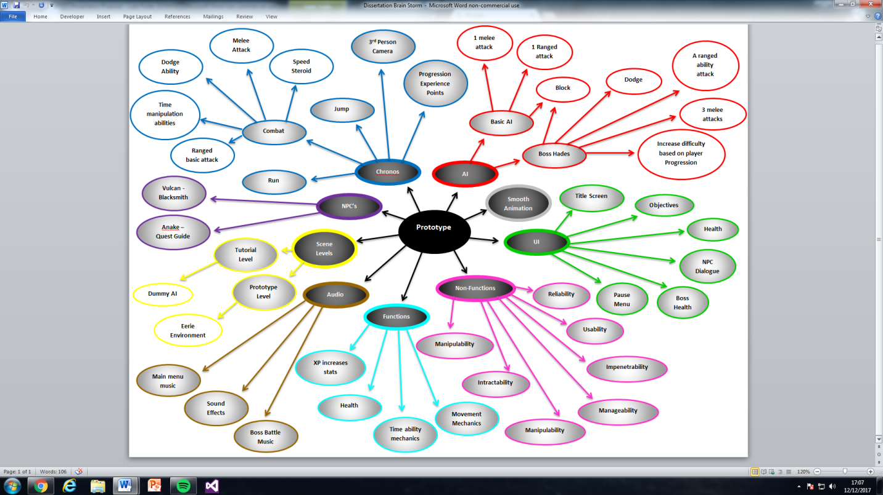

If you look at the Brainstorm produced you can see that requirements are split into subsections based on what they inherit from. Looking at Chronos as an example he has five requirements but the combat requirement expands further, the reason it’s expanded further is because using combat as a requirement is too vague so it needs to be expanded on in more detail. The brainstorm has also been colour coordinated to make it more readable. The brainstorm and the requirements section have result in the requirements gathering objective being met.

### Design in relation to Objectives

The project is oriented around the objectives set in order to reach the aim. Starting off the first objective to be met is to research to determine requirements. This objective has been met from the production of the brainstorm. It has also been met from research carried out in the methodologies, literature survey sections and further research into user stories.

Another objective that has already been met is creating UML diagrams. The creation of UML diagrams has come from the methodologies section; the reason for this is because after researching and describing the unified modelling language it made sense to work with the flow and provide UML examples in relation to the project.

#### Backlog

The agile product backlog in Scrum is a prioritised features list, containing short descriptions of all functionality desired in the product. Typically, a Scrum team and its product owner begin by writing down everything they can think of for agile backlog prioritisation (Mountain Goat Software, 2017). In relation to this project the product backlog was a lot easier to create because of the brainstorm. The brainstorm pin pointed the requirements for the project so for the backlog all that was needed was to list the requirements and prioritise them. The way the requirements were prioritised was by determining what requirements have dependencies on other requirements. Once these dependencies were discovered the backlog was organised into priority order.

The backlog was created on a piece of software called trello. This software is specifically designed for project management. For the prototype the trello board was organised into 4 headings which are Backlog, In-Progress, Testing and Complete. The headings are organised this way to represent the scrum approach. Once a sprint has begun the requirements to be complete in the sprint will move to In-Progress, then once the scrum is near the end it will move to testing and then complete once done. If a requirement hasn’t been met in the current sprint then it’ll be moved back into the backlog for the next sprint. Completing the backlog means another design objective has been met.

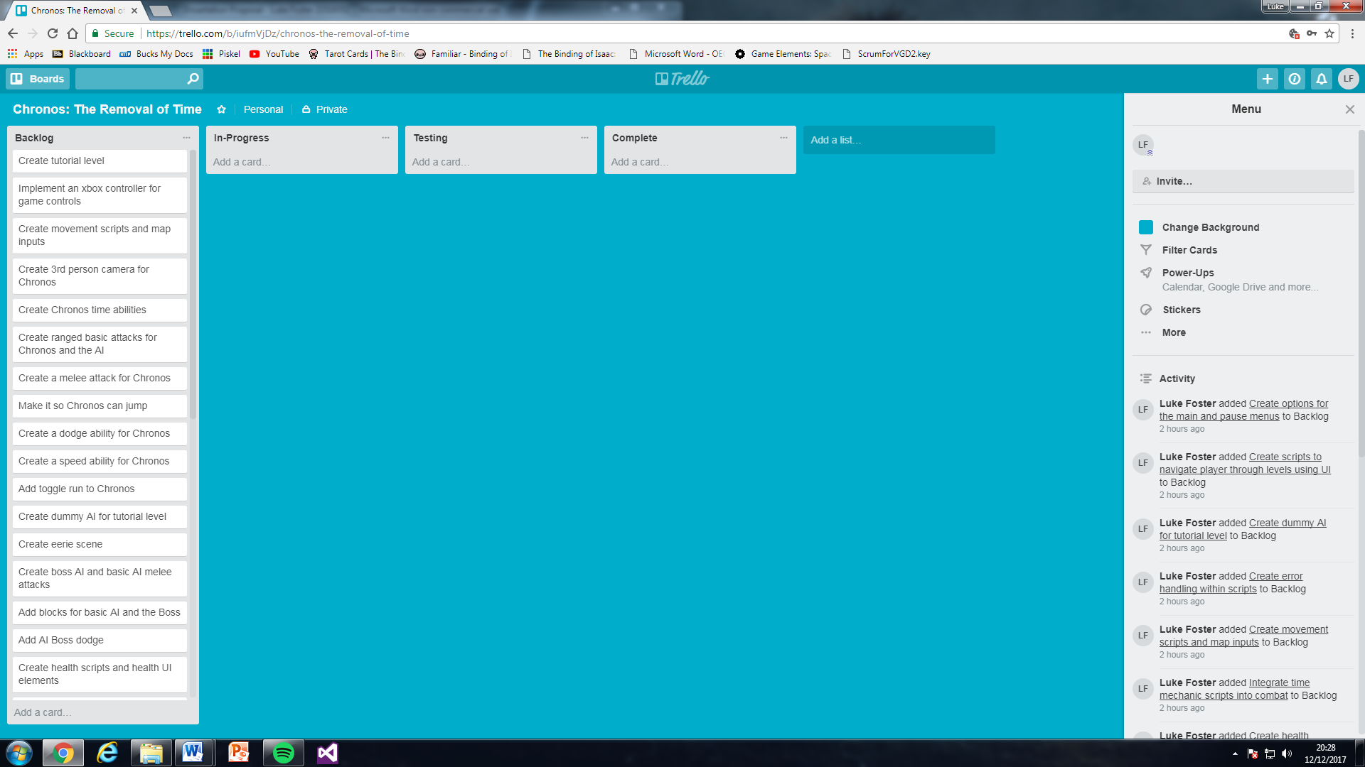

#### Sprint Plan

An objective in the design segment is to create a sprint plan. A sprint plan is a document produced in order to structure the development process. In Scrum, the sprint planning meeting is attended by the product owner, ScrumMaster and the entire Scrum team. During the sprint planning meeting, the product owner describes the highest priority features to the team. The team asks enough questions that they can turn a high-level user story of the product backlog into the more detailed tasks of the sprint backlog (Mountain Goat Software, 2017).

The sprint plan for the prototype was created from the backlog and brainstorm. After prioritising was done in the backlog the project was able to move onto implementing the requirements into the sprint plan. It was determined that each sprint would roughly last 3 weeks based on the deadline of the project. Overall there turned out to be six sprints resulting in project completion to be around the 25th of April, but this date could be pushed further if the risk of extra requirements is met. The sprint plan being created completes the final design objective meaning the project can move onto developing the artefact.

Sprint 1: Starts 20/12/17 – Ends 10/01/18 -6

* Create tutorial level
* Implement an xbox controller for game controls
* Create movement scripts and map inputs
* Create 3rd person camera for Chronos
* Create Chronos time abilities
* Create ranged basic attacks for Chronos
* Create a melee attack for Chronos

Sprint 2: Starts 10/01/18 – Ends 31/01/18 -5

* Make it so Chronos can jump
* Create a dodge ability for Chronos
* Create a speed ability for Chronos
* Add toggle run to Chronos
* Create dummy AI for tutorial level

Sprint 3: Starts 31/01/18 – Ends 21/02/18 -5

* Create Eerie level
* Create ranged attacks for the basic and boss AI
* Create melee attacks for the basic and boss AI
* Add blocks for the basic and boss AI
* Add AI boss dodge

Sprint 4: Starts 21/02/18 – Ends 14/03/18 -5

* Create health scripts and health UI elements
* Increase enemies health and damage in correlation with Chronos’ progress
* Create progression system using XP
* Create experience points and levelling
* Integrate time mechanic scripts into combat

Sprint 5: Starts 14/03/17 – Ends 04/04/18 -6

* Create smooth animations by increasing animation frames per second
* Create quest guide who gives dialogue support to the player
* Implement NPC’s Anake and Vulcan
* Create UI main menu and scripts
* Create scripts to navigate player through levels using UI
* Create error handling within scripts

Sprint 6: Starts 04/04/17 – Ends 25/04/18 -5

* Add pause menu
* Add objectives onto the UI
* Create options for the main and pause menus
* Add main menu music
* Add boss battle music
* Add sound effects to interactions and combat

## Development

### Introduction

In this section the creation of the prototype is going to be documented and analysed. The development process will be following an agile scrum model, a model highlighted to be effective in prior methodology research. A sprint plan and backlog was created in the design stage; this will allowed the development process to have a structure.

At the start of each sprint the backlog will be re-prioritised because tasks could meet a risk which would affect the next sprint. From research previous in the methodology section it was learnt that there are different methods to test while developing. The method chosen is bookend sprints; this involves testing the artefact against requirements at the end of each sprint in the development process (DeFranza, 2014).

### Sprint 1

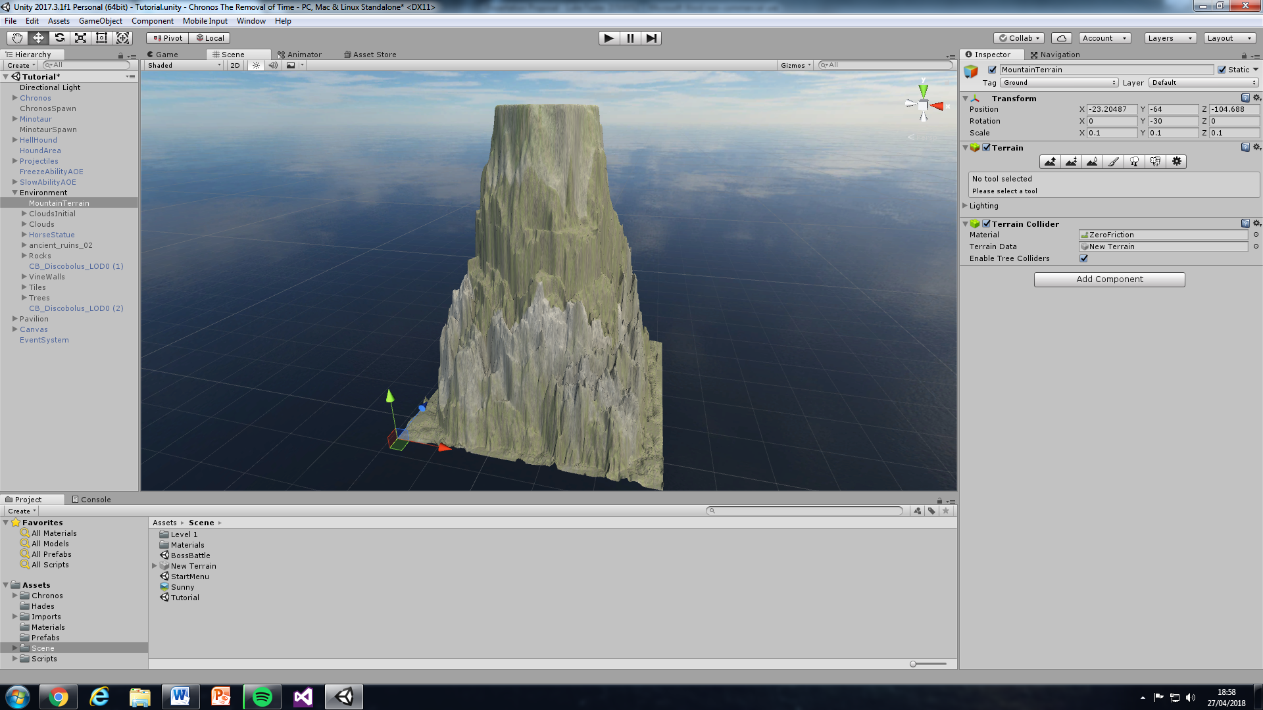Above is a trello board of the first sprint. You can see the first requirement is creating the tutorial level. A level plan was drawn using literature review research into greek mythology and smite to demonstrate the layout of the scene (Curse Inc, 2017). When creating the scene a skybox was added and next a mountain was created (Avionx, 2017). This was followed up by filling out the horizon with clouds (3LE Studios, 2016). Then useful assets were downloaded and used to construct the arena on top of the mountain, the final outcome can be seen below (4sidedpolygon, 2008; bitsong, 2013; 3dfancy, 2014; NEKCOM Entertainment, 2014; ChermandirKun, 2015; R & P Studios, 2017; DEXSOFT-Games, 2017; ChamferBox Studio, 2018).

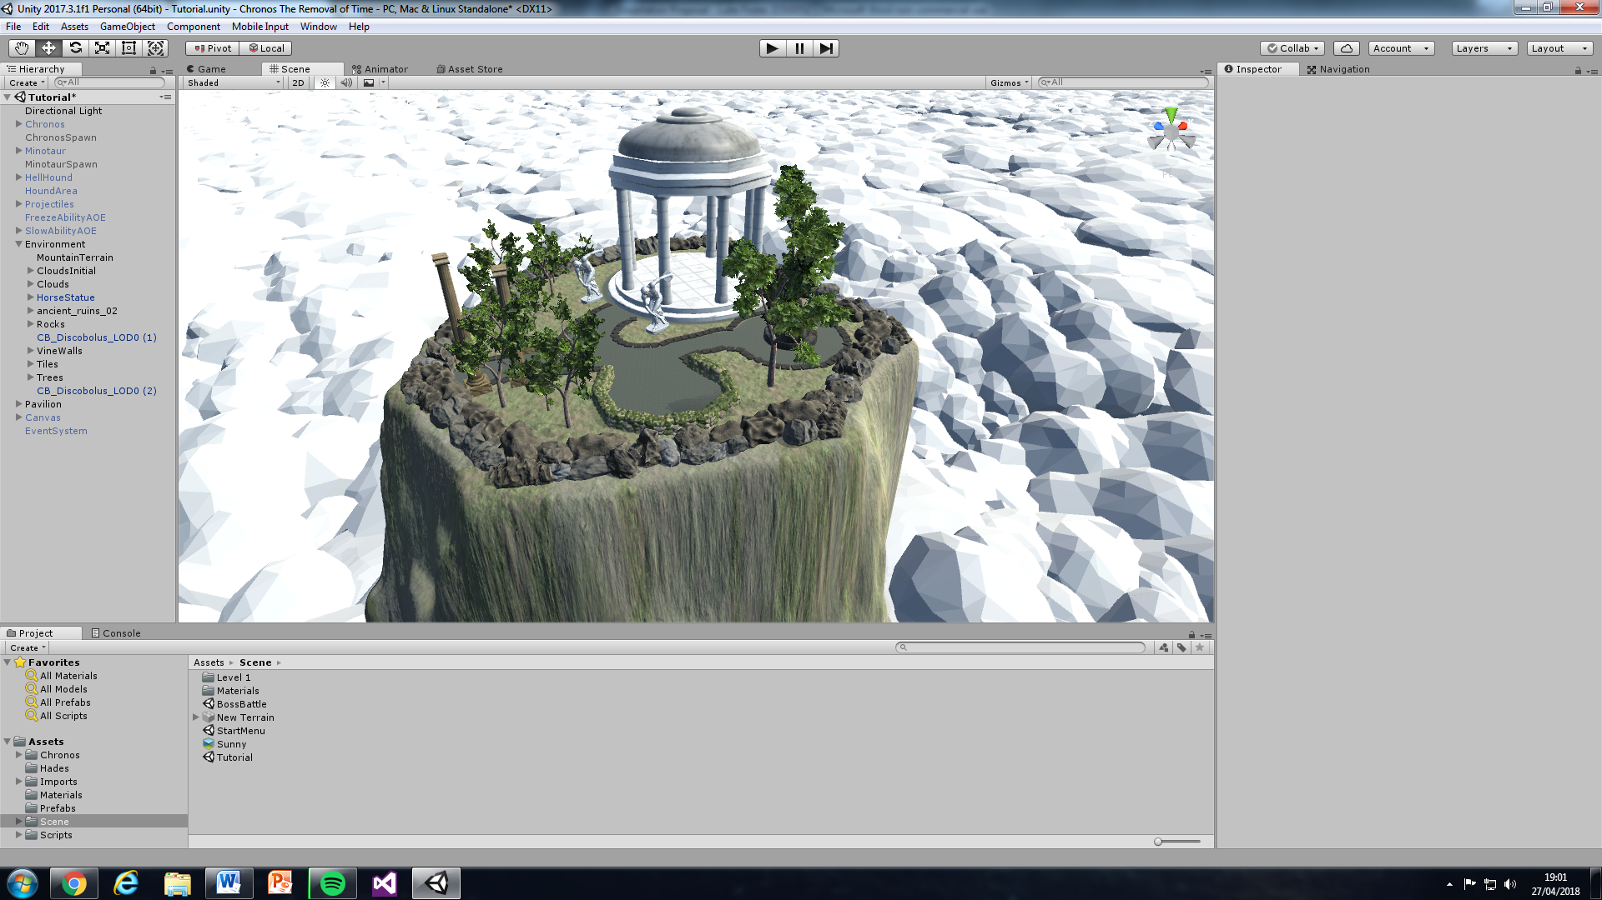

The following illustration below shows a close up of the scene to demonstrate rendered textures (Pochezhertsev, 2014).

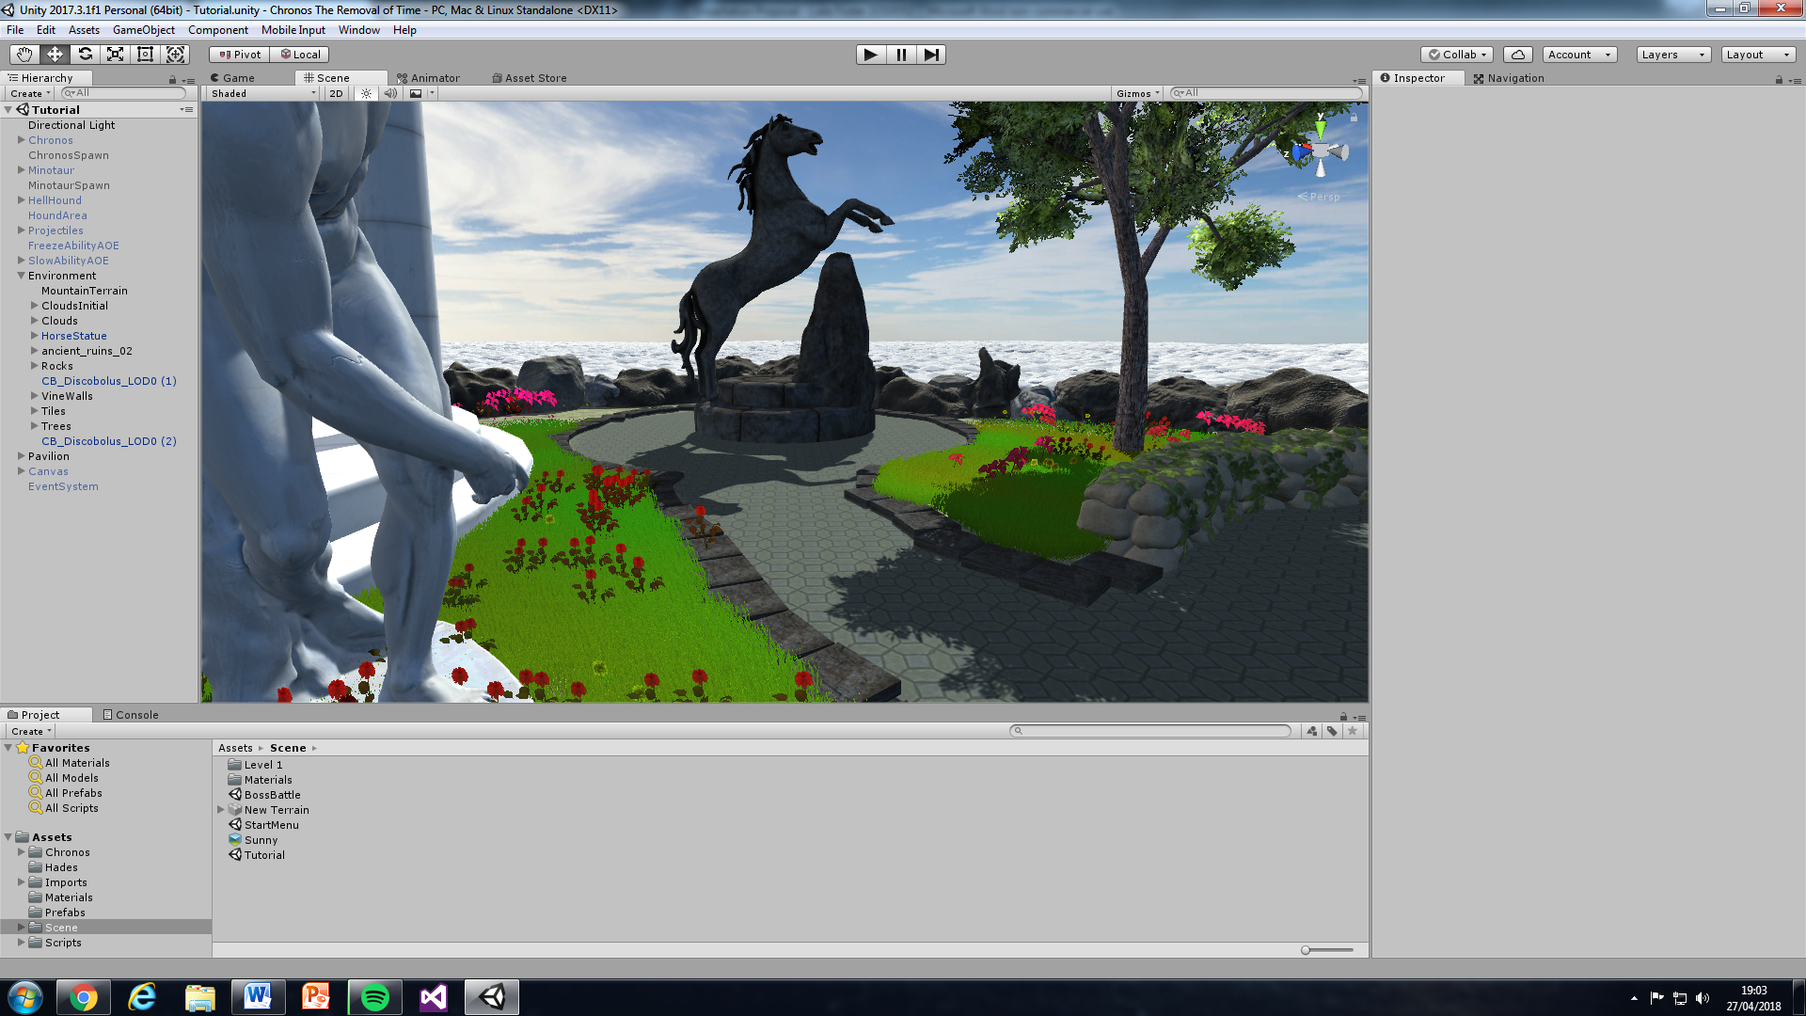

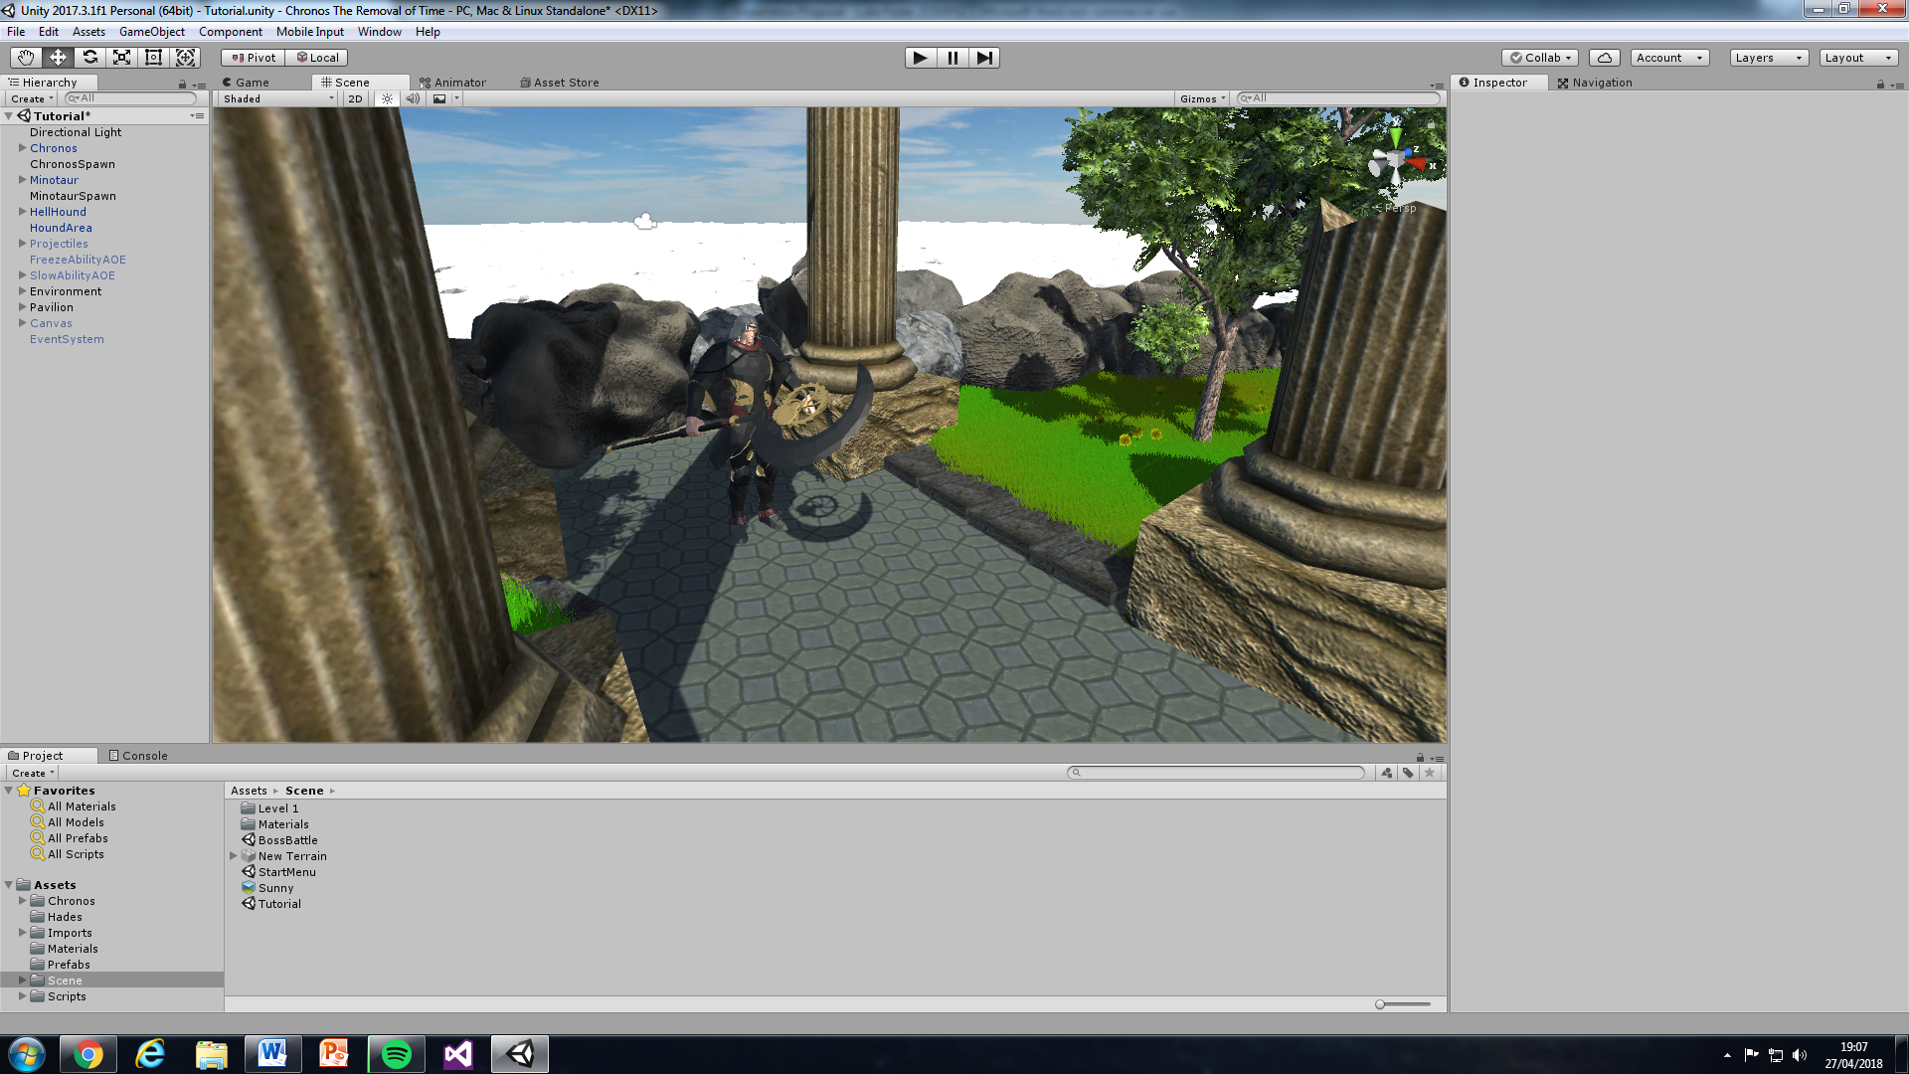Next was creating a 3rd person camera, first a Chronos model was found, recoloured and imported into the project (Spectro57, 2015). After the main camera was attached to Chronos, then the unity standard asset script mouselook was made a component of Chronos to allow the player to control the camera (Unity Technologies, 2012). The following task is to allow the user to move Chronos. Initially a decision was made to create the player control from scratch because it will need to be edited for the project to meet its aim. Controls were then added but limited to wasd keyboard movements due to inaccessibility to an Xbox controller. In result a development objective has been partially met, this is because Chronos has a movement system but not for an xbox controller input. Now Chronos can move it made the next task simpler because it meant a variable just needed increasing to adjust his speed when left shift is being held down. Finally the last task of the first sprint is to create a jump, this involved using physics to apply a vertical force to propel Chronos up and gravity to pull him back down.

### Sprint 2

Development on the first task begins with creating a melee attack; this is done by getting a left mouse click input from the player and using that to instantiate the basic attack logic. The next task had an issue where it uses the same input as the melee attack; this problem was overcome by creating a toggle so that the player can choose which attack should be active. Now the ranged attack can be developed, this is done by creating a projectile when the player left mouse clicks and moving that projectile in a forward direction until it is destroyed or in contact with an enemy.

The third task in the sprint presents creating a dodge. This task proved difficult but returned as a success allowing the user to right click to activate the dodge and use wasd keyboard inputs to control the dodges direction. The final sprint requirement is to develop Chronos’ time abilities, this initially started with a speed ability being created which increases Chronos’ attack and movement speeds when 2 is pressed. The following to be created was the rewind ability this was done by using literature survey research into rewinding time. From literature review research the method Brackey’s used to create a rewind effect was learnt and implemented into the project with adaptations (Brackeys, 2017). The next two abilities and rewind time require interaction with AI for further development; therefore this task will stay in progress for the next sprint.

### Sprint 3

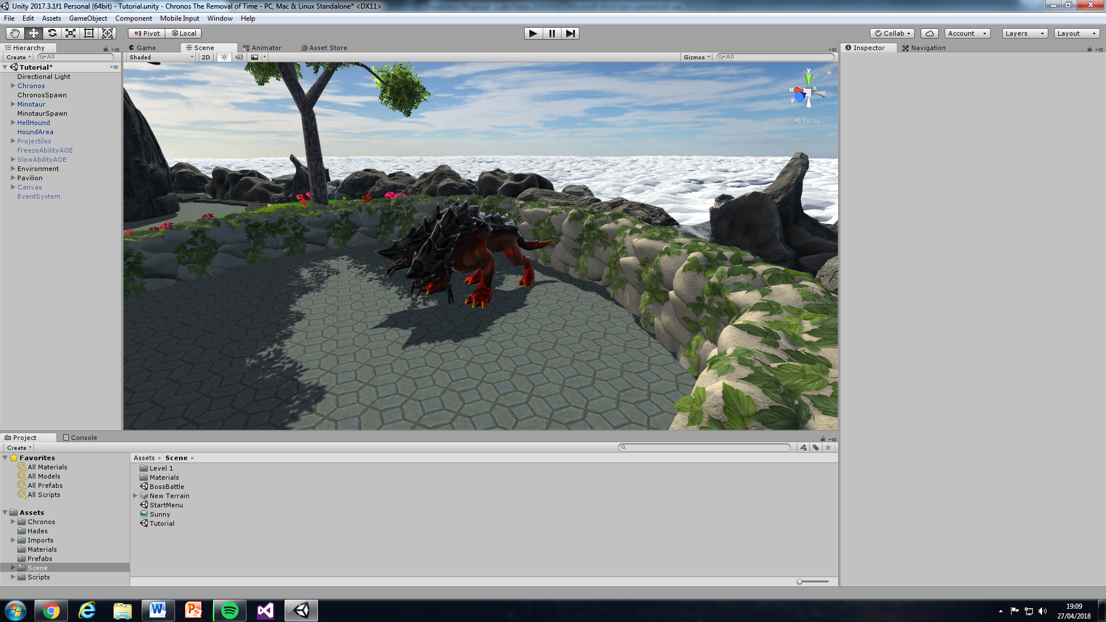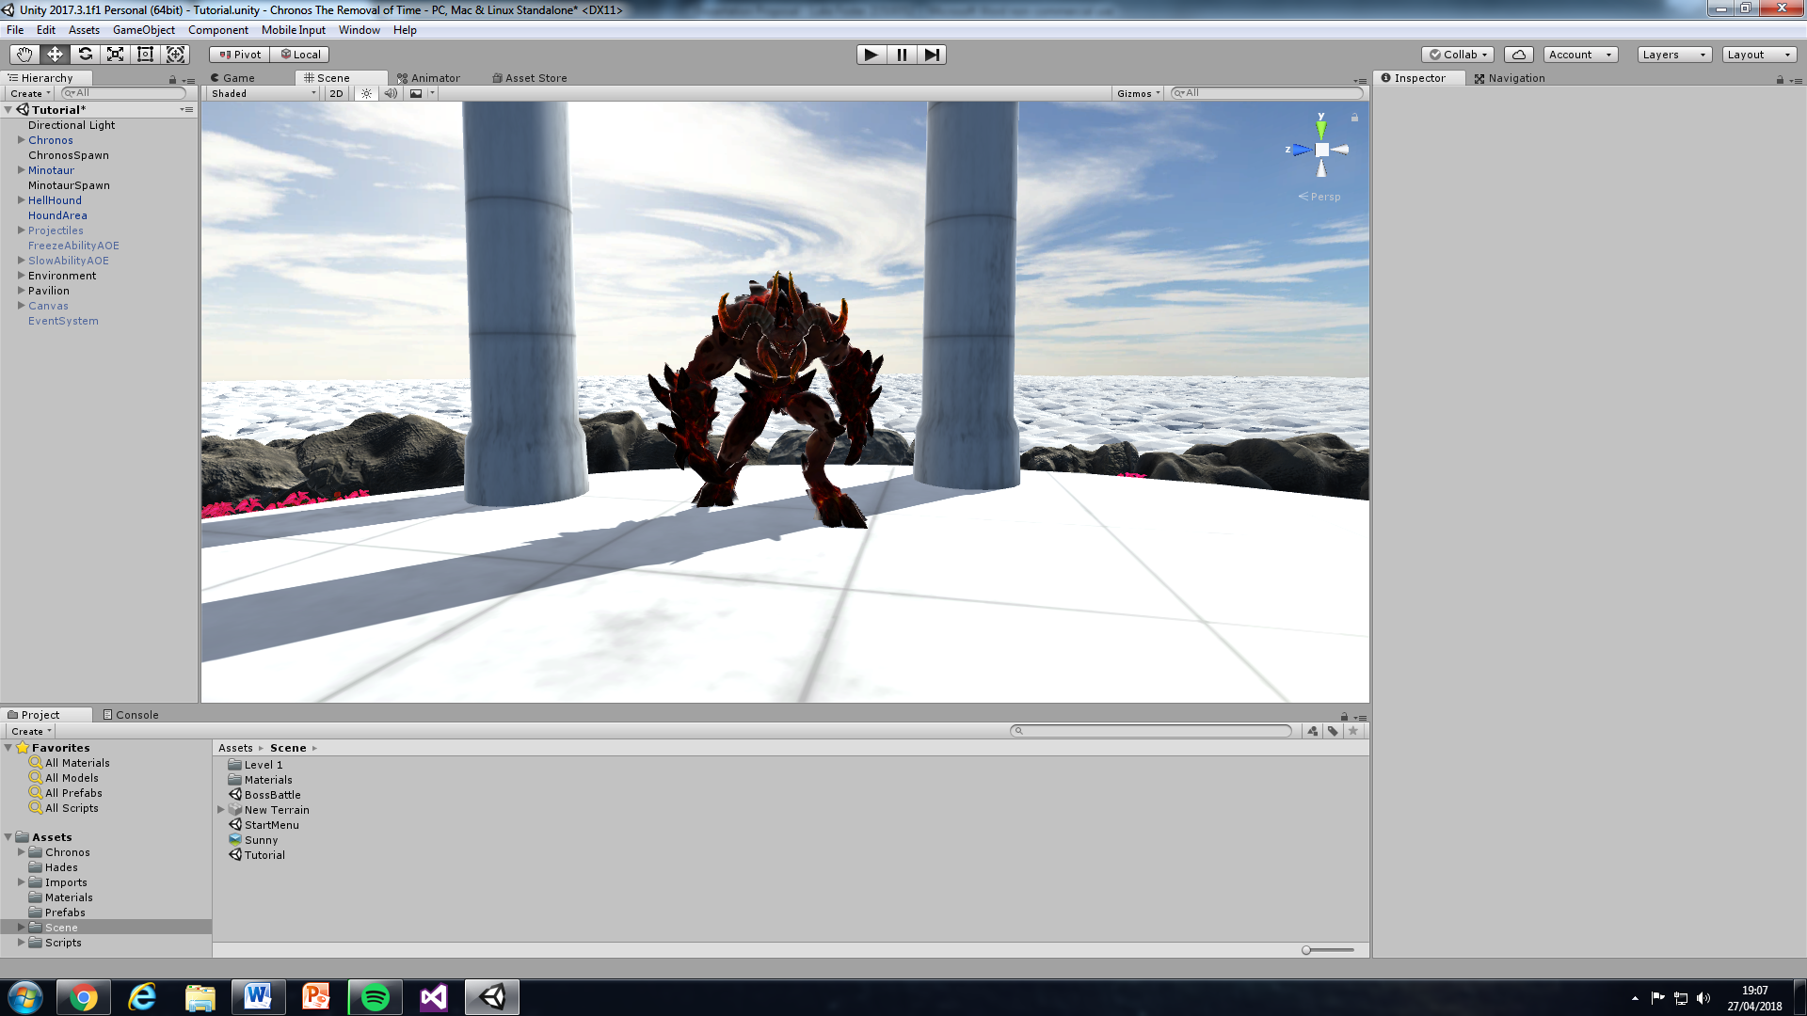The next stage of development looks at constructing the AI, the first step to take is finding assets which resulted in two being found a hell minotaur and a hell hound. These assets can be seen in the tutorial level on the right (CadNav, 2018).

For the first task the development team need to create a dummy AI, so they add logic for detecting Chronos’ attacks and reads whether the attack hit. From here we must move onto completing the next task as the health scripts haven’t been implemented yet. The following tasks in the sprint list can’t be done until the AI has a brain. So a state machine is used from prior knowledge learnt from AI modules. The state machine can implement these sprint tasks as states with its default state being move. For the melee and ranged attack states code is reused from Chronos and adapted accordingly. The final state of blocking allows the Minotaur to block Chronos’ attacks for a set duration, when health is created the Minotaur will also block damage. Now the state machine has been complete an objective is met, this is because an FSM is a relevant AI technique that was developed.

Now that the AI has logic we can look at creating the last two time abilities freezing and slowing time. So the first step taken was to allow the player to cast the freeze and slow abilities by holding the keyboard inputs ‘1’ and ‘3’, this will spawn an object in front of the player and allowing them to control it by moving their mouse. When the player then releases their keyboard input it will activate the ability effects to the AI. Due to the schedule these two abilities must be completed in the next sprint.

### Sprint 4

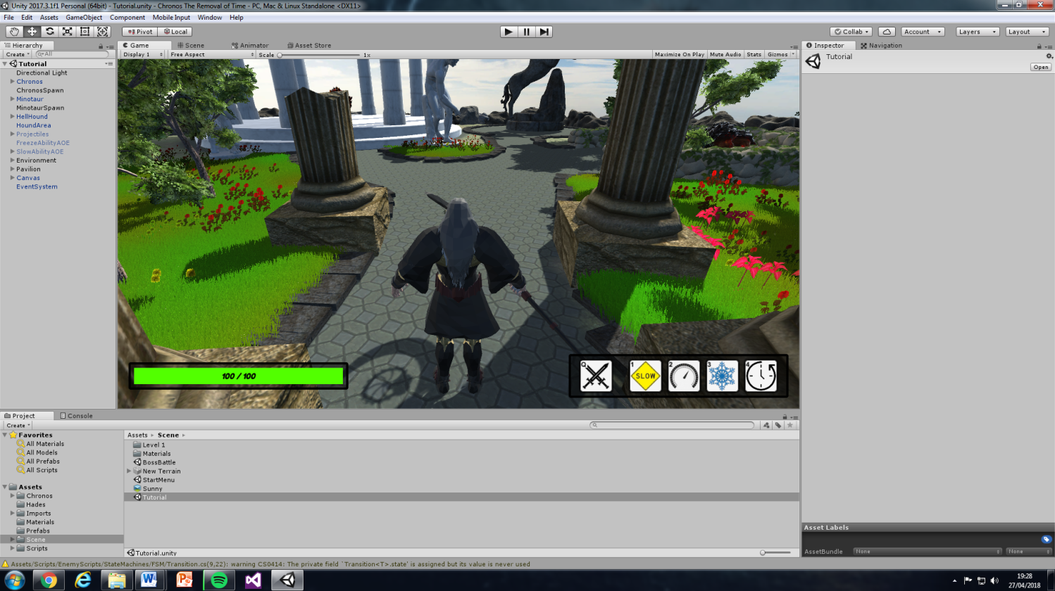At this point completing the time abilities were a priority because of the importance of meeting the aim of the project. The development of the abilities continued until the only thing left to do was applying effects and dealing damage to the Minotaur, the abilities need health and combat integration to progress. From here the development objective, develop time mechanics, has been complete.

The Health scripts and UI task is the highest in priority now because two other tasks are dependent on its progress. Starting this task involved creating a health manager script to monitor and control Chronos and the AI’s health. Afterwards damage was implemented so that characters could detect projectiles and melee contact. At this point it was getting quite difficult to read the output messages in the unity console window, so this is where a health bar asset was downloaded and implemented into the prototypes UI as illustrated on the right (Tank & Healer Studio, 2018).

Looking back at the trello board a group of tasks can be completed together, this is represented by the integrate time mechanics task because if completed the two tasks in- progress will also be completed. At this point in time the project is running behind schedule, this meets a risk because the scope of the project has been increased due to faults in code or needing to learn new skills for development.

### Sprint 5

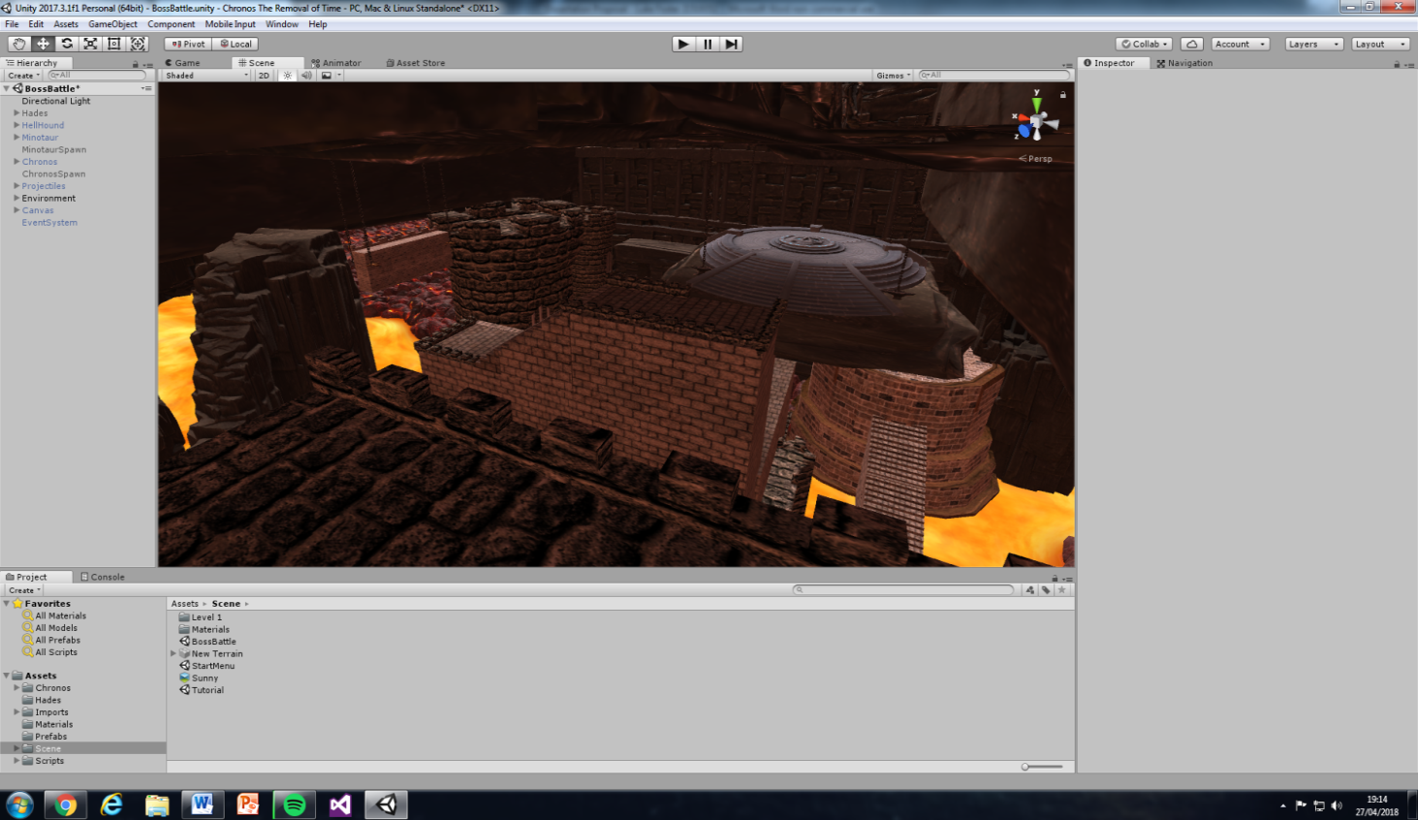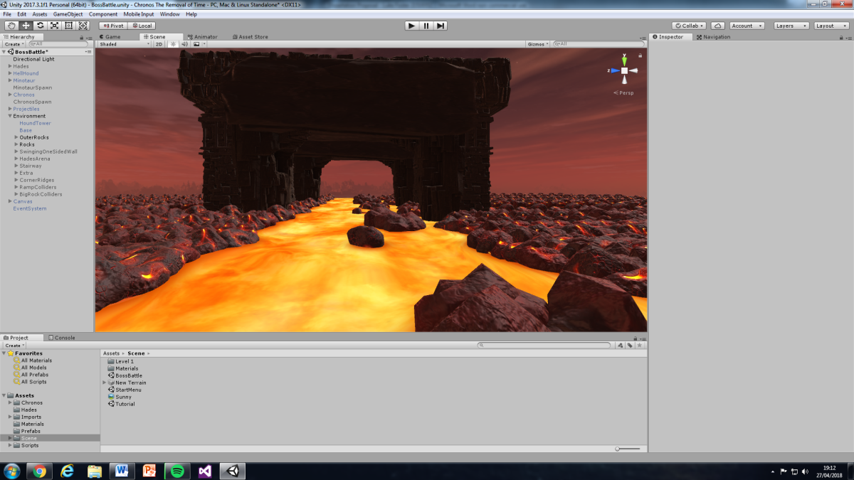In sprint five it starts off from where we left, integrating time mechanics. Completing this task involved allowing the AI to detect Chronos’ abilities, then applying damage and effects to the AI. At this point a development objective has been met of allowing time manipulation to affect the AI. Analysing the trello board we can move onto the first task under the sprint tab. When creating the eerie scene level follows the same steps as with the tutorial scene, but takes inspiration from the imported hell models (CadNav, 2018). Assets are then gathered from different resources online and used to create the environment for the enclosed arena as demonstrated on the right (Moonflower Carnivore, 2015; Ebal Studios, 2017; Koppel, 2017). The next stage is to create the arena, as the project is developing a prototype, assets were imported and laid out to test and demonstrate Chronos’ abilities and other features. (Aquarius Max, 2014; Vladut, 2017). The final outcome the eerie scene can be seen on the right.

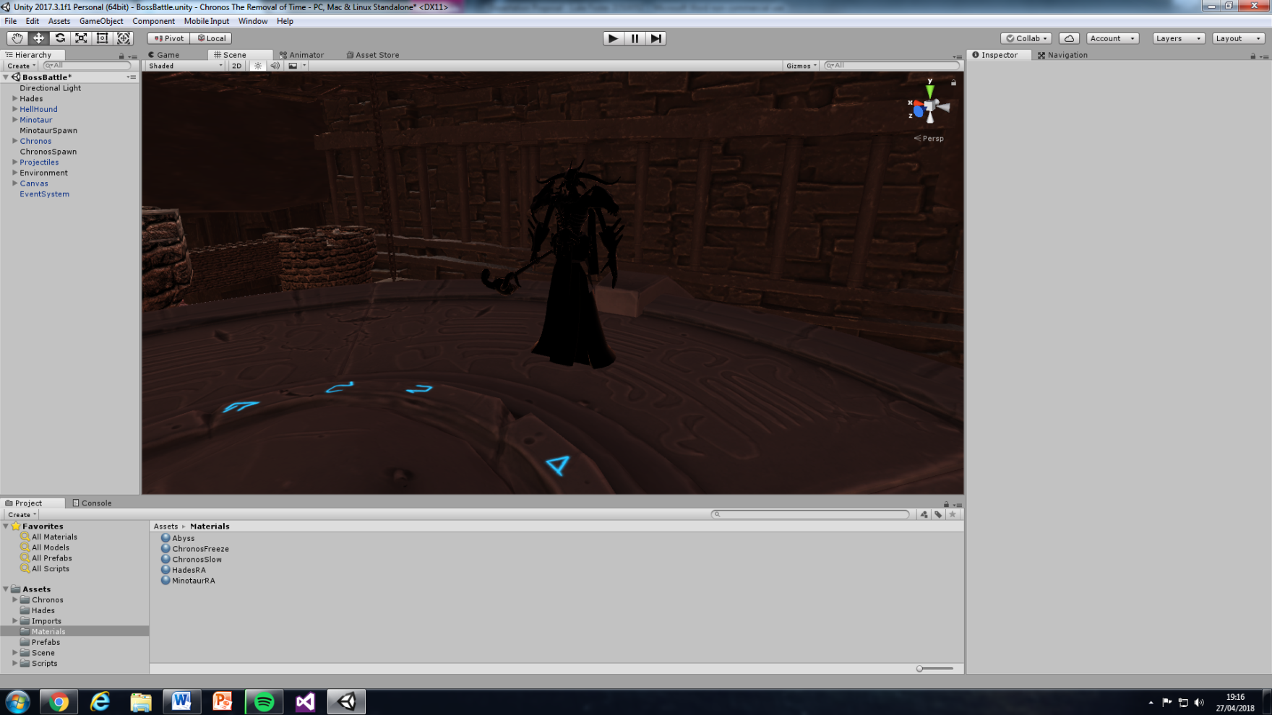Next Chronos and the AI’s logic from the tutorial scene are reused for the new scene. Creating the logic for hades started off by finding a hades model from the same source as the Chronos model (Spectro57, 2015). Then using the Minotaur’s AI brain as a guideline to create hades brain, this resulted in the boss AI block, melee and ranged attack tasks being completed. From here only two tasks remained which was to create the AI dodge and ability. For the dodge ability code is used as a guideline from Chronos’ dodge to create a dodge state for Hades. This dodge state is initiated at random based on when the player basic attacks. For hades ability code is then used as a guideline from Chronos’ freeze ability. After adapting the code, hades will at a random time will cast the ability at the player’s feet. If the player is touching the ability when it detonates they will be dealt damage and rooted to the spot for three seconds. At this point the artefact is playable allowing the player to complete the game and challenge different AI; as a result this completes an important development objective of developing a combat system.

### Sprint 6

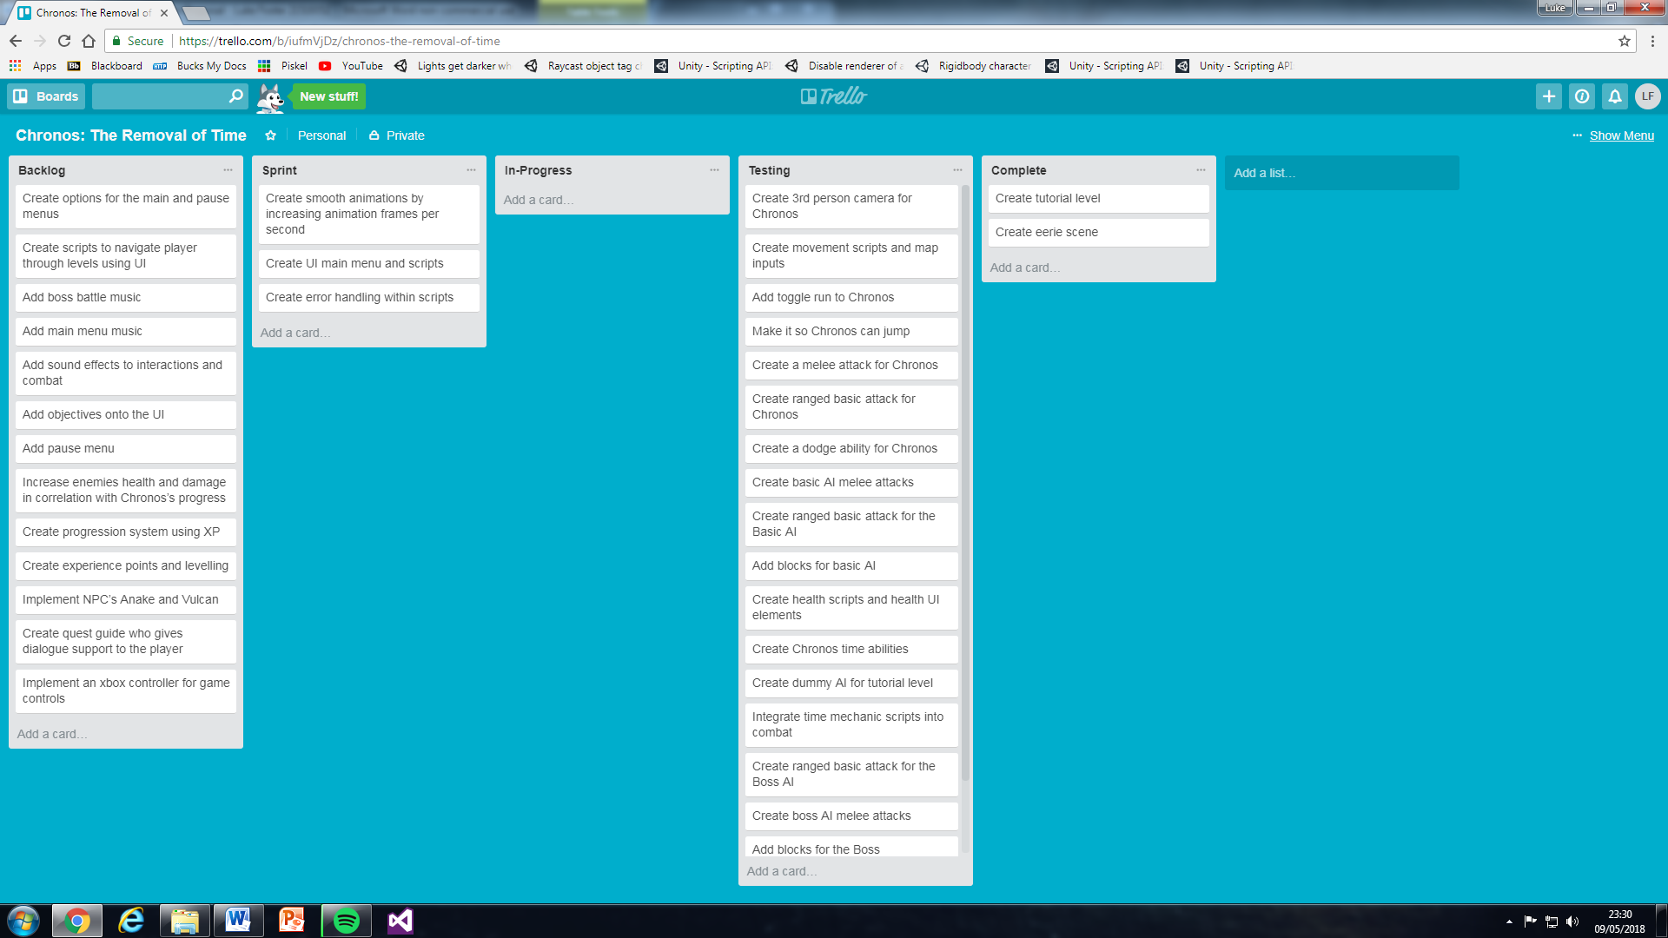

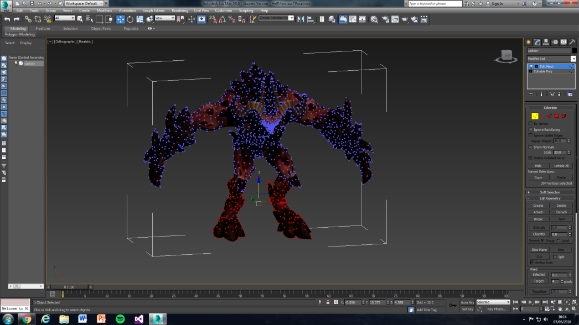In the sixth sprint animations are going to be created with the assistance of Mixamo (Adobe Systems Incorporated, 2018). Rigging the Minotaur model in Mixamo had issues. So using 3DS Max the models unnecessary horns were removed and, as being demonstrated in the illustration, his limps were then modified to position the Minotaur in a T-Pose (Autodesk, 2018). Once complete the Chronos, Hades and Minotaur models are rigged and animated. They are then imported into unity and implemented into their own animators. From here you integrate the animator’s logic with the games logic and time in the animations in.

The next task involves creating a main menu, this started by finding a main menu asset and editing the user interface to just three buttons Tutorial, Boss Battle and Quit (Unity Technologies, 2014). To complete this task each button was assigned a function to control what scene it takes the user to. The final task in the sprint involves error handling; throughout the development process this task has been continuous and would continue in future development.

## Testing

In this section the artefact is going to be tested against the project requirements. Testing will be done by creating a table and comparing the expected outcome of a requirement to the actual outcome, this will result in the project meeting its testing objectives. If requirements expected outcome is not the same as the actual outcome then a solution will be found and implemented, this will be recorded underneath each testing table. Testing each sprint will also involve a general gameplay test to identify any issues that aren’t related to the requirements already stated.

### Sprint 1 – Testing

|  |  |  |  |
| --- | --- | --- | --- |
| **Test No.** | **Requirement** | **Expected Outcome** | **Actual Outcome** |
| **1.** | **Create a tutorial level** | The scene is presented so that the player can identify the theme of the game and see the purpose to the level. | Achieved expected outcome. |
| **2.** | **Create a 3rd person camera for Chronos** | Allows the player to control the main camera from a 3rd person perspective. | Allows the player to control the x-axis for the main camera from a 3rd person perspective. |
| **3.** | **Create movement scripts and map inputs** | Allows the player to move Chronos dynamically from keyboard inputs. | Achieved expected outcome. |
| **4.** | **Add a toggle run to Chronos** | The player can switch between a sprint and walk state from the push of a button. | Chronos walks by default and if left shift is held down he will then sprint. |
| **5.** | **Make it so Chronos can jump** | Chronos can realistically jump to overcome obstacles. | Chronos can jump to overcome obstacles but unrealistically falls to the ground too slow. |

Looking at the testing table you can see that the second test hasn’t achieved the expected outcome. The actual outcome is that the player can only move the camera across the x-axis. This is because when the y-axis is active the camera rotates from the base of Chronos instead of the centre. This is a problem because the cameras distance from Chronos changes giving the player a distorted view of the scene. So a decision was made to lock the camera at just the x-axis rotation because having y-axis camera movement isn’t fundamental to completing the aim of the project and would also not hinder the gameplay.

The next test that returned unsuccessful was adding a toggle sprint. The result of this test was that instead of toggling a button to sprint you have to hold down a button. Analysing the actual outcome a conclusion was drawn that this solution is more beneficial than the expected outcome. The justification behind this conclusion is that the player can adjust speed dynamically whilst also making the game more challenging.

The final test found an issue where the jump felt like Chronos was hanging in the air too long. To solve this problem an investigation was initiated online into realistic jumping and from it was learnt how to accelerate the falling process (Board To Bits Games, 2017). From this new skill a fall multiplier was added to encourage Chronos to be in the air for less time.

### Sprint 2 – Testing

|  |  |  |  |
| --- | --- | --- | --- |
| **Test No.** | **Requirement** | **Expected Outcome** | **Actual Outcome** |
| **6.** | **Create a melee attack for Chronos** | Chronos can perform a melee attack which can detect when enemies are hit. | Achieved expected outcome. |
| **7.** | **Create a ranged basic attack for Chronos** | Chronos can launch a projectile which can be detected by the AI. | Achieved expected outcome. |
| **8.** | **Create a dodge ability for Chronos** | Chronos can dodge in a choice of directions to evade damage and travel faster. | Achieved expected outcome. |
| **9.** | **Create Chronos’ time abilities** | Chronos can manipulate time in four different ways to gain an advantage over his opponent. | Chronos can manipulate time in two different ways before this task moved onto the next sprint. |

Analysing the second sprint tests you can see that the first three achieved their expected outcome. The last test however cannot be done due to the task being completed in the third sprint instead. From here a general gameplay test was conducted and a problem was found. The issue is that Chronos is unable to travel over small obstacles without jumping, instead he should be able to just step over them. To solve this problem a solution was found on a unity forum (TwiiK, 2007). The solution looks at adding logic that will allow Chronos to identify whether an object is in front of him and if he is able to step over it.

### Sprint 3 – Testing

|  |  |  |  |
| --- | --- | --- | --- |
| **Test No.** | **Requirement** | **Expected Outcome** | **Actual Outcome** |
| **10.** | **Create dummy AI for the tutorial level** | The player can practice attacking on a static AI. | The player can practice attacking on a static AI, but without visual representation |
| **11.** | **Create basic AI melee attacks** | The AI is able to move to and attack Chronos at close range. | Achieved expected outcome. |
| **12.** | **Add blocks for basic AI** | The AI is able to block Chronos’ basic attacks. | Achieved expected outcome. |
| **13.** | **Create ranged basic attack for the basic AI** | The AI is capable of attacking Chronos at range. | Achieved expected outcome. |
| **14.** | **Create Chronos’ time abilities** | Chronos can manipulate time in four different ways to gain an advantage over his opponent. | Chronos’ freeze and slow abilities allow the player to cast out of camera view. |

Looking at test ten there is a complication where the dummy AI doesn’t have visual representation for damage being dealt. The reason for the complication is because the dummy AI needs health scripts and UI to be developed before it can continue further. Tests eleven to thirteen achieve their expected outcome.

The final test in sprint three recorded that the player can cast abilities out of camera view. To solve this experience was used from past maths modules to calculate the distance between two objects, then to normalise and retrieve the dot product of the two objects. Using this knowledge research was conducted to discover how to implement these calculations (Unity Technologies, 2017). After, it was implemented so the player can only cast the ability in front of them up to a determined distance of thirty metres.

### Sprint 4 – Testing

|  |  |  |  |
| --- | --- | --- | --- |
| **Test No.** | **Requirement** | **Expected Outcome** | **Actual Outcome** |
| **15.** | **Create Chronos time abilities** | Chronos can manipulate time in four different ways to gain an advantage over his opponent. | Chronos’ freeze and slow still visible after detonation. |
| **16.** | **Create health scripts and UI elements** | The player can visualise damage distribution through a user interface. | Achieved expected outcome. |
| **17.** | **Create dummy AI for the tutorial level** | The player can practice attacking on a static AI. | Achieved expected outcome. |
| **18.** | **Integrate time mechanic scripts into combat** | Chronos’ time abilities affect the AI’s health and behaviour during combat. | Passed onto next sprint. |

In this testing sprint only the fifteenth test didn’t meet its expected outcome because Chronos’ freeze and slow abilities were still visible after detonation. Two attempts were made to solve this issue, but they returned unsuccessful due to the abilities game objects needing to be active. In the end it was solved by conducting research online and learning how hide an object by disabling its renderer (chaosmaker, 2013). This was then implemented into the game but only for the freeze ability, this is because keeping the slow ability visible means that the player can have an indication for when the AI is being slowed.

### Sprint 5 – Testing

|  |  |  |  |
| --- | --- | --- | --- |
| **Test No.** | **Requirement** | **Expected Outcome** | **Actual Outcome** |
| **19.** | **Integrate time mechanic scripts into combat** | Chronos’ time abilities affect the AI’s health and behaviour during combat. | Achieved expected outcome. |
| **20.** | **Create eerie scene** | The scene is presented so that the player can identify the theme of the game and see the purpose to the level. | Merging caused issues within the scene when Chronos and the AI were added. |
| **21.** | **Create a ranged basic attack for the boss AI** | The boss AI is capable of attacking Chronos at range. | Achieved expected outcome. |
| **22.** | **Create a boss AI melee attack** | The boss AI is able to move to and attack Chronos at close range. | When moving the boss AI moves through the scenery. |
| **23.** | **Add blocking for the boss AI** | The boss AI is able to block Chronos’ basic attacks without taking damage. | Achieved expected outcome. |
| **24.** | **Add boss AI dodge** | The boss AI is able to dodge to evade Chronos’ basic attacks. | Achieved expected outcome. |
| **25.** | **Create boss AI ability** | The boss AI can damage Chronos using their ability. | Achieved expected outcome. |

When testing the fifth sprint two requirements did not meet their expected outcome. The first was creating an eerie scene. Unfortunately when trying to merge content from the tutorial scene to the eerie scene a risk was met, this risk is when merging there can be a clash in content, in this case all referencing in scripting returned null. To overcome this risk valuable time was used to reassign the references to game objects in the new scene.

The other requirement was creating the boss AI melee attack. The problem is that the boss AI logic doesn’t move using physics meaning it cannot detect the height of a terrain. To solve this problem research was conducted to find out how to move hades this distance up and detect his distance to the ground (Getyour411, 2013). The solution was then implemented and returned a success. To prevent this issue happening again in future development the AI should always use physics when it comes to mobility, this would result in less code needing to be developed for the AI’s logic.

### Sprint 6 – Testing

|  |  |  |  |
| --- | --- | --- | --- |
| **Test No.** | **Requirement** | **Expected Outcome** | **Actual Outcome** |
| **26.** | **Create error handling within scripts** | The player finds it harder to come across bugs in the artefact. | The player can find bugs mainly in the Boss Battle Scene. |
| **27.** | **Create smooth animations** | Chronos and the AI have appropriate animations for all their actions. | Animations work for Chronos and the AI but have issues in Boss Battle Scene. |
| **28.** | **Create UI main menu and scripts** | The player can navigate through a main menu to either scene or can exit. | The player can navigate through a main menu to either scene or can exit. |

Testing sprint six begun by playing the game to see whether bugs could be located, one was found where if the player entered an enemy’s arena and then went out of range that enemy would still follow the player. To overcome this problem logic was used from the Minotaur in the tutorial scene and was implemented to the enemies in the other scene. For the first task error handling was implemented to prevent an occurrence where the AI would rewind in time once and then their brain would be inactive after. Further error handling was attempted but some outstanding version issues couldn’t be solved.

The next test involved analysing the animations, they were successful in the tutorial scene but in the boss battle they were not in certain areas. An example is when Chronos jumps on certain surfaces of certain objects his jump animation doesn’t instantiate. Also there are animation issues with hades where he can get stuck in a pose. These issues couldn’t be resolved in testing so they remain current version issues. The final task of testing the main menu was a success apart from a slight pause when loading scenes.

## Implementation

### Development Summary

Looking at the start, the development process was quite successful but behind on schedule compared to the sprint time plan in the design. This is justified by analysing the first and second sprint tests, you can see that most requirements achieved their goal and in one case improved the expected outcome. On the other hand this initial stage of development could’ve been improved, this could be done by spending less time on creating the scene and more on Chronos’ time abilities, as they are more of a priority to the aim. Looking at the project objectives for this initial stage one was not completed, this was to develop pseudo code. It didn’t have much of an impact at the start, but having pseudo code could’ve been more useful towards the end of development causing less coding errors.

Next we’ll evaluate the midsection of the development process focused around sprints three and four. This midsection met a risk of extra requirements increasing the scope of the project. It met this risk because constructing the AI’s state machine and move state should’ve been made their own requirements. Looking at the project objectives at this stage they have all progressed but aren’t quite complete.

Finally assessing the fifth and sixth sprint in the development process you can see that all the development objectives have been complete, apart from developing pseudo code. The fifth sprint met a risk; this was when the tutorial scenes content clashed with the eerie scene. To overcome this problem in the future the team should consider gathering requirements at the beginning of sprints. In the sixth sprint you can see that there are still requirements in the backlog, this is because these requirements aren’t fundamental to the aim of the prototype so can be passed onto future development. The sixth sprint suffered with there being issues with the animations, this would be a priority to solve in future development.

### How the Prototype could be implemented into a Working Environment

The prototype could be implemented into a working environment by following the projects implementation objectives, but after further development on the current version. The first direction to take would be building the prototype to play on an Xbox one console as this is the intended market of the game. This is done by changing the games build settings in unity to build onto the unity store, from here you can download a development app on an Xbox one and test the game on console (Filmstorm, 2017).

The next implementation objective would be to protect the Artefact, this would be done automatically because based on UK law, copyright protects your work and stops others from using it without your permission (gov, 2017). There is also an option to patent a game concept/feature by paying a fee each month, this means legally no one else can make, use or sell the concept/feature.

The next objective would be to pitch the prototype concept to a games company. The first course of action to take to complete this objective would be to conduct research and learn how to sell an idea to a company. From this research it was learnt that the first step to take would be to gather information, this involves knowing your market, looking into production and conducting legal work (achieved in previous objective) (Monosoff, 2006). For the prototype you could learn the market by gathering as much feedback as possible by conducting a survey or having the public test the artefact. Production of the game concept would follow the same agile methodology as in the prototype but at a larger scale. The next step would be to create a presentation to present to potential licensors. This would be followed up by creating a prioritised of prospective targets to sell to (Monosoff, 2006). An example of who might be a high priority to sell to for this prototype would be Hi-Rez studios; this is because their game Smite is very similar to the prototype, so an idea would be because Smite has no single player the prototype could be pitched to be implemented as a campaign feature for Smite (IGN, 2014). Finally the game would be ready to sell to a company, when negotiating the sale the product owner and licensor would discuss up-front payments, royalties, annual minimums and exclusivities, but for this prototype these such stage are hypothetical as the artefact won’t be for sale after completing the project (Monosoff, 2006).

### Current Version Issues

One issue occurs with Chronos’ jump, when he is in the air he can only move at a walk speed. The problem with this is that the jump should be realistic and Chronos should move through the air at the same speed as he left the ground. Another issue is to do with the colliders on game objects. If the player was to move Chronos fast using the sprint or dodge feature and collides with an object, sometimes Chronos can jolt through the object.

If the player casts Chronos’ freeze or slow ability whilst the other ability is active there is a chance the ability won’t be destroyed or apply effects to the AI. This is an issue because the player will be unable to use the ability that hasn’t been destroyed. There are also occasions where the slow ability is unable to be casted on hades.

Previously two issues were described in sprint test six, another is when the Minotaur is killed and another respawns in the tutorial level, if you use Chronos’ rewind ability the Minotaur will get stuck in his walk animation. If other obscure conditions are met then animations can break, this could be due to not every transition between animations being considered and would be investigated further in future development.

## Conclusions

Critically evaluating the project involves comparing the end result of the project to the project milestones stated such as objectives, requirements and the aim. Comparing the objectives you can see that they were successful apart from one which was to create pseudo code. This objective not being complete impacted the development process; not having well prepared code meant that development of features took longer than expected and errors weren’t anticipated or at least considered. In hindsight pseudo code should’ve been a design objective instead and from this has been learnt the importance of being prepared for the development process.

The aim of the project has been met this is because the prototype allows the player to manipulate time using combat mechanics and draw their own conclusions about which time mechanic is the most effective. On the path to meeting the aim lessons have been learnt and improvements can be made. An example would be when conducting research in the literature survey there could’ve been more depth into how the time abilities would interact with the AI and also more research into the development of the abilities such as how to cast them.

Analysing the requirements complete in the testing section, you can see that there are several that did not begin development, as mentioned before in the development summary. It was learnt that these requirements were incomplete due to project risks being met. In hindsight the risk sections is weak, the risks need to be broken down to be more specific and the contingency action needs to be implemented sooner. A method that should’ve been implemented would be requirement gathering at the beginning of sprints.

Summarising the conclusion, the project meets its intended purpose and succeeded in creating a prototype to demonstrate the effectiveness of time manipulation in combat. Supporting agile methodologies structured the development process from a well prepared design allowing the project to meet its aim. Although further development could be continued into making the prototype more enhanced for the player experience, e.g. navigation, NPCs or quest guides.

## Recommendations for Further Work

Looking at the future development of the prototype there is room for improvement. The prototype could continue from where it left off completing the last remaining requirements to enhance the player experience.

Further development should also be focused on also correcting current version issues. The issue of Chronos’ jump speed could be resolved by researching how to rebuild Chronos’ movement system and jump so that it works using physics. This would also fix the issue of Chronos moving through objects as the unity game engine has updated their physics improving object collision detection (Unity, 2014).

Further development would also focus on fixing the issue where Chronos’ abilities clash when cast at the same time. Analysing how the abilities are cast and detected it was learnt that both abilities were developed interacting with one another, this means that the AI can only detect one of Chronos’ abilities at a time. To overcome this problem in future development Chronos’ freeze and slow abilities could be rebuilt so that they are detected on separate scripts, thus breaking up the interaction between the two.

In future development the project would need to focus on completing error handling as a priority as this result in less bugs in the game. It would also need to focus on rebuilding the animator controllers for hades and investigating into Chronos’ jump to see if a line of code is preventing the jump animation from being invoked.

## Glossary

Prerequisites - A thing that is required as a prior condition for something else to happen or exist.

Manipulate - Handle or control (a tool, mechanism, information, etc.) in a skilful manner.

Game Mechanic - A rule based systems / simulations that facilitate and encourage a user to explore and learn the properties of their possibility space through the use of feedback mechanisms.

Feature - A distinctive attribute or aspect of something.

AI – Artificial Intelligence

UML - Unified Modelling language

Pseudo - Not genuine/sham.

AOE – Area of Effect

FSM – Finite State Machine

# References

3dfancy, 2014. *Stone Floor Texture Tile.* [Online]   
Available at: https://assetstore.unity.com/packages/2d/textures-materials/roads/stone-floor-texture-tile-18683  
[Accessed 02 01 2018].

3LE Studios, 2016. *3LE Low Poly Cloud Pack.* [Online]   
Available at: https://assetstore.unity.com/packages/3d/3le-low-poly-cloud-pack-65911  
[Accessed 21 12 2018].

4sidedpolygon, 2008. *4sided-ploygon-pavilion.zip.* [Online]   
Available at: https://www.turbosquid.com/3d-models/pavillion-gazebo-obj-free/415444  
[Accessed 30 12 2017].

Adobe Systems Incorporated, 2018. *Mixamo.* [Online]   
Available at: https://www.mixamo.com/#/  
[Accessed 07 05 2018].

Altered Reality Entertainment LLC, 2015. *Time Machine: Undo-Redo Scripts.* [Online]   
Available at: https://www.assetstore.unity3d.com/en/#!/content/5414  
[Accessed 30 10 2017].

Ambler, S. W., 2012. *The Agile System Development Life Cycle (SDLC).* [Online]   
Available at: http://www.ambysoft.com/essays/agileLifecycle.html  
[Accessed 01 12 2017].

Aquarius Max, 2014. *Castle Supply Lite.* [Online]   
Available at: https://assetstore.unity.com/packages/3d/environments/fantasy/castle-supply-lite-23699  
[Accessed 20 03 2018].

Autodesk, 2018. *3DS Max.* [Online]   
Available at: https://www.autodesk.co.uk/products/3ds-max/overview?mktvar002=716535&mkwid=sBUZXOmjF|pcrid|212217280485|pkw|3ds%20max|pmt|e|pdv|c|slid||pgrid|46458173452|ptaid|kwd-13133432|&intent=&utm_medium=cpc&utm_source=google&utm_campaign=GGL_3dsMax_UK_BR_SEM&utm_t  
[Accessed 05 05 2018].

Avionx, 2017. *Skybox Series Free.* [Online]   
Available at: https://assetstore.unity.com/packages/2d/textures-materials/sky/skybox-series-free-103633  
[Accessed 22 12 2017].

Barker, D., 2014. *The Physics of Stopping Time: What Would a World Without Time be Like?.* [Online]   
Available at: https://futurism.com/the-physics-of-stopping-time-2/  
[Accessed 22 10 2017].

Barker, S., 2017. *Review: Superhot.* [Online]   
Available at: http://www.pushsquare.com/reviews/ps4/superhot  
[Accessed 20 10 2017].

Bennatan, E. M., 1992. *Software Project Management: A Practitioner's Approach.* McGraw-Hill International Limited ed. New York: s.n.

bitsong, 2013. *Dry Stone Wall with Leafy Vines.* [Online]   
Available at: https://assetstore.unity.com/packages/3d/props/exterior/dry-stone-wall-with-leafy-vines-6236  
[Accessed 01 01 2018].

Board To Bits Games, 2017. *Better Jumping in Unity With Four Lines of Code.* [Online]   
Available at: https://www.youtube.com/watch?v=7KiK0Aqtmzc  
[Accessed 18 01 2018].

Bowes, J., 2014. *Agile vs Waterfall: Comparing project management methods.* [Online]   
Available at: https://manifesto.co.uk/agile-vs-waterfall-comparing-project-management-methodologies/  
[Accessed 17 11 28].

Brackeys, 2017. *How to make Slow Motion in Unity - Bullet Time Tutorial.* [Online]   
Available at: https://www.youtube.com/watch?v=0VGosgaoTsw  
[Accessed 10 07 2017].

Brackeys, 2017. *Rewind Time in Unity.* [Online]   
Available at: https://www.youtube.com/watch?v=eqlHpPzS22U  
[Accessed 10 07 2017].

Brown, A., 2017. *Younger men play video games, but so do a diverse group of other Americans.* [Online]   
Available at: http://www.pewresearch.org/fact-tank/2017/09/11/younger-men-play-video-games-but-so-do-a-diverse-group-of-other-americans/  
[Accessed 25 11 2017].

CadNav, 2018. *Lava Hellhound 3D Model.* [Online]   
Available at: http://www.cadnav.com/3d-models/model-38871.html  
[Accessed 30 01 2018].

CadNav, 2018. *Lava Minotaur Demon 3D Model.* [Online]   
Available at: http://www.cadnav.com/3d-models/model-38868.html  
[Accessed 30 01 2018].

Campbell, N., 2016. *FIFA 16: designing video games using agile methodologies.* [Online]   
Available at: http://blog.learningpeople.co.uk/fifa-16-designing-video-games-using-agile-methodologies  
[Accessed 12 01 2017].

ChamferBox Studio, 2018. *Discobolus Statue.* [Online]   
Available at: https://assetstore.unity.com/packages/3d/props/discobolus-statue-107544  
[Accessed 24 01 2018].

chaosmaker, 2013. *Disable renderer of a child.* [Online]   
Available at: https://answers.unity.com/questions/571068/disable-renderer-of-a-child.html  
[Accessed 19 03 2018].

ChermandirKun, 2015. *Horse Statue.* [Online]   
Available at: https://assetstore.unity.com/packages/3d/environments/fantasy/horse-statue-52025  
[Accessed 28 12 2017].

Cogswell, J., 2010. *REVIEW: MonoDevelop 2.2 Looks Good on Windows.* [Online]   
Available at: http://www.eweek.com/development/review-monodevelop-2.2-looks-good-on-windows  
[Accessed 25 10 2017].

Cohn, M., 2004. *User Stories Applied.* 1st ed. London: Pearson.

Curse Inc, 2017. *Training.* [Online]   
Available at: https://smite.gamepedia.com/Training  
[Accessed 21 12 2017].

DeFranza, D., 2014. *How Does Testing Fit Into Agile Development Cycles.* [Online]   
Available at: https://www.brooksbell.com/blog/testing-fit-agile-development-cycles/  
[Accessed 03 02 2018].

DEXSOFT-Games, 2017. *Free Rocks.* [Online]   
Available at: https://assetstore.unity.com/packages/3d/environments/landscapes/free-rocks-19288  
[Accessed 27 12 2017].

E, A., 2015. *The Ten Best Game Mechanics of All Time.* [Online]   
Available at: http://www.gamerassaultweekly.com/2015/03/ten-best-game-mechanics-time/  
[Accessed 07 07 2017].

Ebal Studios, 2017. *Space Shooter Asteroids.* [Online]   
Available at: https://assetstore.unity.com/packages/vfx/shaders/lava-flowing-shader-33635  
[Accessed 20 03 2018].

Eriksson, H.-E. & Penker, M., 1998. *UML Toolkit.* Hoboken(New Jersey): John Wiley & Sons.

Evans-Thirlwell, E., 2017. *How video games win back time.* [Online]   
Available at: http://www.eurogamer.net/articles/2017-08-26-on-games-as-time-travel-machines  
[Accessed 24 10 2017].

Filmstorm, 2017. *How to Build a Unity Game to Xbox One.* [Online]   
Available at: https://www.youtube.com/watch?v=uibEl3SmI1k  
[Accessed 05 05 2018].

Getyour411, 2013. *Simple raycast telling distance from ground.* [Online]   
Available at: https://answers.unity.com/questions/531544/simple-raycast-telling-distance-from-ground.html  
[Accessed 10 04 2018].

Gill, N. S., 2017. *Greek Gods, Myths, and Legends.* [Online]   
Available at: https://www.thoughtco.com/greek-gods-myths-and-legends-119894  
[Accessed 10 10 2017].

Goldsmith, R. F., 2009. *What is the difference between functional and nonfunctional requirements? Why do I need both?.* [Online]   
Available at: http://searchsoftwarequality.techtarget.com/answer/Differentiating-between-Functional-and-Nonfunctional-Requirements  
[Accessed 17 12 09].

gov, 2017. *How copyright protects your work.* [Online]   
Available at: https://www.gov.uk/copyright  
[Accessed 05 05 2018].

Hill, K., 2014. *Why You Never Actually Feel the Need For Speed In Video Games.* [Online]   
Available at: http://blogs.discovermagazine.com/but-not-simpler/2014/04/15/never-actually-feel-need-speed-video-games/#.WfovNVt-qUk  
[Accessed 27 10 2017].

Hi-Rez Studios, 2013. *SMITE God Reveal - Chronos, Keeper of Time.* [Online]   
Available at: https://www.youtube.com/watch?v=akVaCTioU9U  
[Accessed 25 10 2017].

Hi-Rez Studios, 2014. *SMITE - God Reveal - Janus, God of Portals and Transitions.* [Online]   
Available at: https://www.youtube.com/watch?v=9US7evaihQM  
[Accessed 22 10 2017].

Howell, E., 2013. *Time Travel: Theories, Paradoxes & Possibilities.* [Online]   
Available at: https://www.space.com/21675-time-travel.html  
[Accessed 24 10 2017].

IGN, 2001. *Max Payne.* [Online]   
Available at: http://uk.ign.com/articles/2001/07/27/max-payne-8  
[Accessed 19 10 2017].

IGN, 2012. *Prince of Persia: The Sands of Time Guide part 2.* [Online]   
Available at: http://uk.ign.com/wikis/prince-of-persia-the-sands-of-time/Guide_part_2  
[Accessed 23 10 2017].

IGN, 2014. *Smte Starter Guide.* [Online]   
Available at: http://uk.ign.com/wikis/smite/Starter_Guide  
[Accessed 06 05 2018].

IGN, 2017. *MARIO KART 8 DELUXE REVIEW.* [Online]   
Available at: http://uk.ign.com/articles/2017/04/20/mario-kart-8-deluxe-review  
[Accessed 28 10 2017].

Jackson, L. B., 2014. *Smite Review.* [Online]   
Available at: http://uk.ign.com/articles/2014/04/01/smite-review  
[Accessed 16 07 2017].

Koppel, S., 2017. *Boss of War | Assets.* [Online]   
Available at: https://assetstore.unity.com/packages/3d/environments/boss-of-war-assets-86108  
[Accessed 02 04 2018].

Lacey, M., 2016. *The Scrum Field Guide.* Second Edition ed. London: Pearson.

Machkovech, S., 2016. *Quantum Break review: A storytelling success, a live-action failure.* [Online]   
Available at: https://arstechnica.com/gaming/2016/04/quantum-break-review-a-storytelling-success-a-live-action-failure/  
[Accessed 23 10 2017].

Monosoff, T., 2006. *Three Steps to Selling Your Idea.* [Online]   
Available at: https://www.entrepreneur.com/article/83496  
[Accessed 06 05 2018].

Moonflower Carnivore, 2015. *Lava Flowing Shader.* [Online]   
Available at: https://assetstore.unity.com/packages/vfx/shaders/lava-flowing-shader-33635  
[Accessed 14 03 2018].

Mountain Goat Software, 2017. *Scrum Product Backlog.* [Online]   
Available at: https://www.mountaingoatsoftware.com/agile/scrum/scrum-tools/product-backlog  
[Accessed 10 12 2017].

Mountain Goat Software, 2017. *Sprint Planning Meeting.* [Online]   
Available at: https://www.mountaingoatsoftware.com/agile/scrum/meetings/sprint-planning-meeting  
[Accessed 17 12 08].

Murray, S., 2017. *The 15 Fastest Video Game Characters Ever And Their Estimated Top Speed.* [Online]   
Available at: https://www.thegamer.com/the-15-fastest-video-game-characters-ever-and-their-estimated-top-speed/  
[Accessed 26 10 2017].

NEKCOM Entertainment, 2014. *Ancient Ruins in the desert - Part2.* [Online]   
Available at: https://assetstore.unity.com/packages/3d/environments/ancient-ruins-in-the-desert-part2-19178  
[Accessed 30 12 2017].

NeuralFrights, 2017. *Dark Souls Combat System 101: The complex mechanics explained.* [Online]   
Available at: http://fighter101.net/main/2017/03/19/dark-souls-combat-system-101-the-complex-mechanics-explained/  
[Accessed 08 10 2017].

Pluralsight, 2015. *Unity, Source 2, Unreal Engine 4, or CryENGINE - Which Game Engine Should I Choose?.* [Online]   
Available at: https://www.pluralsight.com/blog/film-games/unity-udk-cryengine-game-engine-choose  
[Accessed 24 10 2017].

Pochezhertsev, V., 2014. *Grass And Flowers Pack 1.* [Online]   
Available at: https://assetstore.unity.com/packages/2d/textures-materials/grass-and-flowers-pack-1-17100  
[Accessed 01 01 2018].

Porter, W., 2010. *A videogame history of bullet-time.* [Online]   
Available at: http://www.gamesradar.com/a-videogame-history-of-bullet-time/  
[Accessed 18 10 2017].

Porter, W., 2010. *A videogame history of bullet-time.* [Online]   
Available at: http://www.gamesradar.com/a-videogame-history-of-bullet-time/2/  
[Accessed 18 10 2017].

R & P Studios, 2017. *Rocks HD Pack.* [Online]   
Available at: https://assetstore.unity.com/packages/3d/environments/landscapes/rocks-hd-pack-81901  
[Accessed 27 12 2017].

Rastelli, S., 2017. *Brainstorming as a Game to Generate Ideas.* [Online]   
Available at: https://www.scrumalliance.org/community/articles/2017/april/brainstorming-as-a-game-to-generate-ideas  
[Accessed 2017 12 06].

Spectro57, 2015. *Gods of smite.* [Online]   
Available at: https://www.thingiverse.com/thing:926531  
[Accessed 01 02 2018].

Stiller, E. & Le Blanc, C., 2002. *Project-Based Software Engineering.* Massachusetts: Addison Wesley.

Sullivan, L., 2014. *Top 7... Greatest uses of time control in gaming.* [Online]   
Available at: http://www.gamesradar.com/top-7-greatest-uses-time-control-game-mechanic/  
[Accessed 24 10 2017].

Tank & Healer Studio, 2018. *Simple Health Bar.* [Online]   
Available at: https://assetstore.unity.com/packages/tools/gui/simple-health-bar-free-95420  
[Accessed 01 03 2018].

Teale, F., 2016. *Game Elements: Space and Time.* [Online]   
Available at: http://www.leagueofgamemakers.com/game-elements-space-and-time/  
[Accessed 24 10 2017].

Travers, P., 1999. *The Matrix.* [Online]   
Available at: http://www.rollingstone.com/movies/reviews/the-matrix-20010418  
[Accessed 19 10 2017].

TwiiK, 2007. *Rigidbody character controller with step handling.* [Online]   
[Accessed 28 01 2018].

uml-diagrams.org, 2017. *UML Communication Diagrams Overview.* [Online]   
Available at: https://www.uml-diagrams.org/communication-diagrams.html  
[Accessed 17 12 10].

uml-diagrams.org, 2017. *UML Use Case Diagrams.* [Online]   
Available at: https://www.uml-diagrams.org/use-case-diagrams.html  
[Accessed 10 12 2017].

Unity Technologies, 2012. *Mouse Look Script Help.* [Online]   
Available at: https://answers.unity.com/questions/302795/mouse-look-script-help-1.html  
[Accessed 08 01 2018].

Unity Technologies, 2014. *Unity Samples: UI.* [Online]   
Available at: https://assetstore.unity.com/packages/essentials/unity-samples-ui-25468  
[Accessed 10 04 2018].

Unity Technologies, 2017. *Vector3.Distance.* [Online]   
Available at: https://docs.unity3d.com/ScriptReference/Vector3.Distance.html  
[Accessed 20 01 2018].

Unity Technologies, 2017. *Vector3.Dot.* [Online]   
Available at: https://docs.unity3d.com/ScriptReference/Vector3.Dot.html  
[Accessed 20 01 2018].

Unity, 2014. *High-performance physics in Unity 5.* [Online]   
Available at: https://blogs.unity3d.com/2014/07/08/high-performance-physics-in-unity-5/  
[Accessed 06 05 2018].

Unity, 2017. *Time.* [Online]   
Available at: https://docs.unity3d.com/ScriptReference/Time.html  
[Accessed 24 10 2017].

Vladut, O., 2017. *Skull Platform.* [Online]   
Available at: https://assetstore.unity.com/packages/3d/props/skull-platform-105664  
[Accessed 01 04 2018].

Whitehead, D., 2008. *Sonic Unleashed.* [Online]   
Available at: http://www.eurogamer.net/articles/sonic-unleashed-review  
[Accessed 28 10 2017].

Zarzecki, M., 2016. *How to Build a Prince-of-Persia-Style Time-Rewind System, Part 1.* [Online]   
Available at: https://gamedevelopment.tutsplus.com/tutorials/how-to-build-a-prince-of-persia-style-time-rewind-system-part-1--cms-26090  
[Accessed 24 10 2017].

## Bibliography

Pederson, R., 2009. *Game Design Foundations.* [Book]

Available at: <https://books.google.co.uk/books?id=0flChljb9IIC&pg=PA150&lpg=PA150&dq=freeze+time+game+mechanic&source=bl&ots=RZJCdNNeYe&sig=PSIS7GIIPcrDunfh_98n-5vH-wk&hl=en&sa=X&ved=0ahUKEwiZu_3k55vXAhUKYlAKHa7rDj8Q6AEIUTAG#v=onepage&q=freeze%20time%20game%20mechanic&f=false>

[Accessed 24 10 2017].

Mackey, B., 2015. *What are the best uses of time travel in video games?* [Online]

Available at: <http://www.usgamer.net/articles/what-are-the-best-uses-of-time-travel-in-video-games>

[Accessed 22 10 2017]

Adams, E. Dormans, J., 2012. *Game Mechanics Advanced Game Design.* [Book]

Available at: <https://books.google.co.uk/books?id=moG9m2rGrTUC&pg=PA74&lpg=PA74&dq=freeze+time+game+mechanic&source=bl&ots=3sLCawb3pl&sig=JWYDfC9cj8tA-4meITaFwvQgxOA&hl=en&sa=X&ved=0ahUKEwiZu_3k55vXAhUKYlAKHa7rDj8Q6AEIWjAI#v=onepage&q=freeze%20time%20game%20mechanic&f=false>

[Accessed 24 10 2017]

Bourg, D. Seeman, G., 2004. *AI for Game Developers.* [Book]

[Accessed 27 10 2017]

Rabin, S., 2014. *Game AI Pro.* [Book]

[Accessed 27 10 2017]

Oxland, K., 2004. *Gameplay and Design.* [Book]

[Accessed 27 10 2017]

## Appendix A: Project Plan

Below are the questions from the survey:

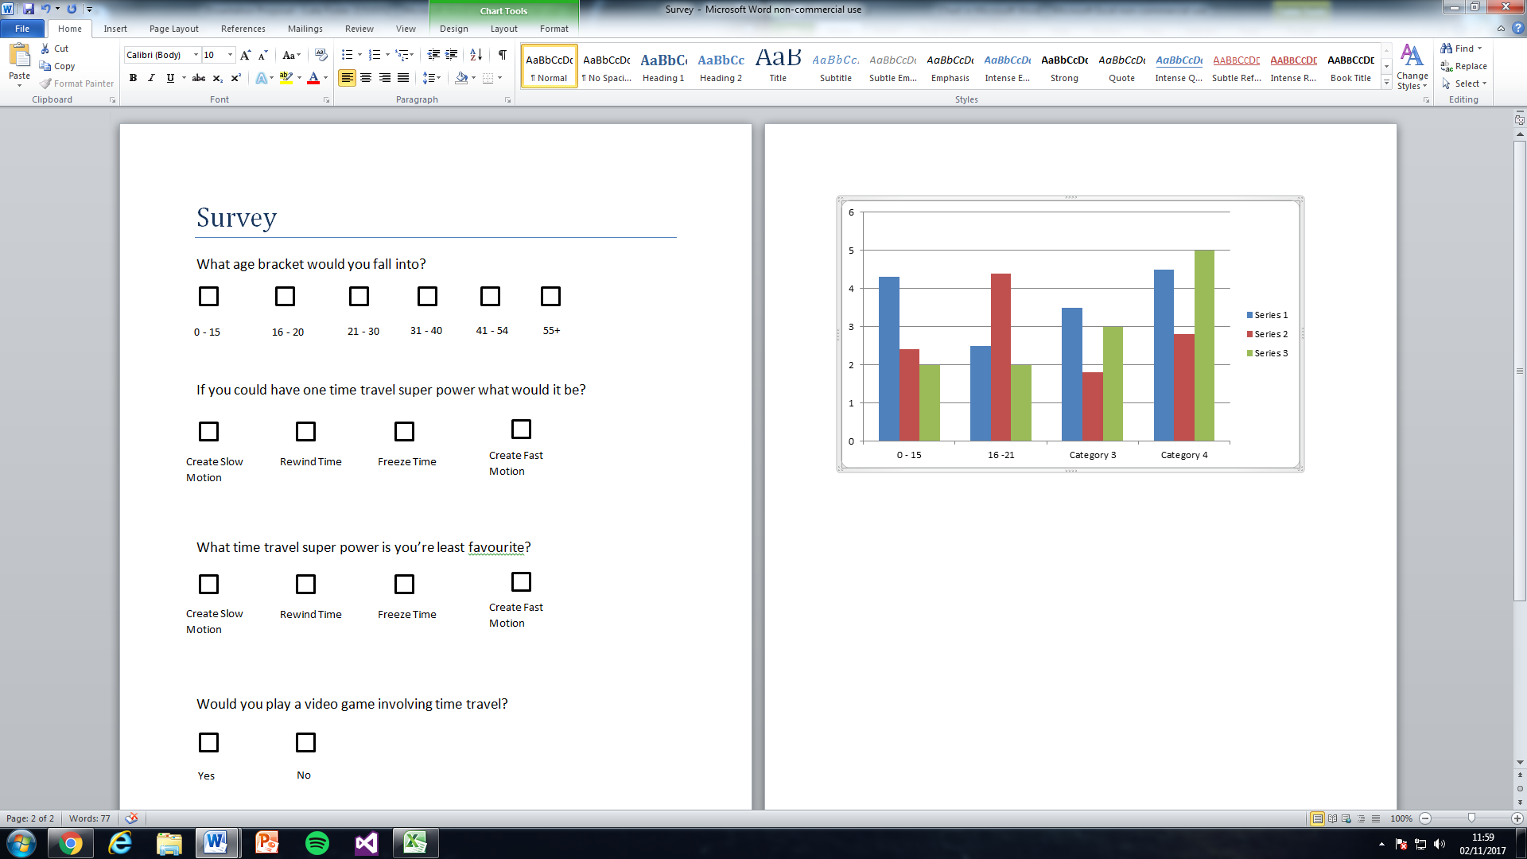

If you could have one time travel super power what would it be? Results.

What time travel super power is you’re least favourite? Results.

Would you play a video game involving time travel? Results.

## Appendix B: Literature Review Research Scripts

Time Manager Script for Slow Motion

|  |
| --- |
| using UnityEngine; |
|  |  |
|  | public class TimeManager : MonoBehaviour { |
|  |  |
|  | public float slowdownFactor = 0.05f; |
|  | public float slowdownLength = 2f; |
|  |  |
|  | void Update () |
|  | { |
|  | Time.timeScale += (1f / slowdownLength) * Time.unscaledDeltaTime; |
|  | Time.timeScale = Mathf.Clamp(Time.timeScale, 0f, 1f); |
|  | } |
|  |  |
|  | public void DoSlowmotion () |
|  | { |
|  | Time.timeScale = slowdownFactor; |
|  | Time.fixedDeltaTime = Time.timeScale * .02f; |
|  | } |
|  |  |
|  | } |

Explosion Gun Script (Inherits from Time Manager)

|  |
| --- |
| using UnityEngine; |
|  |  |
|  | public class ExplosionGun : MonoBehaviour { |
|  |  |
|  | public GameObject explosion; // The explosion prefab |
|  | public Camera cam; // Reference to the Player camera |
|  |  |
|  | public TimeManager timeManager; |
|  |  |
|  | void Update () |
|  | { |
|  | // If the player presses fire |
|  | if (Input.GetButtonDown("Fire1")) |
|  | Shoot(); |
|  | } |
|  |  |
|  | void Shoot () |
|  | { |
|  | RaycastHit _hitInfo; |
|  | // If we hit something |
|  | if (Physics.Raycast(cam.transform.position, cam.transform.forward, out _hitInfo)) |
|  | { |
|  | // Create an explosion at the impact point |
|  | Instantiate(explosion, _hitInfo.point, Quaternion.LookRotation(_hitInfo.normal)); |
|  |  |
|  | timeManager.DoSlowmotion(); |
|  | } |
|  | } |
|  |  |
|  | } |

Rewind Time Script

|  |
| --- |
| using System.Collections; |
|  | using System.Collections.Generic; |
|  | using UnityEngine; |
|  |  |
|  | public class TimeBody : MonoBehaviour { |
|  |  |
|  | bool isRewinding = false; |
|  |  |
|  | public float recordTime = 5f; |
|  |  |
|  | List<PointInTime> pointsInTime; |
|  |  |
|  | Rigidbody rb; |
|  |  |
|  | // Use this for initialization |
|  | void Start () { |
|  | pointsInTime = new List<PointInTime>(); |
|  | rb = GetComponent<Rigidbody>(); |
|  | } |
|  |  |
|  | // Update is called once per frame |
|  | void Update () { |
|  | if (Input.GetKeyDown(KeyCode.Return)) |
|  | StartRewind(); |
|  | if (Input.GetKeyUp(KeyCode.Return)) |
|  | StopRewind(); |
|  | } |
|  |  |
|  | void FixedUpdate () |
|  | { |
|  | if (isRewinding) |
|  | Rewind(); |
|  | else |
|  | Record(); |
|  | } |
|  |  |
|  | void Rewind () |
|  | { |
|  | if (pointsInTime.Count > 0) |
|  | { |
|  | PointInTime pointInTime = pointsInTime[0]; |
|  | transform.position = pointInTime.position; |
|  | transform.rotation = pointInTime.rotation; |
|  | pointsInTime.RemoveAt(0); |
|  | } else |
|  | { |
|  | StopRewind(); |
|  | } |
|  |  |
|  | } |
|  |  |
|  | void Record () |
|  | { |
|  | if (pointsInTime.Count > Mathf.Round(recordTime / Time.fixedDeltaTime)) |
|  | { |
|  | pointsInTime.RemoveAt(pointsInTime.Count - 1); |
|  | } |
|  |  |
|  | pointsInTime.Insert(0, new PointInTime(transform.position, transform.rotation)); |
|  | } |
|  |  |
|  | public void StartRewind () |
|  | { |
|  | isRewinding = true; |
|  | rb.isKinematic = true; |
|  | } |
|  |  |
|  | public void StopRewind () |
|  | { |
|  | isRewinding = false; |
|  | rb.isKinematic = false; |
|  | } |
|  | } |

## Other Appendixes: Scripts

### PlayerController

using System.Collections;

using System.Collections.Generic;

using UnityEngine;

using UnityEngine.UI;

using UnityEngine.SceneManagement;

public class PlayerController : MonoBehaviour

{

float x, z, VerticalSpeed, HorizontalSpeed;

float jumpVelocity = 10.0f;

float fallMultiplier = 5.0f;

float delay = 0.25f;

public float attackTimer = 0.0f;

float FallSpeed = 1.0f;

public float MovementSpeedBoost = 1.0f;

public float AttackSpeedBoost = 0.0f;

public float DodgeCooldown = 2.0f;

int Count = 0;

int maxCount = 1;

public bool StopAnim = false;

public bool grounded = true;

bool basicAttacking = false;

public bool rangedAttack = false;

bool ToggleAttack = false;

bool dodge = false;

public bool DodgeCooldownActive = false;

bool MeleeContact = false;

bool MeleeContactOnce = false;

bool MeleedMinotaur = false;

bool MeleedHound = false;

bool MeleedHades = false;

public bool RootActive = false;

bool[] dodgeDirection = new bool[4];

public GameObject ProjectilePrefab;

public Transform ProjectileSpawn;

GameObject Projectile;

Rigidbody rb;

GameObject minotaur;

GameObject HellHound;

GameObject Hades;

GameObject chronosModel;

HealthManager HM;

BasicStateDrivenBrain BSDB;

HadesStateDrivenBrain HadesSDB;

CapsuleCollider capsule;

BoxCollider boxCollider;

Vector2 input;

Vector3 desiredMove;

public GameObject CrossedSwords, BowAndArrow;

Scene currentScene;

string sceneName;

public Animator ChronosAnimController;

void Awake()

{

rb = GetComponent<Rigidbody>();

}

void Start ()

{

x = 0.0f;

z = 0.0f;

Count = maxCount;

VerticalSpeed = 10.0f;

HorizontalSpeed = 8.0f;

minotaur = GameObject.Find("Minotaur");

HM = minotaur.GetComponent<HealthManager>();

BSDB = minotaur.GetComponent<BasicStateDrivenBrain>();

chronosModel = GameObject.Find("ChronosModel");

boxCollider = chronosModel.GetComponent<BoxCollider>();

capsule = GetComponent<CapsuleCollider>();

currentScene = SceneManager.GetActiveScene();

sceneName = currentScene.name;

ChronosAnimController = GetComponentInChildren<Animator>();

for (int i = 0; i < dodgeDirection.Length; i++)

{

dodgeDirection[i] = false;

}

}

void OnCollisionEnter(Collision col)

{

grounded = true;

Count = 1;

}

void OnCollisionStay(Collision col)

{

grounded = true;

}

void OnCollisionExit(Collision col)

{

grounded = false;

}

void OnTriggerStay(Collider col)

{

if(col.gameObject.name == ("HellMinotaur") && attackTimer >= (0.65f - AttackSpeedBoost) && MeleeContact == false && MeleeContactOnce == false && ToggleAttack == false)

{

Debug.Log("Melee Connected to Minotaur");

MeleedMinotaur = true;

MeleeContact = true;

MeleeContactOnce = true;

}

if (col.gameObject.name == ("HellHoundModel") && attackTimer >= (0.65f - AttackSpeedBoost) && MeleeContact == false && MeleeContactOnce == false && ToggleAttack == false)

{

Debug.Log("Melee Connected to Hell Hound");

MeleedHound = true;

MeleeContact = true;

MeleeContactOnce = true;

}

if (col.gameObject.name == ("HadesModel") && attackTimer >= (0.65f - AttackSpeedBoost) && MeleeContact == false && MeleeContactOnce == false && ToggleAttack == false)

{

Debug.Log("Melee Connected to Hades");

MeleedHades = true;

MeleeContact = true;

MeleeContactOnce = true;

}

}

void MeleeDamage()

{

if(MeleedMinotaur == true)

{

minotaur = GameObject.Find("Minotaur");

HM = minotaur.GetComponent<HealthManager>();

BSDB = minotaur.GetComponent<BasicStateDrivenBrain>();

if (BSDB.Blocking != true)

HM.MinotaurHealth -= 10;

else

Debug.Log("Minotaur Successfully Blocked the Melee");

MeleeContact = false;

MeleedMinotaur = false;

}

if(MeleedHound == true)

{

HellHound = GameObject.Find("HellHound");

HM = HellHound.GetComponent<HealthManager>();

HM.HoundHealth -= 10;

MeleeContact = false;

MeleedHound = false;

}

if(MeleedHades == true)

{

Hades = GameObject.Find("Hades");

HM = Hades.GetComponent<HealthManager>();

HadesSDB = Hades.GetComponent<HadesStateDrivenBrain>();

if (HadesSDB.Blocking != true)

HM.HadesHealth -= 10;

else

Debug.Log("Hades Successfully Blocked the Melee");

MeleeContact = false;

MeleedHades = false;

}

}

void Walk()

{

//Chronos wasd movement

z = Input.GetAxis("Vertical") * Time.deltaTime * VerticalSpeed * MovementSpeedBoost / FallSpeed;

x = Input.GetAxis("Horizontal") * Time.deltaTime * HorizontalSpeed * MovementSpeedBoost / FallSpeed;

if (Input.GetAxis("Vertical") < 0)

z = z / 2.0f;

if (Input.GetAxis("Vertical") > 0 && Input.GetAxis("Horizontal") == 0 && grounded == true && basicAttacking == false && rangedAttack == false && StopAnim == false)

ChronosAnimController.SetBool("Forward", true);

else

ChronosAnimController.SetBool("Forward", false);

if (Input.GetAxis("Vertical") < 0 && Input.GetAxis("Horizontal") == 0 && grounded == true && basicAttacking == false && rangedAttack == false && StopAnim == false)

ChronosAnimController.SetBool("Backward", true);

else

ChronosAnimController.SetBool("Backward", false);

if (Input.GetAxis("Horizontal") < 0 && Input.GetAxis("Vertical") == 0 && grounded == true && basicAttacking == false && rangedAttack == false && StopAnim == false)

ChronosAnimController.SetBool("Left", true);

else

ChronosAnimController.SetBool("Left", false);

if (Input.GetAxis("Horizontal") > 0 && Input.GetAxis("Vertical") == 0 && grounded == true && basicAttacking == false && rangedAttack == false && StopAnim == false)

ChronosAnimController.SetBool("Right", true);

else

ChronosAnimController.SetBool("Right", false);

if (Input.GetAxis("Vertical") > 0 && Input.GetAxis("Horizontal") < 0 && grounded == true && basicAttacking == false && rangedAttack == false && StopAnim == false)

ChronosAnimController.SetBool("ForwardLeft", true);

else

ChronosAnimController.SetBool("ForwardLeft", false);

if (Input.GetAxis("Vertical") > 0 && Input.GetAxis("Horizontal") > 0 && grounded == true && basicAttacking == false && rangedAttack == false && StopAnim == false)

ChronosAnimController.SetBool("ForwardRight", true);

else

ChronosAnimController.SetBool("ForwardRight", false);

if (Input.GetAxis("Vertical") < 0 && Input.GetAxis("Horizontal") < 0 && grounded == true && basicAttacking == false && rangedAttack == false && StopAnim == false)

ChronosAnimController.SetBool("BackwardLeft", true);

else

ChronosAnimController.SetBool("BackwardLeft", false);

if (Input.GetAxis("Vertical") < 0 && Input.GetAxis("Horizontal") > 0 && grounded == true && basicAttacking == false && rangedAttack == false && StopAnim == false)

ChronosAnimController.SetBool("BackwardRight", true);

else

ChronosAnimController.SetBool("BackwardRight", false);

transform.Translate(x, 0, z);

}

void Sprint()

{

//Chronos sprint

if (Input.GetKey(KeyCode.LeftShift) && grounded == true && Input.GetAxis("Vertical") > 0 && basicAttacking == false)

{

ChronosAnimController.speed = 1.5f;

VerticalSpeed = 15.0f;

}

else

{

ChronosAnimController.speed = 1.0f;

VerticalSpeed = 10.0f;

}

}

void Dodge()

{

delay -= Time.deltaTime;

//Determines Chronos's direction of dodge

if (Input.GetKey("w") && (Input.GetKey("a") != true) && (Input.GetKey("d") != true))

dodgeDirection[0] = true;

else if (Input.GetKey("a"))

dodgeDirection[1] = true;

else if (Input.GetKey("d"))

dodgeDirection[2] = true;

else if (Input.GetKey("s"))

dodgeDirection[3] = true;

else

{

Count = 1;

dodge = false;

DodgeCooldownActive = true;

}

//Moves Chronos in direction of dodge

if (dodgeDirection[0] == true && dodgeDirection[1] == false && dodgeDirection[2] == false)

transform.Translate(Vector3.forward * Time.deltaTime * 40.0f);

else if (dodgeDirection[1] == true)

transform.Translate(Vector3.left * Time.deltaTime * 40.0f);

else if (dodgeDirection[2] == true)

transform.Translate(Vector3.right * Time.deltaTime * 40.0f);

else if (dodgeDirection[3] == true)

transform.Translate(Vector3.back * Time.deltaTime * 40.0f);

if (delay < 0)

{

for (int i = 0; i < dodgeDirection.Length; i++)

{

dodgeDirection[i] = false;

}

Count = 1;

dodge = false;

DodgeCooldownActive = true;

}

}

void GetInput()

{

float h = Input.GetAxis("Horizontal");

float v = Input.GetAxis("Vertical");

input = new Vector2(h, v);

}

void StepCheck()

{

if (input.x == 0 && input.y == 0)

{

return;

}

Vector3 direction = desiredMove.normalized;

float length = capsule.radius + 0.01f;

Ray ray = new Ray(transform.position + new Vector3(0, 0.25f, 0), direction);

Debug.DrawRay(transform.position + new Vector3(0, 0.25f, 0), direction * length);

if (Physics.Raycast(ray, length))

{

Ray ray2 = new Ray(transform.position + new Vector3(0, 0.25f, 0), direction);

Debug.DrawRay(transform.position + new Vector3(0, 0.25f, 0), direction * length);

if (!Physics.Raycast(ray2, length))

{

Vector3 rayStart = transform.position + new Vector3(0, 0.25f, 0) + direction * length;

Ray ray3 = new Ray(rayStart, Vector3.down);

Debug.DrawRay(rayStart, Vector3.down * 0.25f);

RaycastHit hit;

if (Physics.Raycast(ray3, out hit, 0.25f))

{

Vector3 stepHeight = hit.point;

transform.position = new Vector3(transform.position.x, stepHeight.y, transform.position.z);

}

}

}

}

void SpawnPrefab()

{

Projectile = (GameObject)Instantiate(ProjectilePrefab, ProjectileSpawn.position, ProjectileSpawn.rotation);

Destroy(Projectile, (0.6f - AttackSpeedBoost));

}

void FixedUpdate()

{

//Chronos jump

if (Input.GetKeyDown(KeyCode.Space) && Count == maxCount && Input.GetKey("1") == false && Input.GetKey("3") == false && RootActive == false)

{

grounded = false;

ChronosAnimController.SetBool("Jump", true);

rb.velocity = Vector3.up * jumpVelocity;

Count = 0;

}

//Increases Chronos's fall speed

if (rb.velocity.y < 0)

{

rb.velocity += Vector3.up * Physics.gravity.y * (fallMultiplier - 1) * Time.deltaTime;

}

}

void Update()

{

StepCheck();

GetInput();

desiredMove = transform.forward * input.y * 10.0f + transform.right * input.x * 8.0f;

//Calls the Walk, Sprint and Dodge functions based on whether conditions are met

if (dodge == false)

{

if(sceneName == "Tutorial")

Walk();

else

{

if(RootActive == false)

Walk();

}

if (basicAttacking == true)

{

attackTimer += Time.deltaTime;

ChronosAnimController.SetBool("Melee", true);

if (attackTimer >= (0.55f - AttackSpeedBoost))

boxCollider.enabled = true;

if (attackTimer >= (1.0f - AttackSpeedBoost))

{

basicAttacking = false;

ChronosAnimController.SetBool("Melee", false);

MeleeContactOnce = false;

attackTimer = 0.0f;

boxCollider.enabled = false;

}

}

else if(rangedAttack == true)

{

attackTimer += Time.deltaTime;

if (attackTimer > 0.6)

ChronosAnimController.SetBool("RangedAttack", false);

if (attackTimer < (0.9f - AttackSpeedBoost))

{

if (Projectile != null)

{

Projectile.transform.Translate(Vector3.forward * Time.deltaTime * 40.0f);

}

}

else

{

rangedAttack = false;

attackTimer = 0.0f;

}

}

else

{

if (sceneName == "Tutorial")

Sprint();

else

{

if (RootActive == false)

Sprint();

}

}

}

else

{

if (sceneName == "Tutorial")

Dodge();

else

{

if (RootActive == false)

Dodge();

}

}

//Player left clicks to basic attack

if(Input.GetMouseButtonDown(0) && Input.GetKey(KeyCode.LeftShift) == false && dodge == false && Input.GetKey("1") == false && Input.GetKey("3") == false)

{

if(ToggleAttack == false)

{

if (attackTimer <= 0)

{

basicAttacking = true;

Debug.Log("Melee Attack");

}

}

else if(ToggleAttack == true)

{

if (attackTimer <= 0)

{

if (rangedAttack == false)

{

Invoke("SpawnPrefab", 0.3f);

ChronosAnimController.SetBool("RangedAttack", true);

}

rangedAttack = true;

}

}

}

//When Q is pressed it will toggle Chronos between

if(Input.GetKeyDown("q") == true)

{

if(ToggleAttack == false)

{

ToggleAttack = true;

CrossedSwords.SetActive(false);

BowAndArrow.SetActive(true);

Debug.Log("Switched to Ranged");

}

else

{

ToggleAttack = false;

CrossedSwords.SetActive(true);

BowAndArrow.SetActive(false);

Debug.Log("Switched to Melee");

}

}

//Player right clicks to dodge

if (Input.GetMouseButtonDown(1) && grounded == true && Count == 1 && Input.GetKey("1") == false && Input.GetKey("3") == false && DodgeCooldownActive == false)

{

dodge = true;

Count = 0;

delay = 0.25f;

attackTimer = 0.0f;

DodgeCooldown = 2.0f;

x = 0;

z = 0;

}

if(Input.GetKeyDown(KeyCode.Escape))

SceneManager.LoadScene("StartMenu");

if(sceneName == "BossBattle")

{

Hades = GameObject.Find("Hades");

if(Hades == null)

SceneManager.LoadScene("StartMenu");

}

if (MeleeContact == true)

MeleeDamage();

//Changing fall speed to make player move slower while in the air

if (grounded == false)

{

FallSpeed = 1.25f;

}

else

{

FallSpeed = 1.0f;

ChronosAnimController.SetBool("Jump", false);

}

if(DodgeCooldownActive == true)

{

DodgeCooldown -= Time.deltaTime;

if (DodgeCooldown <= 0.0f)

DodgeCooldownActive = false;

}

}

}

### HealthManager

using System.Collections;

using UnityEngine;

using UnityEngine.UI;

using UnityEngine.SceneManagement;

public class HealthManager : MonoBehaviour

{

public int MinotaurHealth = 100;

public int MinotaurMAXhealth = 100;

public int ChronosHealth = 100;

public int ChronosMAXHealth = 100;

float ChronosHealthRefresh = 2.0f;

public int HoundHealth = 100;

public int HoundMAXHealth = 100;

public int HadesHealth = 100;

public int HadesMaxHealth = 100;

float HoundHealthRefresh = 2.0f;

public bool HitOnce = false;

float LavaDamageCountdown = 0.8f;

float delay = 0.5f;

GameObject minotaur;

GameObject Base;

GameObject hellHound;

GameObject hades;

BasicStateDrivenBrain BSDB;

HoundStateDrivenBrain HSDB;

HellMinotaurActive HMA;

Transform ChronosSpawnTransform;

Transform ChronosTransform;

Scene currentScene;

string sceneName;

void Start()

{

MinotaurMAXhealth = 100;

ChronosMAXHealth = 100;

HoundMAXHealth = 100;

minotaur = GameObject.Find("Minotaur");

BSDB = minotaur.GetComponent<BasicStateDrivenBrain>();

hellHound = GameObject.Find("HellHound");

if (sceneName == "BossBattle")

{

HSDB = hellHound.GetComponent<HoundStateDrivenBrain>();

hades = GameObject.Find("Hades");

}

Base = GameObject.Find("Base");

HMA = Base.GetComponent<HellMinotaurActive>();

ChronosTransform = GameObject.Find("Chronos").transform;

ChronosSpawnTransform = GameObject.Find("ChronosSpawn").transform;

}

void OnCollisionStay(Collision collision)

{

if(this.gameObject.name == ("Chronos") && collision.gameObject.tag == "Lava")

{

LavaDamageCountdown -= Time.deltaTime;

Debug.Log("Chronos is touching lava");

if (LavaDamageCountdown <= 0.0f)

{

ChronosHealth -= 20;

LavaDamageCountdown = 0.8f;

}

}

if (this.gameObject.name == ("HellHound") && collision.gameObject.tag == "Lava")

{

LavaDamageCountdown -= Time.deltaTime;

Debug.Log("Chronos is touching lava");

if (LavaDamageCountdown <= 0.0f)

{

HoundHealth -= 20;

LavaDamageCountdown = 0.8f;

}

}

if (this.gameObject.name == ("Minotaur") && collision.gameObject.tag == "Lava")

{

LavaDamageCountdown -= Time.deltaTime;

Debug.Log("Chronos is touching lava");

if (LavaDamageCountdown <= 0.0f)

{

MinotaurHealth -= 20;

LavaDamageCountdown = 0.8f;

}

}

if (this.gameObject.name == ("Hades") && collision.gameObject.tag == "Lava")

{

LavaDamageCountdown -= Time.deltaTime;

Debug.Log("Hades is touching lava");

if (LavaDamageCountdown <= 0.0f)

{

HadesHealth -= 20;

LavaDamageCountdown = 0.8f;

}

}

}

void OnTriggerEnter(Collider col)

{

if(col.gameObject.name == ("ChronosSphere(Clone)") && this.gameObject.name == ("HellHound") && HitOnce == false)

{

HoundHealth -= 10;

Debug.Log("Projectile Hit Hound");

delay = 0.5f;

HitOnce = true;

}

if (col.gameObject.name == ("ChronosSphere(Clone)") && this.gameObject.name == ("Minotaur") && HitOnce == false)

{

minotaur = GameObject.Find("Minotaur");

BSDB = minotaur.GetComponent<BasicStateDrivenBrain>();

if (BSDB.Blocking == false)

MinotaurHealth -= 10;

else

Debug.Log("Minotaur Blocked the Projectile");

Debug.Log("Projectile Hit Minotaur");

delay = 0.5f;

HitOnce = true;

}

if (col.gameObject.name == ("ChronosSphere(Clone)") && this.gameObject.name == ("Hades") && HitOnce == false)

{

hades = GameObject.Find("Hades");

if (hades.GetComponent<HadesStateDrivenBrain>().Blocking == false)

HadesHealth -= 10;

else

Debug.Log("Hades Blocked the Projectile");

Debug.Log("Projectile Hit Hades");

delay = 0.5f;

HitOnce = true;

}

if ((col.gameObject.name == ("MinotaurSphere(Clone)") || col.gameObject.name == ("HadesSphere(Clone)")) && this.gameObject.name == ("Chronos") && HitOnce == false)

{

Debug.Log("Projectile Hit Chronos");

ChronosHealth -= 10;

delay = 0.2f;

HitOnce = true;

}

}

void Update()

{

currentScene = SceneManager.GetActiveScene();

sceneName = currentScene.name;

if (BSDB.InContactWithChronos == true && BSDB.MeleeContact == true && HitOnce == false)

{

Debug.Log("Minotaur Dealt 10 Damage");

ChronosHealth -= 10;

delay = 0.2f;

HitOnce = true;

}

if(sceneName == "BossBattle")

{

if(hellHound != null)

HSDB = hellHound.GetComponent<HoundStateDrivenBrain>();

if (HSDB.InContactWithChronos == true && HSDB.MeleeContact == true && HitOnce == false)

{

Debug.Log("Hound Dealt 10 Damage");

ChronosHealth -= 10;

delay = 0.2f;

HitOnce = true;

}

hades = GameObject.Find("Hades");

if (hades != null)

{

if (hades.GetComponent<HadesStateDrivenBrain>().InContactWithChronos == true && hades.GetComponent<HadesStateDrivenBrain>().MeleeContact == true && HitOnce == false)

{

Debug.Log("Hades Dealt 10 Damage");

ChronosHealth -= 10;

delay = 0.2f;

HitOnce = true;

}

}

}

if (this.gameObject.name == ("Chronos") && HMA.ChronosRegenerates == true && ChronosHealth != ChronosMAXHealth && sceneName == "Tutorial")

{

ChronosHealthRefresh -= Time.deltaTime;

if (ChronosHealthRefresh <= 0.0f)

{

ChronosHealth += 10;

Debug.Log("Chronos healed 10 health");

ChronosHealthRefresh = 2.0f;

}

}

if (this.gameObject.name == ("HellHound") && HoundHealth != HoundMAXHealth && sceneName == "Tutorial")

{

HoundHealthRefresh -= Time.deltaTime;

if (HoundHealthRefresh <= 0.0f)

{

HoundHealth = HoundMAXHealth;

HoundHealthRefresh = 2.0f;

}

}

if (MinotaurHealth <= 0)

{

Destroy(gameObject);

Debug.Log("Should be Destroyed");

}

if (HoundHealth <= 0)

{

Destroy(gameObject);

Debug.Log("Should be Destroyed");

}

if (HadesHealth <= 0)

{

if (hades.GetComponent<HadesStateDrivenBrain>().RootCircle != null)

Destroy(hades.GetComponent<HadesStateDrivenBrain>().RootCircle);

Destroy(gameObject);

Debug.Log("Should be Destroyed");

}

if (ChronosHealth <= 0)

{

ChronosTransform.position = ChronosSpawnTransform.position;

ChronosTransform.rotation = ChronosSpawnTransform.rotation;

ChronosHealth = ChronosMAXHealth;

}

if (HitOnce == true)

{

delay -= Time.deltaTime;

if (delay <= 0.0f)

HitOnce = false;

}

}

}

### ChronosAbilityDetection

using System.Collections;

using System.Collections.Generic;

using UnityEngine;

public class ChronosAbilityDetection : MonoBehaviour

{

GameObject Hades;

GameObject Chronos;

HadesStateDrivenBrain HadesSDB;

PlayerController PC;

HealthManager HM;

public bool RootEffect = false;

public bool DamageOnce = false;

public float RootDuration = 0.0f;

void Start()

{

Hades = GameObject.Find("Hades");

HadesSDB = Hades.GetComponent<HadesStateDrivenBrain>();

Chronos = GameObject.Find("Chronos");

HM = Chronos.GetComponent<HealthManager>();

PC = Chronos.GetComponent<PlayerController>();

}

void OnTriggerEnter(Collider col)

{

if (col.gameObject.name == "HadesAbilityAOE(Clone)")

{

HadesSDB.AbilityHittingChronos = true;

Debug.Log("Ability hitting chronos");

}

}

void OnTriggerStay(Collider col)

{

if(col.gameObject.name == "HadesAbilityAOE(Clone)")

{

HadesSDB.AbilityHittingChronos = true;

Debug.Log("Ability hitting chronos");

}

}

void OnTriggerExit(Collider col)

{

if (col.gameObject.name == "HadesAbilityAOE(Clone)")

{

HadesSDB.AbilityHittingChronos = false;

}

}

void Update()

{

if (HadesSDB.AbilityDamage == true && DamageOnce == false)

{

Debug.Log("Damage being dealt");

HM.ChronosHealth -= 20;

RootEffect = true;

RootDuration = 0.0f;

HadesSDB.RootCircle.GetComponent<Renderer>().enabled = false;

DamageOnce = true;

}

if(RootEffect == true)

{

RootDuration += Time.deltaTime;

if (RootDuration < 3.0f)

PC.RootActive = true;

if(RootDuration >= 3.0f)

{

PC.RootActive = false;

HadesSDB.AbilityDamage = false;

Destroy(HadesSDB.RootCircle);

DamageOnce = false;

RootEffect = false;

}

}

}

}

### SlowTimeAbility

using System.Collections;

using System.Collections.Generic;

using UnityEngine;

using UnityEngine.UI;

using UnityEngine.SceneManagement;

public class SlowTimeAbility : MonoBehaviour

{

float sensitivityY;

public GameObject SlowAbilityPrefab;

public Transform SlowAbilitySpawn;

public Transform ChronosTransform;

public GameObject SlowCircle;

AbilityTriggerDetection MinotaurATD;

AbilityTriggerDetection HoundATD;

AbilityTriggerDetection HadesATD;

bool InitiateSlow = false;

GameObject hellMinotaur;

GameObject hellHound;

GameObject Hades;

PlayerController PC;

public GameObject OneActive;

public GameObject OneCoolDownTextActive;

public Text OneCoolDownText;

float Cooldown = 8.0f;

bool CooldownActive = false;

float SlowDuration = 0.0f;

public bool IsSlowAbility = false;

public bool IsEnabled = false;

bool PlaceAbility = false;

Scene currentScene;

string sceneName;

void Start ()

{

sensitivityY = 3.0f;

hellMinotaur = GameObject.Find("HellMinotaur");

hellHound = GameObject.Find("HellHoundModel");

MinotaurATD = hellMinotaur.GetComponent<AbilityTriggerDetection>();

HoundATD = hellHound.GetComponent<AbilityTriggerDetection>();

PC = GetComponent<PlayerController>();

PlaceAbility = false;

currentScene = SceneManager.GetActiveScene();

sceneName = currentScene.name;

}

void Update ()

{

if (PlaceAbility == false && PC.grounded == true && CooldownActive == false)

{

if (Input.GetKeyDown("1"))

{

SlowCircle = (GameObject)Instantiate(SlowAbilityPrefab, SlowAbilitySpawn.position, ChronosTransform.rotation);

OneActive.SetActive(true);

Cooldown = 8.0f;

}

if (Input.GetKey("1"))

{

if(SlowCircle != null)

SlowCircle.transform.parent = ChronosTransform;

IsEnabled = false;

float distance = Vector3.Distance(SlowCircle.transform.position, ChronosTransform.position);

Vector3 forward = ChronosTransform.transform.TransformDirection(Vector3.forward);

Vector3 toOther = SlowCircle.transform.position - ChronosTransform.position;

if (distance < 30.00f && Vector3.Dot(forward, toOther) > 0)

SlowCircle.transform.Translate(Vector3.forward * Input.GetAxis("Mouse Y") * sensitivityY);

else if (Input.GetAxis("Mouse Y") > 0 && distance < 30.00f && Vector3.Dot(forward, toOther) >= 0)

SlowCircle.transform.Translate(Vector3.forward * Input.GetAxis("Mouse Y") * sensitivityY);

else if (Input.GetAxis("Mouse Y") < 0 && distance >= 30.00f && Vector3.Dot(forward, toOther) > 0)

SlowCircle.transform.Translate(Vector3.forward * Input.GetAxis("Mouse Y") * sensitivityY);

else if (distance >= 30.00f)

distance = 30.00f;

else if (Vector3.Dot(forward, toOther) < 0)

SlowCircle.transform.position = ChronosTransform.position;

else

SlowCircle.transform.position = ChronosTransform.position;

}

if (Input.GetKeyUp("1"))

{

if(SlowCircle != null)

SlowCircle.transform.parent = null;

InitiateSlow = true;

PC.StopAnim = true;

PC.ChronosAnimController.SetBool("Slow", true);

PlaceAbility = true;

}

}

else

{

if (InitiateSlow == true)

{

SlowDuration = 0.0f;

IsEnabled = true;

IsSlowAbility = true;

CooldownActive = true;

}

}

if (IsSlowAbility == true)

{

InitiateSlow = false;

SlowDuration += Time.deltaTime;

if(SlowDuration >= 1.0f)

{

PC.StopAnim = false;

PC.ChronosAnimController.SetBool("Slow", false);

}

hellMinotaur = GameObject.Find("HellMinotaur");

if(hellMinotaur != null)

MinotaurATD = hellMinotaur.GetComponent<AbilityTriggerDetection>();

if (SlowCircle != null)

{

if (sceneName == "Tutorial")

{

if (MinotaurATD.minotaurHit == true)

{

SlowCircle.transform.localPosition = new Vector3(0, -3.44f, 0);

foreach (Renderer r in SlowCircle.GetComponentsInChildren<Renderer>())

r.enabled = true;

}

if (HoundATD.HoundHit == true)

{

SlowCircle.transform.localPosition = new Vector3(0.00019f, -0.0095f, 0.00174f);

foreach (Renderer r in SlowCircle.GetComponentsInChildren<Renderer>())

r.enabled = true;

}

if (MinotaurATD.minotaurHit == false && HoundATD.HoundHit == false)

{

foreach (Renderer r in SlowCircle.GetComponentsInChildren<Renderer>())

r.enabled = false;

}

}

if (sceneName == "BossBattle")

{

Hades = GameObject.Find("HadesModel");

if(Hades != null)

HadesATD = Hades.GetComponent<AbilityTriggerDetection>();

if (MinotaurATD.minotaurHit == true)

{

SlowCircle.transform.localPosition = new Vector3(0, -3.17f, 0);

foreach (Renderer r in SlowCircle.GetComponentsInChildren<Renderer>())

r.enabled = true;

}

if (HoundATD.HoundHit == true)

{

SlowCircle.transform.localPosition = new Vector3(0.00019f, -0.0095f, 0.00174f);

foreach (Renderer r in SlowCircle.GetComponentsInChildren<Renderer>())

r.enabled = true;

}

if (HadesATD.HadesHit == true)

{

SlowCircle.transform.localPosition = new Vector3(0f, -0.535f, 0f);

foreach (Renderer r in SlowCircle.GetComponentsInChildren<Renderer>())

r.enabled = true;

}

if (MinotaurATD.minotaurHit == false && HoundATD.HoundHit == false && HadesATD.HadesHit == false)

{

foreach (Renderer r in SlowCircle.GetComponentsInChildren<Renderer>())

r.enabled = false;

}

}

}

if (SlowDuration >= 3.0f)

{

PlaceAbility = false;

if (MinotaurATD.minotaurHit == true)

{

// revert slow effect to normal

MinotaurATD.BSDB.MovementSlow = 0.0f;

MinotaurATD.BSDB.RangedAttackSlow = 0.0f;

MinotaurATD.BSDB.RangedAttackDurationIncrease = 0.0f;

MinotaurATD.BSDB.MeleeDurationIncrease = 0.0f;

MinotaurATD.BSDB.MeleeContactIncrease = 0.0f;

MinotaurATD.BSDB.BlockDurationIncrease = 0.0f;

MinotaurATD.BSDB.BlockDelayIncrease = 0.0f;

MinotaurATD.BSDB.MinotaurAnimController.speed = 1.0f;

}

if (sceneName == "BossBattle")

{

if (HoundATD.HoundHit == true)

{

HoundATD.HSDB.MovementSlow = 0.0f;

HoundATD.HSDB.MeleeDurationIncrease = 0.0f;

HoundATD.HSDB.MeleeContactIncrease = 0.0f;

}

if (HadesATD.HadesHit == true)

{

HadesATD.HadesSDB.MovementSlow = 0.0f;

HadesATD.HadesSDB.RangedAttackSlow = 0.0f;

HadesATD.HadesSDB.RangedAttackDurationIncrease = 0.0f;

HadesATD.HadesSDB.MeleeDurationIncrease = 0.0f;

HadesATD.HadesSDB.MeleeContactIncrease = 0.0f;

HadesATD.HadesSDB.BlockDurationIncrease = 0.0f;

HadesATD.HadesSDB.BlockDelayIncrease = 0.0f;

HadesATD.HadesSDB.HadesAnimController.speed = 1.0f;

}

HadesATD.HadesHit = false;

}

Destroy(SlowCircle);

MinotaurATD.minotaurHit = false;

HoundATD.HoundHit = false;

IsSlowAbility = false;

}

}

if (CooldownActive == true)

{

OneCoolDownTextActive.SetActive(true);

Cooldown -= Time.deltaTime;

string CooldownToString = ((int)Cooldown + 1).ToString();

OneCoolDownText.text = CooldownToString;

if (Cooldown <= 0.0f)

{

OneActive.SetActive(false);

OneCoolDownTextActive.SetActive(false);

CooldownActive = false;

}

}

}

}

### SpeedAbility

using System.Collections;

using System.Collections.Generic;

using UnityEngine;

using UnityEngine.UI;

public class SpeedAbility : MonoBehaviour

{

GameObject Chronos;

PlayerController playerController;

public float abilityTimer = 0.0f;

public float Cooldown = 6.0f;

private bool speedAbilityActive = false;

public GameObject TwoActive;

public GameObject TwoCoolDownTextActive;

public Text TwoCoolDownText;

Animator ChronosAnimController;

void Start ()

{

Chronos = GameObject.Find("Chronos");

playerController = Chronos.GetComponent<PlayerController>();

ChronosAnimController = GetComponentInChildren<Animator>();

}

void Update ()

{

if (speedAbilityActive == false)

{

if (Input.GetKeyDown("2"))

{

playerController.MovementSpeedBoost = 1.5f;

playerController.AttackSpeedBoost = 0.3f;

ChronosAnimController.speed = 1.5f;

abilityTimer = 0.0f;

Cooldown = 6.0f;

TwoActive.SetActive(true);

speedAbilityActive = true;

Debug.Log("Speed Ability has been Activated");

}

}

else

{

abilityTimer += Time.deltaTime;

}

if(abilityTimer >= 6.0f)

{

playerController.MovementSpeedBoost = 1.0f;

playerController.AttackSpeedBoost = 0.0f;

ChronosAnimController.speed = 1.0f;

TwoCoolDownTextActive.SetActive(true);

Cooldown -= Time.deltaTime;

string CooldownToString = ((int)Cooldown + 1).ToString();

TwoCoolDownText.text = CooldownToString;

if(Cooldown <= 0.0f)

{

speedAbilityActive = false;

TwoActive.SetActive(false);

TwoCoolDownTextActive.SetActive(false);

abilityTimer = 0.0f;

}

}

}

}

### FreezeAbility

using System.Collections;

using System.Collections.Generic;

using UnityEngine;

using UnityEngine.UI;

using UnityEngine.SceneManagement;

public class FreezeTimeAbility : MonoBehaviour

{

float sensitivityY;

public GameObject FreezeAbilityPrefab;

public Transform FreezeAbilitySpawn;

public Transform ChronosTransform;

public GameObject FreezeCircle;

float AbilityDuration = 0.0f;

AbilityTriggerDetection ATD;

AbilityTriggerDetection HoundATD;

AbilityTriggerDetection HadesATD;

public GameObject hellMinotaur;

GameObject hellHound;

GameObject Hades;

bool InitiateFreeze = false;

PlayerController PC;

public GameObject ThreeActive;

public GameObject ThreeCoolDownTextActive;

public Text ThreeCoolDownText;

float Cooldown = 8.0f;

bool CooldownActive = false;

public bool IsFreezeAbility = false;

float FreezeDuration = 0.0f;

public bool IsEnabled = false;

bool PlaceAbility = false;

Scene currentScene;

string sceneName;

void Start ()

{

sensitivityY = 3.0f;

hellMinotaur = GameObject.Find("HellMinotaur");

hellHound = GameObject.Find("HellHoundModel");

ATD = hellMinotaur.GetComponent<AbilityTriggerDetection>(); // Initialises the reference to AbilityTriggerDetection script through the hellMinotaur GameObject

HoundATD = hellHound.GetComponent<AbilityTriggerDetection>();

PC = GetComponent<PlayerController>();

PlaceAbility = false;

currentScene = SceneManager.GetActiveScene();

sceneName = currentScene.name;

}

void Update ()

{

if (PlaceAbility == false && PC.grounded == true && CooldownActive == false)

{

if (Input.GetKeyDown("3")) // Returns true when 3 is first pressed

{

FreezeCircle = (GameObject)Instantiate(FreezeAbilityPrefab, FreezeAbilitySpawn.position, ChronosTransform.rotation); // Instantiates FreezeAbilityAOE Prefab

FreezeCircle.GetComponent<Renderer>().enabled = true;

AbilityDuration = 0.0f;

Cooldown = 8.0f;

ThreeActive.SetActive(true);

}

if (Input.GetKey("3"))

{

if(FreezeCircle != null)

FreezeCircle.transform.parent = ChronosTransform; // Prefab becomes a child object of Chronos

IsEnabled = false;

float distance = Vector3.Distance(FreezeCircle.transform.position, ChronosTransform.position); // Calculates the distance between Chronos and the prefab

Vector3 forward = ChronosTransform.transform.TransformDirection(Vector3.forward); // Finds direction Chronos is facing

Vector3 toOther = FreezeCircle.transform.position - ChronosTransform.position; // Finds magnitude

if (distance < 30.00f && Vector3.Dot(forward, toOther) > 0) // Makes sure you can only move prefab when it's in positive direction and up to 30 in distance

FreezeCircle.transform.Translate(Vector3.forward * Input.GetAxis("Mouse Y") * sensitivityY);

else if (Input.GetAxis("Mouse Y") > 0 && distance < 30.00f && Vector3.Dot(forward, toOther) >= 0) // Can only move mouse up when prefab is at Chronos' feet

FreezeCircle.transform.Translate(Vector3.forward * Input.GetAxis("Mouse Y") * sensitivityY);

else if (Input.GetAxis("Mouse Y") < 0 && distance >= 30.00f && Vector3.Dot(forward, toOther) > 0) // Can only move mouse down when prefab is at a distance of 30

FreezeCircle.transform.Translate(Vector3.forward * Input.GetAxis("Mouse Y") * sensitivityY);

else if (distance >= 30.00f) // Ensures prefab stays at 30 if it ends up over 30 distance

distance = 30.00f;

else if (Vector3.Dot(forward, toOther) < 0) // Ensures prefab stays at Chronos' feet if it were to go negative

FreezeCircle.transform.position = ChronosTransform.position;

else

FreezeCircle.transform.position = ChronosTransform.position;

}

if (Input.GetKeyUp("3"))

{

if (FreezeCircle != null)

FreezeCircle.transform.parent = null; // Detaches prefab from Chronos

PC.StopAnim = true;

PC.ChronosAnimController.SetBool("Freeze", true);

InitiateFreeze = true;

PlaceAbility = true; // Ability has been placed now

}

}

else

{

if (InitiateFreeze == true)

{

AbilityDuration += Time.deltaTime;

if (AbilityDuration >= 1.0f)

{

FreezeDuration = 0.0f;

IsEnabled = true;

FreezeCircle.GetComponent<Renderer>().enabled = false; // Hides prefab

IsFreezeAbility = true;

CooldownActive = true;

PC.StopAnim = false;

PC.ChronosAnimController.SetBool("Freeze", false);

AbilityDuration = 0.0f;

}

}

}

if (IsFreezeAbility == true)

{

InitiateFreeze = false;

FreezeDuration += Time.deltaTime;

if (FreezeDuration >= 3.0f)

{

hellMinotaur = GameObject.Find("HellMinotaur");

if (hellMinotaur != null)

ATD = hellMinotaur.GetComponent<AbilityTriggerDetection>();

PlaceAbility = false;

if (ATD.minotaurHit == true && hellMinotaur != null && HoundATD.HoundHit == false)

{

ATD.BSDB.enabled = true;

ATD.BSDB.MinotaurAnimController.enabled = true;

}

if (sceneName == "BossBattle")

{

Hades = GameObject.Find("HadesModel");

if(Hades != null)

HadesATD = Hades.GetComponent<AbilityTriggerDetection>();

if (HoundATD.HoundHit == true && hellHound != null)

HoundATD.HSDB.enabled = true;

if (HadesATD.HadesHit == true && Hades != null)

{

HadesATD.HadesSDB.enabled = true;

HadesATD.HadesSDB.HadesAnimController.enabled = true;

}

HadesATD.HadesHit = false;

}

Destroy(FreezeCircle);

ATD.minotaurHit = false;

HoundATD.HoundHit = false;

IsFreezeAbility = false;

}

}

if (CooldownActive == true)

{

ThreeCoolDownTextActive.SetActive(true);

Cooldown -= Time.deltaTime;

string CooldownToString = ((int)Cooldown + 1).ToString();

ThreeCoolDownText.text = CooldownToString;

if (Cooldown <= 0.0f)

{

ThreeActive.SetActive(false);

ThreeCoolDownTextActive.SetActive(false);

CooldownActive = false;

}

}

}

}

### RewindAbility

using System.Collections;

using System.Collections.Generic;

using UnityEngine;

using UnityEngine.UI;

public class RewindTimeAbility : MonoBehaviour

{

bool isRewinding = false;

public float recordTime = 5f;

public float ButtonDownTimer = 4.5f;

public float Cooldown = 10.0f;

int PressCount = 0;

bool RewindActive = false;

bool CooldownActive = false;

public static List<PointInTime> pointsInTime;

PlayerController playerController;

HealthManager HM;

SpeedAbility speedAbility;

SlowTimeAbility STA;

FreezeTimeAbility FTA;

Rigidbody rb;

public GameObject FourActive;

public GameObject FourCoolDownTextActive;

public Text FourCoolDownText;

Animator ChronosAnimController;

void Start ()

{

pointsInTime = new List<PointInTime>();

playerController = GetComponent<PlayerController>();

speedAbility = GetComponent<SpeedAbility>();

STA = GetComponent<SlowTimeAbility>();

FTA = GetComponent<FreezeTimeAbility>();

rb = GetComponent<Rigidbody>();

HM = GetComponent<HealthManager>();

ChronosAnimController = GetComponentInChildren<Animator>();

}

void Update ()

{

if (Input.GetKeyDown("4") && RewindActive == false && CooldownActive == false)

{

StartRewind();

Debug.Log("Rewinding");

FourActive.SetActive(true);

PressCount = 1;

Cooldown = 10.0f;

RewindActive = true;

}

if (Input.GetKeyUp("4"))

{

StopRewind();

ButtonDownTimer = 4.5f;

PressCount = 0;

playerController.enabled = true;

speedAbility.enabled = true;

STA.enabled = true;

FTA.enabled = true;

Debug.Log("Not Rewinding");

}

if(CooldownActive == true)

{

FourCoolDownTextActive.SetActive(true);

Cooldown -= Time.deltaTime;

string CooldownToString = ((int)Cooldown + 1).ToString();

FourCoolDownText.text = CooldownToString;

if (Cooldown <= 0.0f)

{

FourCoolDownTextActive.SetActive(false);

FourActive.SetActive(false);

CooldownActive = false;

}

}

}

void FixedUpdate()

{

if (isRewinding)

Rewind();

else

Record();

}

void Rewind()

{

ButtonDownTimer -= Time.deltaTime;

if (pointsInTime.Count > 0 && Input.GetKey("4") && PressCount == 1 && ButtonDownTimer > 0.0f && CooldownActive == false)

{

PointInTime pointInTime = pointsInTime[0];

transform.position = pointInTime.position;

transform.rotation = pointInTime.rotation;

HM.ChronosHealth = pointInTime.chronosHealth;

pointsInTime.RemoveAt(0);

ChronosAnimController.SetBool("Forward", false);

ChronosAnimController.SetBool("ForwardLeft", false);

ChronosAnimController.SetBool("ForwardRight", false);

ChronosAnimController.SetBool("Left", false);

ChronosAnimController.SetBool("Right", false);

ChronosAnimController.SetBool("Backward", false);

ChronosAnimController.SetBool("BackwardLeft", false);

ChronosAnimController.SetBool("BackwardRight", false);

ChronosAnimController.SetBool("Melee", false);

ChronosAnimController.SetBool("RangedAttack", false);

ChronosAnimController.SetBool("Jump", false);

playerController.enabled = false;

speedAbility.enabled = false;

STA.enabled = false;

FTA.enabled = false;

}

else

{

StopRewind();

playerController.enabled = true;

speedAbility.enabled = true;

STA.enabled = true;

FTA.enabled = true;

RewindActive = false;

}

}

void Record()

{

if (pointsInTime.Count > Mathf.Round(recordTime / Time.fixedDeltaTime))

{

pointsInTime.RemoveAt(pointsInTime.Count - 1);

}

pointsInTime.Insert(0, new PointInTime(transform.position, transform.rotation, HM.ChronosHealth));

}

public void StartRewind()

{

isRewinding = true;

rb.isKinematic = true;

}

public void StopRewind()

{

isRewinding = false;

rb.isKinematic = false;

CooldownActive = true;

}

}

### AbilityTriggerDetection

using System.Collections;

using System.Collections.Generic;

using UnityEngine;

using UnityEngine.UI;

using UnityEngine.SceneManagement;

public class AbilityTriggerDetection : MonoBehaviour

{

GameObject minotaur;

GameObject chronos;

GameObject HellHound;

GameObject Hades;

public BasicStateDrivenBrain BSDB;

public HoundStateDrivenBrain HSDB;

public HadesStateDrivenBrain HadesSDB;

FreezeTimeAbility FTA;

SlowTimeAbility STA;

public HealthManager HM;

public bool minotaurHit = false;

public bool HoundHit = false;

public bool HadesHit = false;

Scene currentScene;

string sceneName;

void Start()

{

//Initialises Minotaur brain, Health Manager and Freeze time ability

minotaur = GameObject.FindGameObjectWithTag("Enemy");

chronos = GameObject.Find("Chronos");

HellHound = GameObject.Find("HellHound");

BSDB = minotaur.GetComponent<BasicStateDrivenBrain>();

FTA = chronos.GetComponent<FreezeTimeAbility>();

STA = chronos.GetComponent<SlowTimeAbility>();

HM = minotaur.GetComponent<HealthManager>();

HSDB = HellHound.GetComponent<HoundStateDrivenBrain>();

if (sceneName == "BossBattle")

{

Hades = GameObject.Find("Hades");

HadesSDB = Hades.GetComponent<HadesStateDrivenBrain>();

}

currentScene = SceneManager.GetActiveScene();

sceneName = currentScene.name;

minotaurHit = false;

HoundHit = false;

HadesHit = false;

}

void OnTriggerStay(Collider col)

{

if (this.gameObject.name == ("HellMinotaur") && col.gameObject.name == ("FreezeAbilityAOE(Clone)") && FTA.IsEnabled == true && FTA.IsFreezeAbility == true)

{

Debug.Log("Minotaur has been frozen");

minotaur.GetComponent<HealthManager>().MinotaurHealth -= 20; // Reduces Minotaur health by 20

BSDB.MinotaurAnimController.enabled = false;

BSDB.enabled = false; // Disables Minotaur brain

minotaurHit = true; // Reads that the Minotaur has been hit

FTA.IsEnabled = false;

}

if (this.gameObject.name == ("HellMinotaur") && col.gameObject.name == ("SlowAbilityAOE(Clone)") && STA.IsEnabled == true && STA.IsSlowAbility == true)

{

Debug.Log("Minotaur has been slowed");

minotaur.GetComponent<HealthManager>().MinotaurHealth -= 10; // Reduces Minotaur health by 10

// Changes variable in BSDB to slow AI

BSDB.MovementSlow = 1.5f;

BSDB.RangedAttackSlow = 20.0f;

BSDB.RangedAttackDurationIncrease = 0.6f;

BSDB.MeleeDurationIncrease = 1.2f;

BSDB.MeleeContactIncrease = 1.0f;

BSDB.BlockDurationIncrease = 0.8f;

BSDB.BlockDelayIncrease = 0.2f;

BSDB.MinotaurAnimController.speed = 0.5f;

STA.SlowCircle.transform.parent = minotaur.transform;

minotaurHit = true; // Reads that the Minotaur has been hit

STA.IsEnabled = false;

}

if (this.gameObject.name == ("HellHoundModel") && col.gameObject.name == ("FreezeAbilityAOE(Clone)") && FTA.IsEnabled == true && FTA.IsFreezeAbility == true)

{

Debug.Log("Hound has been frozen");

HellHound.GetComponent<HealthManager>().HoundHealth -= 20; // Reduces Hound health by 20

if(sceneName == "BossBattle")

{

HSDB.enabled = false;

HoundHit = true;

}

FTA.IsEnabled = false;

}

if (this.gameObject.name == ("HellHoundModel") && col.gameObject.name == ("SlowAbilityAOE(Clone)") && STA.IsEnabled == true && STA.IsSlowAbility == true)

{

Debug.Log("Hound has been slowed");

if(sceneName == "BossBattle")

{

HellHound.GetComponent<HealthManager>().HoundHealth -= 10; // Reduces Minotaur health by 10

HSDB.MovementSlow = 1.5f;

HSDB.MeleeDurationIncrease = 1.2f;

HSDB.MeleeContactIncrease = 1.0f;

}

STA.SlowCircle.transform.parent = HellHound.transform;

HoundHit = true;

STA.IsEnabled = false;

}

if (this.gameObject.name == ("HadesModel") && col.gameObject.name == ("FreezeAbilityAOE(Clone)") && FTA.IsEnabled == true && FTA.IsFreezeAbility == true)

{

Debug.Log("Hades has been frozen");

Hades = GameObject.Find("Hades");

Hades.GetComponent<HealthManager>().HadesHealth -= 20; // Reduces Hades health by 20

HadesSDB = Hades.GetComponent<HadesStateDrivenBrain>();

HadesSDB.HadesAnimController.enabled = false;

HadesSDB.enabled = false; // Disables Hades brain

HadesHit = true; // Reads that Hades has been hit

FTA.IsEnabled = false;

}

if (this.gameObject.name == ("HadesModel") && col.gameObject.name == ("SlowAbilityAOE(Clone)") && STA.IsEnabled == true && STA.IsSlowAbility == true)

{

Debug.Log("Hades has been slowed");

Hades = GameObject.Find("Hades");

Hades.GetComponent<HealthManager>().HadesHealth -= 10; // Reduces Hades health by 10

// Changes variable in HadesSDB to slow AI

HadesSDB = Hades.GetComponent<HadesStateDrivenBrain>();

HadesSDB.MovementSlow = 1.5f;

HadesSDB.RangedAttackSlow = 20.0f;

HadesSDB.RangedAttackDurationIncrease = 0.6f;

HadesSDB.MeleeDurationIncrease = 1.2f;

HadesSDB.MeleeContactIncrease = 1.0f;

HadesSDB.BlockDurationIncrease = 0.8f;

HadesSDB.BlockDelayIncrease = 0.2f;

HadesSDB.HadesAnimController.speed = 0.5f;

STA.SlowCircle.transform.parent = Hades.transform;

HadesHit = true; // Reads that the Hades has been hit

STA.IsEnabled = false;

}

}

}

### HellMinotaurActive

using System.Collections;

using System.Collections.Generic;

using UnityEngine;

using UnityEngine.SceneManagement;

public class HellMinotaurActive : MonoBehaviour

{

BasicStateDrivenBrain BSDB;

HealthManager HM;

GameObject HellMinotaur;

GameObject Chronos;

FreezeTimeAbility FTA;

MinotaurRewind minotaurRewind;

Scene currentScene;

string sceneName;

public GameObject HealthBar;

public GameObject MinotaurPrefab;

public Transform MinotaurSpawn;

bool ReturnToSpawn = false;

public float RespawnTimer;

bool RespawnOnce = false;

public bool ChronosRegenerates = false;

void Start ()

{

HellMinotaur = GameObject.Find("Minotaur");

Chronos = GameObject.Find("Chronos");

ReturnToSpawn = false;

BSDB = HellMinotaur.GetComponent<BasicStateDrivenBrain>();

HM = HellMinotaur.GetComponent<HealthManager>();

FTA = Chronos.GetComponent<FreezeTimeAbility>();

minotaurRewind = HellMinotaur.GetComponent<MinotaurRewind>();

RespawnTimer = 4.0f;

}

void OnTriggerEnter(Collider col)

{

if(col.gameObject.name == ("Chronos") && HellMinotaur != null)

{

BSDB.enabled = true;

HealthBar.SetActive(true);

BSDB.MinotaurAnimController.SetBool("BrainActiveAnim", true);

ReturnToSpawn = false;

Debug.Log("Minotaur brain is active");

}

}

void OnTriggerStay(Collider col)

{

if (col.gameObject.name == ("Chronos") && HellMinotaur != null && FTA.IsFreezeAbility == false)

{

if(minotaurRewind.RewindActive == false)

{

BSDB.enabled = true;

BSDB.MinotaurAnimController.SetBool("BrainActiveAnim", true);

}

HealthBar.SetActive(true);

ReturnToSpawn = false;

}

if (col.gameObject.name == ("Chronos"))

ChronosRegenerates = false;

}

void OnTriggerExit(Collider col)

{

if(col.gameObject.name == ("Chronos"))

{

if (HellMinotaur != null)

{

BSDB.enabled = false;

ReturnToSpawn = true;

Debug.Log("Minotaur brain has been disabled");

}

HealthBar.SetActive(false);

currentScene = SceneManager.GetActiveScene();

sceneName = currentScene.name;

if(sceneName == "Tutorial")

ChronosRegenerates = true;

}

}

void Update()

{

if (HellMinotaur != null)

{

float distance = Vector3.Distance(HellMinotaur.transform.position, MinotaurSpawn.position);

RespawnTimer = 4.0f;

RespawnOnce = false;

if (ReturnToSpawn == true)

{

if (distance >= 0 && distance <= 0.100000f)

{

HellMinotaur.transform.rotation = Quaternion.RotateTowards(HellMinotaur.transform.rotation, MinotaurSpawn.rotation, 2.0f);

BSDB.MinotaurAnimController.SetBool("BrainActiveAnim", false);

}

else

{

Vector3 TargetPosition = new Vector3(MinotaurSpawn.position.x, HellMinotaur.transform.position.y, MinotaurSpawn.position.z);

HellMinotaur.transform.LookAt(TargetPosition);

HellMinotaur.transform.Translate(Vector3.forward * (3 - BSDB.MovementSlow) * Time.deltaTime);

BSDB.MinotaurAnimController.SetBool("MeleeAnim", false);

BSDB.MinotaurAnimController.SetBool("RangedAnim", false);

BSDB.MinotaurAnimController.SetBool("BlockAnim", false);

}

}

}

else

{

RespawnTimer -= Time.deltaTime;

HealthBar.SetActive(false);

currentScene = SceneManager.GetActiveScene();

sceneName = currentScene.name;

if (RespawnTimer <= 0.0f && RespawnOnce == false && sceneName == "Tutorial")

{

GameObject NewMinotaur = (GameObject)Instantiate(MinotaurPrefab, MinotaurSpawn.position, MinotaurSpawn.rotation);

NewMinotaur.name = "Minotaur";

HellMinotaur = GameObject.Find("Minotaur");

BSDB = HellMinotaur.GetComponent<BasicStateDrivenBrain>();

HM = HellMinotaur.GetComponent<HealthManager>();

HM.MinotaurHealth = HM.MinotaurMAXhealth;

RespawnOnce = true;

}

}

}

}

### HellHoundActive

using System.Collections;

using System.Collections.Generic;

using UnityEngine;

using UnityEngine.SceneManagement;

public class HellHoundActive : MonoBehaviour

{

public GameObject HealthBar;

Scene currentScene;

string sceneName;

HoundStateDrivenBrain HSDB;

GameObject hellHound;

HoundRewind houndRewind;

FreezeTimeAbility FTA;

GameObject Chronos;

bool ReturnToSpawn = false;

public Transform HoundSpawn;

void Start()

{

currentScene = SceneManager.GetActiveScene();

sceneName = currentScene.name;

Chronos = GameObject.Find("Chronos");

hellHound = GameObject.Find("HellHound");

if(sceneName == "BossBattle")

HSDB = hellHound.GetComponent<HoundStateDrivenBrain>();

houndRewind = hellHound.GetComponent<HoundRewind>();

FTA = Chronos.GetComponent<FreezeTimeAbility>();

}

void OnTriggerEnter(Collider col)

{

if (col.gameObject.name == ("Chronos") && hellHound != null)

{

HealthBar.SetActive(true);

if(sceneName == "BossBattle")

ReturnToSpawn = false;

if (sceneName == "BossBattle")

{

HSDB.enabled = true;

}

}

}

void OnTriggerStay(Collider col)

{

if (col.gameObject.name == ("Chronos") && hellHound != null && FTA.IsFreezeAbility == false)

{

if(sceneName == "BossBattle")

if (houndRewind.RewindActive == false)

HSDB.enabled = true;

if (sceneName == "BossBattle")

ReturnToSpawn = false;

HealthBar.SetActive(true);

}

if (hellHound == null)

HealthBar.SetActive(false);

}

void OnTriggerExit(Collider col)

{

if (col.gameObject.name == ("Chronos"))

{

HealthBar.SetActive(false);

if(hellHound != null)

ReturnToSpawn = true;

if (sceneName == "BossBattle")

{

if(hellHound != null)

HSDB.enabled = false;

}

}

}

void Update()

{

if(sceneName == "BossBattle")

{

if (hellHound != null)

{

HoundSpawn = GameObject.Find("HoundSpawn").transform;

float distance = Vector3.Distance(hellHound.transform.position, HoundSpawn.position);

if (ReturnToSpawn == true)

{

if (distance >= 0 && distance <= 0.100000f)

{

hellHound.transform.rotation = Quaternion.RotateTowards(hellHound.transform.rotation, HoundSpawn.rotation, 2.0f);

}

else

{

Vector3 TargetPosition = new Vector3(HoundSpawn.position.x, hellHound.transform.position.y, HoundSpawn.position.z);

hellHound.transform.LookAt(TargetPosition);

hellHound.transform.Translate(Vector3.forward * (3 - HSDB.MovementSlow) * Time.deltaTime);

}

}

}

else

{

HealthBar.SetActive(false);

}

}

}

}

### HadesActive

using System.Collections;

using System.Collections.Generic;

using UnityEngine;

using UnityEngine.SceneManagement;

public class HadesActive : MonoBehaviour

{

HadesStateDrivenBrain HadesSDB;

GameObject Hades;

GameObject Chronos;

FreezeTimeAbility FTA;

HadesRewind hadesRewind;

Scene currentScene;

string sceneName;

public GameObject HealthBar;

bool ReturnToSpawn = false;

public Transform HadesSpawn;

void Start ()

{

Hades = GameObject.Find("Hades");

Chronos = GameObject.Find("Chronos");

HadesSDB = Hades.GetComponent<HadesStateDrivenBrain>();

FTA = Chronos.GetComponent<FreezeTimeAbility>();

hadesRewind = Hades.GetComponent<HadesRewind>();

}

void OnTriggerEnter(Collider col)

{

if (col.gameObject.name == ("Chronos") && Hades != null)

{

HadesSDB.enabled = true;

HealthBar.SetActive(true);

HadesSDB.HadesAnimController.SetBool("BrainActiveAnim", true);

ReturnToSpawn = false;

Debug.Log("Hades brain is active");

}

}

void OnTriggerStay(Collider col)

{

if (col.gameObject.name == ("Chronos") && Hades != null && FTA.IsFreezeAbility == false)

{

if (hadesRewind.RewindActive == false)

{

HadesSDB.enabled = true;

HadesSDB.HadesAnimController.SetBool("BrainActiveAnim", true);

}

ReturnToSpawn = false;

HealthBar.SetActive(true);

}

if (Hades == null)

HealthBar.SetActive(false);

}

void OnTriggerExit(Collider col)

{

if (col.gameObject.name == ("Chronos"))

{

if (Hades != null)

{

HadesSDB.enabled = false;

ReturnToSpawn = true;

Debug.Log("Hades brain has been disabled");

}

HealthBar.SetActive(false);

}

}

void Update()

{

if (Hades != null)

{

HadesSpawn = GameObject.Find("HadesSpawn").transform;

float distance = Vector3.Distance(Hades.transform.position, HadesSpawn.position);

if (ReturnToSpawn == true)

{

if (distance >= 0 && distance <= 0.100000f)

{

Hades.transform.rotation = Quaternion.RotateTowards(Hades.transform.rotation, HadesSpawn.rotation, 2.0f);

HadesSDB.HadesAnimController.SetBool("BrainActiveAnim", false);

}

else

{

Vector3 TargetPosition = new Vector3(HadesSpawn.position.x, HadesSpawn.transform.position.y, HadesSpawn.position.z);

Hades.transform.LookAt(TargetPosition);

Hades.transform.Translate(Vector3.forward * (3 - HadesSDB.MovementSlow) * Time.deltaTime);

HadesSDB.HadesAnimController.SetBool("MeleeAnim", false);

HadesSDB.HadesAnimController.SetBool("RangedAnim", false);

HadesSDB.HadesAnimController.SetBool("BlockAnim", false);

HadesSDB.HadesAnimController.SetBool("AbilityAnim", false);

}

}

}

else

{

HealthBar.SetActive(false);

}

}

}

### MinotaurRewind

using System.Collections;

using System.Collections.Generic;

using UnityEngine;

public class MinotaurRewind : MonoBehaviour

{

bool isRewinding = false;

float RecordTime = 5f;

List<MinotaurPointInTime> minotaurPointsInTime;

BasicStateDrivenBrain BSDB;

public float ButtonDownTimer = 4.5f;

public float Cooldown = 10.0f;

int PressCount = 0;

public bool RewindActive = false;

bool CooldownActive = false;

Animator MinotaurAnimController;

void Start ()

{

minotaurPointsInTime = new List<MinotaurPointInTime>();

BSDB = GetComponent<BasicStateDrivenBrain>();

MinotaurAnimController = GetComponentInChildren<Animator>();

}

void Update ()

{

if(Input.GetKeyDown("4") && RewindActive == false && CooldownActive == false)

{

StartRewind();

Debug.Log("Minotaur Rewinding");

PressCount = 1;

Cooldown = 10.0f;

RewindActive = true;

}

if (Input.GetKeyUp("4"))

{

StopRewind();

Debug.Log("Minotaur Not Rewinding");

ButtonDownTimer = 4.5f;

PressCount = 0;

}

if (CooldownActive == true)

{

Cooldown -= Time.deltaTime;

if (Cooldown <= 0.0f)

CooldownActive = false;

}

}

void FixedUpdate()

{

if (isRewinding)

Rewind();

else

Record();

}

void Rewind()

{

ButtonDownTimer -= Time.deltaTime;

if (minotaurPointsInTime.Count > 0 && Input.GetKey("4") && PressCount == 1 && ButtonDownTimer > 0.0f && CooldownActive == false)

{

MinotaurPointInTime pointInTime = minotaurPointsInTime[0];

transform.position = pointInTime.position;

transform.rotation = pointInTime.rotation;

minotaurPointsInTime.RemoveAt(0);

BSDB.enabled = false;

MinotaurAnimController.SetBool("BrainActiveAnim", false);

MinotaurAnimController.SetBool("MeleeAnim", false);

MinotaurAnimController.SetBool("RangedAnim", false);

MinotaurAnimController.SetBool("BlockAnim", false);

}

else

{

StopRewind();

RewindActive = false;

}

}

void Record()

{

if(minotaurPointsInTime.Count > Mathf.Round(RecordTime / Time.fixedDeltaTime))

{

minotaurPointsInTime.RemoveAt(minotaurPointsInTime.Count - 1);

}

minotaurPointsInTime.Insert(0, new MinotaurPointInTime(transform.position, transform.rotation));

}

void StartRewind()

{

isRewinding = true;

}

void StopRewind()

{

isRewinding = false;

CooldownActive = true;

}

}

### HoundRewind

using System.Collections;

using System.Collections.Generic;

using UnityEngine;

public class HoundRewind : MonoBehaviour

{

bool isRewinding = false;

float RecordTime = 5f;

List<HoundPointInTime> houndPointsInTime;

HoundStateDrivenBrain HSDB;

public float ButtonDownTimer = 4.5f;

public float Cooldown = 10.0f;

int PressCount = 0;

public bool RewindActive = false;

bool CooldownActive = false;

void Start()

{

houndPointsInTime = new List<HoundPointInTime>();

HSDB = GetComponent<HoundStateDrivenBrain>();

}

void Update()

{

if (Input.GetKeyDown("4") && RewindActive == false && CooldownActive == false)

{

StartRewind();

Debug.Log("Hound Rewinding");

PressCount = 1;

Cooldown = 10.0f;

RewindActive = true;

}

if (Input.GetKeyUp("4"))

{

StopRewind();

Debug.Log("Hound Not Rewinding");

ButtonDownTimer = 4.5f;

PressCount = 0;

}

if (CooldownActive == true)

{

Cooldown -= Time.deltaTime;

if (Cooldown <= 0.0f)

CooldownActive = false;

}

}

void FixedUpdate()

{

if (isRewinding)

Rewind();

else

Record();

}

void Rewind()

{

ButtonDownTimer -= Time.deltaTime;

if (houndPointsInTime.Count > 0 && Input.GetKey("4") && PressCount == 1 && ButtonDownTimer > 0.0f && CooldownActive == false)

{

HoundPointInTime pointInTime = houndPointsInTime[0];

transform.position = pointInTime.position;

transform.rotation = pointInTime.rotation;

houndPointsInTime.RemoveAt(0);

HSDB.enabled = false;

}

else

{

StopRewind();

RewindActive = false;

}

}

void Record()

{

if (houndPointsInTime.Count > Mathf.Round(RecordTime / Time.fixedDeltaTime))

{

houndPointsInTime.RemoveAt(houndPointsInTime.Count - 1);

}

houndPointsInTime.Insert(0, new HoundPointInTime(transform.position, transform.rotation));

}

void StartRewind()

{

isRewinding = true;

}

void StopRewind()

{

isRewinding = false;

CooldownActive = true;

}

}

### HadesRewind

using System.Collections;

using System.Collections.Generic;

using UnityEngine;

public class HadesRewind : MonoBehaviour

{

bool isRewinding = false;

float RecordTime = 5f;

List<HadesPointInTime> hadesPointsInTime;

HadesStateDrivenBrain HadesSDB;

public float ButtonDownTimer = 4.5f;

public float Cooldown = 10.0f;

int PressCount = 0;

public bool RewindActive = false;

bool CooldownActive = false;

Animator HadesAnimController;

void Start()

{

hadesPointsInTime = new List<HadesPointInTime>();

HadesSDB = GetComponent<HadesStateDrivenBrain>();

HadesAnimController = GetComponentInChildren<Animator>();

}

void Update()

{

if (Input.GetKeyDown("4") && RewindActive == false && CooldownActive == false)

{

StartRewind();

Debug.Log("Hades Rewinding");

PressCount = 1;

Cooldown = 10.0f;

RewindActive = true;

}

if (Input.GetKeyUp("4"))

{

StopRewind();

Debug.Log("Hades Not Rewinding");

ButtonDownTimer = 4.5f;

PressCount = 0;

}

if (CooldownActive == true)

{

Cooldown -= Time.deltaTime;

if (Cooldown <= 0.0f)

CooldownActive = false;

}

}

void FixedUpdate()

{

if (isRewinding)

Rewind();

else

Record();

}

void Rewind()

{

ButtonDownTimer -= Time.deltaTime;

if (hadesPointsInTime.Count > 0 && Input.GetKey("4") && PressCount == 1 && ButtonDownTimer > 0.0f && CooldownActive == false)

{

HadesPointInTime pointInTime = hadesPointsInTime[0];

transform.position = pointInTime.position;

transform.rotation = pointInTime.rotation;

hadesPointsInTime.RemoveAt(0);

HadesAnimController.SetBool("BrainActiveAnim", false);

HadesAnimController.SetBool("MeleeAnim", false);

HadesAnimController.SetBool("RangedAnim", false);

HadesAnimController.SetBool("BlockAnim", false);

HadesAnimController.SetBool("AbilityAnim", false);

HadesSDB.enabled = false;

}

else

{

StopRewind();

RewindActive = false;

}

}

void Record()

{

if (hadesPointsInTime.Count > Mathf.Round(RecordTime / Time.fixedDeltaTime))

{

hadesPointsInTime.RemoveAt(hadesPointsInTime.Count - 1);

}

hadesPointsInTime.Insert(0, new HadesPointInTime(transform.position, transform.rotation));

}

void StartRewind()

{

isRewinding = true;

}

void StopRewind()

{

isRewinding = false;

CooldownActive = true;

}

}

### BasicStateDrivenBrain

using UnityEngine;

using System.Collections;

public class BasicStateDrivenBrain : BasicAIController

{

// Declares the constant state names

public enum BasicAIStates { BasicMove, BasicMelee, BasicRangedAttack, BasicBlock };

// Sets up state machine variable

public FSM<BasicAIStates> basicAIStateMachine;

// Puts a 0.4s interval on the state machine

protected float thinkInterval = 0.4f;

// Initialises chopperStateActive to true

public bool basicAIStateActive = true;

public Transform ChronosTransform;

public bool InMeleeRange = false;

public bool RangedAttackActive = false;

public bool Block = false;

public bool Blocking = false;

public bool MeleeContact = false;

public bool InContactWithChronos = false;

public float MeleeDuration = 0.0f;

public float RangedAttackDuration = 0.0f;

public float randomTimer = 0.0f;

public float randomRangedAttackValue;

public float BlockDuration = 0.0f;

public float MovementSlow = 0.0f;

public float RangedAttackSlow = 0.0f;

public float RangedAttackDurationIncrease = 0.0f;

public float MeleeDurationIncrease = 0.0f;

public float MeleeContactIncrease = 0.0f;

public float BlockDurationIncrease = 0.0f;

public float BlockDelayIncrease = 0.0f;

public int ClickCount = 0;

public int randomBlock;

public GameObject ProjectilePrefab;

public Transform ProjectileSpawn;

public GameObject Projectile;

public Animator MinotaurAnimController;

protected void Awake()

{

// Sets up a new FSM

basicAIStateMachine = new FSM<BasicAIStates>();

// This adds in all the new states into the state machine using variables declared

basicAIStateMachine.AddState(new BasicMove<BasicAIStates>(BasicAIStates.BasicMove, this, 0f));

basicAIStateMachine.AddState(new BasicMelee<BasicAIStates>(BasicAIStates.BasicMelee, this, 0f));

basicAIStateMachine.AddState(new BasicRangedAttack<BasicAIStates>(BasicAIStates.BasicRangedAttack, this, 0f));

basicAIStateMachine.AddState(new BasicBlock<BasicAIStates>(BasicAIStates.BasicBlock, this, 0f));

// Sets Idle as first state to be in once plays been activated

basicAIStateMachine.SetInitialState (BasicAIStates.BasicMove);

// These are all the transitions of the states I will require within this program

basicAIStateMachine.AddTransition (BasicAIStates.BasicMove, BasicAIStates.BasicMelee);

basicAIStateMachine.AddTransition (BasicAIStates.BasicMove, BasicAIStates.BasicRangedAttack);

basicAIStateMachine.AddTransition (BasicAIStates.BasicMove, BasicAIStates.BasicBlock);

basicAIStateMachine.AddTransition(BasicAIStates.BasicMelee, BasicAIStates.BasicMove);

basicAIStateMachine.AddTransition(BasicAIStates.BasicRangedAttack, BasicAIStates.BasicMove);

basicAIStateMachine.AddTransition(BasicAIStates.BasicBlock, BasicAIStates.BasicMove);

}

// These Guards determine the conditions states need to meet to be initialised

public bool GuardBasicMoveToBasicMelee(State<BasicAIStates> currentState)

{

return (InMeleeRange == true);

}

public bool GuardBasicMoveToBasicRangedAttack(State<BasicAIStates> currentState)

{

return (RangedAttackActive == true);

}

public bool GuardBasicMoveToBasicBlock(State<BasicAIStates> currentState)

{

return (Block == true);

}

public bool GuardBasicMeleeToBasicMove(State<BasicAIStates> currentState)

{

return (MeleeDuration >= (2.05f + MeleeDurationIncrease));

}

public bool GuardBasicRangedAttackToBasicMove(State<BasicAIStates> currentState)

{

return (RangedAttackDuration >= 3.1f);

}

public bool GuardBasicBlockToBasicMove(State<BasicAIStates> currentState)

{

return (BlockDuration >= (1.6f + BlockDurationIncrease));

}

public void Start()

{

// Calls to Think function

StartCoroutine(Think());

randomRangedAttackValue = Random.Range(3.0f, 8.0f);

randomBlock = Random.Range(1, 4);

ChronosTransform = GameObject.Find("Chronos").transform;

MinotaurAnimController = GetComponentInChildren<Animator>();

MinotaurAnimController.SetBool("BrainActiveAnim", true);

}

public void Update()

{

base.Update ();

// Refers to all act callbacks within other scripts

if (basicAIStateActive)

{

basicAIStateMachine.CurrentState.Act ();

}

ChronosTransform = GameObject.Find("Chronos").transform;

randomTimer += Time.deltaTime;

if (randomTimer >= randomRangedAttackValue)

RangedAttackActive = true;

if (Input.GetMouseButtonDown(0) && ClickCount == 0)

randomBlock = Random.Range(1, 4);

if (Input.GetMouseButtonDown(0) && ClickCount == 0 && randomBlock == 2)

{

ClickCount = 1;

Block = true;

}

if (gameObject == null && Projectile != null)

Destroy(Projectile);

}

protected IEnumerator Think()

{

yield return new WaitForSeconds(thinkInterval);

// Checks state machine

basicAIStateMachine.Check();

// Calls to Think function

StartCoroutine(Think());

}

void OnTriggerStay(Collider col)

{

if(col.gameObject.name == ("Chronos"))

{

InMeleeRange = true;

InContactWithChronos = true;

}

}

void OnTriggerExit(Collider col)

{

InContactWithChronos = false;

}

}

### BasicMove

using System.Collections;

using UnityEngine;

public class BasicMove<T> : BasicAIState<T>

{

public BasicMove(T stateName, BasicStateDrivenBrain controller, float minDuration) : base(stateName, controller, minDuration) { }

public override void OnEnter()

{

base.OnEnter();

}

public override void OnLeave()

{

base.OnLeave();

}

public override void Act()

{

Vector3 TargetPosition = new Vector3(brain.ChronosTransform.position.x, brain.transform.position.y, brain.ChronosTransform.position.z);

brain.transform.LookAt(TargetPosition);

brain.transform.Translate(Vector3.forward * (3 - brain.MovementSlow) * Time.deltaTime);

}

}

### BasicMelee

using System.Collections;

using System.Collections.Generic;

using UnityEngine;

public class BasicMelee<T> : BasicAIState<T>

{

public BasicMelee(T stateName, BasicStateDrivenBrain controller, float minDuration) : base(stateName, controller, minDuration) { }

public override void OnEnter()

{

base.OnEnter();

brain.MinotaurAnimController.SetBool("MeleeAnim", true);

brain.MeleeDuration = 0.0f;

}

public override void OnLeave()

{

base.OnLeave();

brain.MinotaurAnimController.SetBool("MeleeAnim", false);

brain.MeleeDuration = 0.0f;

brain.InMeleeRange = false;

}

public override void Act()

{

brain.MeleeDuration += Time.deltaTime;

Vector3 TargetPosition = new Vector3(brain.ChronosTransform.position.x, brain.transform.position.y, brain.ChronosTransform.position.z);

brain.transform.LookAt(TargetPosition);

if (brain.MeleeDuration >= (0.7000f + brain.MeleeContactIncrease) && brain.MeleeDuration <= (0.7666f + brain.MeleeContactIncrease))

{

Debug.Log("Minotaur Melee Contact");

brain.MeleeContact = true;

}

else

{

brain.MeleeContact = false;

}

}

}

### BasicRangedAttack

using System.Collections;

using System.Collections.Generic;

using UnityEngine;

public class BasicRangedAttack<T> : BasicAIState<T>

{

public BasicRangedAttack(T stateName, BasicStateDrivenBrain controller, float minDuration) : base(stateName, controller, minDuration) { }

bool SpawnOnce;

public override void OnEnter()

{

base.OnEnter();

brain.MinotaurAnimController.SetBool("RangedAnim", true);

brain.RangedAttackDuration = 0.0f;

SpawnOnce = false;

}

public override void OnLeave()

{

base.OnLeave();

brain.MinotaurAnimController.SetBool("RangedAnim", false);

brain.randomTimer = 0.0f;

brain.RangedAttackActive = false;

brain.randomRangedAttackValue = Random.Range(4.0f, 8.0f);

}

public override void Act()

{

brain.RangedAttackDuration += Time.deltaTime;

if (brain.Projectile == null && brain.RangedAttackDuration >= 0.73f && brain.RangedAttackDuration <= 1.32f && SpawnOnce == false)

{

brain.Projectile = (GameObject)UnityEngine.Object.Instantiate(brain.ProjectilePrefab, brain.ProjectileSpawn.position, brain.ProjectileSpawn.rotation);

SpawnOnce = true;

}

if (brain.RangedAttackDuration > (0.73f + brain.RangedAttackDurationIncrease) && brain.RangedAttackDuration < (1.33f + brain.RangedAttackDurationIncrease) && brain.Projectile != null)

brain.Projectile.transform.Translate(Vector3.forward * Time.deltaTime * (40.0f - brain.RangedAttackSlow));

if (brain.Projectile != null && brain.RangedAttackDuration > (1.33f + brain.RangedAttackDurationIncrease))

UnityEngine.Object.Destroy(brain.Projectile);

}

}

### BasicBlock

using System.Collections;

using System.Collections.Generic;

using UnityEngine;

public class BasicBlock<T> : BasicAIState<T>

{

public BasicBlock(T stateName, BasicStateDrivenBrain controller, float minDuration) : base(stateName, controller, minDuration) { }

public override void OnEnter()

{

base.OnEnter();

brain.MinotaurAnimController.SetBool("BlockAnim", true);

brain.BlockDuration = 0.0f;

}

public override void OnLeave()

{

base.OnLeave();

brain.MinotaurAnimController.SetBool("BlockAnim", false);

brain.ClickCount = 0;

brain.BlockDuration = 0.0f;

brain.Block = false;

brain.Blocking = false;

}

public override void Act()

{

Debug.Log("Blocking");

brain.Blocking = true;

brain.BlockDuration += Time.deltaTime;

}

}

### HadesStateDrivenBrain

using System.Collections;

using System.Collections.Generic;

using UnityEngine;

public class HadesStateDrivenBrain : BasicAIController

{

// Declares the constant state names

public enum HadesAIStates { HadesMove, HadesMelee, HadesRangedAttack, HadesBlock, HadesDodge, HadesAbility };

// Sets up state machine variable

public FSM<HadesAIStates> hadesAIStateMachine;

// Puts a 0.4s interval on the state machine

protected float thinkInterval = 0.4f;

// Initialises chopperStateActive to true

public bool hadesAIStateActive = true;

public Transform ChronosTransform;

public bool InMeleeRange = false;

public bool RangedAttackActive = false;

public bool Block = false;

public bool Blocking = false;

public bool MeleeContact = false;

public bool InContactWithChronos = false;

public bool Dodge = false;

public bool AbilityHittingChronos = false;

public bool AbilityActive = false;

public bool AbilityDamage = false;

public float MeleeDuration = 0.0f;

public float RangedAttackDuration = 0.0f;

public float randomAbilityTimer = 0.0f;

public float randomTimer = 0.0f;

public float randomRangedAttackValue;

public float BlockDuration = 0.0f;

public float MovementSlow = 0.0f;

public float RangedAttackSlow = 0.0f;

public float RangedAttackDurationIncrease = 0.0f;

public float MeleeDurationIncrease = 0.0f;

public float MeleeContactIncrease = 0.0f;

public float BlockDurationIncrease = 0.0f;

public float BlockDelayIncrease = 0.0f;

public float AbilityDelay = 0.0f;

public int ClickCount = 0;

public int randomBlock;

public int randomDodge;

public int randomAbility;

public GameObject ProjectilePrefab;

public Transform ProjectileSpawn;

public GameObject Projectile;

public RaycastHit hit = new RaycastHit();

public GameObject RootCircle;

public GameObject RootAbilityPrefab;

public Animator HadesAnimController;

protected void Awake()

{

// Sets up a new FSM

hadesAIStateMachine = new FSM<HadesAIStates>();

// This adds in all the new states into the state machine using variables declared

hadesAIStateMachine.AddState(new HadesMove<HadesAIStates>(HadesAIStates.HadesMove, this, 0f));

hadesAIStateMachine.AddState(new HadesMelee<HadesAIStates>(HadesAIStates.HadesMelee, this, 0f));

hadesAIStateMachine.AddState(new HadesRangedAttack<HadesAIStates>(HadesAIStates.HadesRangedAttack, this, 0f));

hadesAIStateMachine.AddState(new HadesBlock<HadesAIStates>(HadesAIStates.HadesBlock, this, 0f));

hadesAIStateMachine.AddState(new HadesDodge<HadesAIStates>(HadesAIStates.HadesDodge, this, 0f));

hadesAIStateMachine.AddState(new HadesAbility<HadesAIStates>(HadesAIStates.HadesAbility, this, 0f));

// Sets Idle as first state to be in once plays been activated

hadesAIStateMachine.SetInitialState(HadesAIStates.HadesMove);

// These are all the transitions of the states I will require within this program

hadesAIStateMachine.AddTransition(HadesAIStates.HadesMove, HadesAIStates.HadesMelee);

hadesAIStateMachine.AddTransition(HadesAIStates.HadesMove, HadesAIStates.HadesRangedAttack);

hadesAIStateMachine.AddTransition(HadesAIStates.HadesMove, HadesAIStates.HadesBlock);

hadesAIStateMachine.AddTransition(HadesAIStates.HadesMove, HadesAIStates.HadesDodge);

hadesAIStateMachine.AddTransition(HadesAIStates.HadesMove, HadesAIStates.HadesAbility);

hadesAIStateMachine.AddTransition(HadesAIStates.HadesMelee, HadesAIStates.HadesMove);

hadesAIStateMachine.AddTransition(HadesAIStates.HadesRangedAttack, HadesAIStates.HadesMove);

hadesAIStateMachine.AddTransition(HadesAIStates.HadesBlock, HadesAIStates.HadesMove);

hadesAIStateMachine.AddTransition(HadesAIStates.HadesDodge, HadesAIStates.HadesMove);

hadesAIStateMachine.AddTransition(HadesAIStates.HadesAbility, HadesAIStates.HadesMove);

}

// These Guards determine the conditions states need to meet to be initialised

public bool GuardHadesMoveToHadesMelee(State<HadesAIStates> currentState)

{

return (InMeleeRange == true);

}

public bool GuardHadesMoveToHadesRangedAttack(State<HadesAIStates> currentState)

{

return (RangedAttackActive == true);

}

public bool GuardHadesMoveToHadesBlock(State<HadesAIStates> currentState)

{

return (Block == true);

}

public bool GuardHadesMoveToHadesDodge(State<HadesAIStates> currentState)

{

return (Dodge == true);

}

public bool GuardHadesMoveToHadesAbility(State<HadesAIStates> currentState)

{

return (AbilityActive == true);

}

public bool GuardHadesMeleeToHadesMove(State<HadesAIStates> currentState)

{

return (MeleeDuration >= (2.3f + MeleeDurationIncrease));

}

public bool GuardHadesRangedAttackToHadesMove(State<HadesAIStates> currentState)

{

return (RangedAttackDuration >= 2.2f);

}

public bool GuardHadesBlockToHadesMove(State<HadesAIStates> currentState)

{

return (BlockDuration >= (0.8f + BlockDurationIncrease));

}

public bool GuardHadesDodgeToHadesMove(State<HadesAIStates> currentState)

{

return (Dodge == false);

}

public bool GuardHadesAbilityToHadesMove(State<HadesAIStates> currentState)

{

return (AbilityDelay >= 2.0f);

}

public void Start()

{

// Calls to Think function

StartCoroutine(Think());

randomRangedAttackValue = Random.Range(3.0f, 8.0f);

randomBlock = Random.Range(1, 5);

randomDodge = Random.Range(1, 5);

randomAbility = Random.Range(10, 16);

ChronosTransform = GameObject.Find("Chronos").transform;

HadesAnimController = GetComponentInChildren<Animator>();

HadesAnimController.SetBool("BrainActiveAnim", true);

}

public void Update()

{

base.Update();

// Refers to all act callbacks within other scripts

if (hadesAIStateActive)

{

hadesAIStateMachine.CurrentState.Act();

}

ChronosTransform = GameObject.Find("Chronos").transform;

randomTimer += Time.deltaTime;

if (randomTimer >= randomRangedAttackValue)

RangedAttackActive = true;

randomAbilityTimer += Time.deltaTime;

if (randomAbilityTimer >= randomAbility && AbilityDelay < 1.8f)

AbilityActive = true;

if (Input.GetMouseButtonDown(0) && ClickCount == 0)

{

randomBlock = Random.Range(1, 5);

randomDodge = Random.Range(1, 5);

}

if (Input.GetMouseButtonDown(0) && ClickCount == 0 && randomBlock == 2)

{

ClickCount = 1;

Block = true;

}

if (Input.GetMouseButtonDown(0) && ClickCount == 0 && randomDodge == 2)

{

ClickCount = 1;

Dodge = true;

}

if (gameObject == null && Projectile != null)

Destroy(Projectile);

if (Physics.Raycast(transform.position, -Vector3.up, out hit))

{

var distanceToGround = hit.distance;

}

if (hit.distance >= 6.1f && hit.transform.tag == "Ground")

transform.Translate(-Vector3.up * (3 - MovementSlow) * Time.deltaTime);

else if (hit.distance <= 5.9f && hit.transform.tag == "Ground")

transform.Translate(Vector3.up * (3 - MovementSlow) * Time.deltaTime);

}

protected IEnumerator Think()

{

yield return new WaitForSeconds(thinkInterval);

// Checks state machine

hadesAIStateMachine.Check();

// Calls to Think function

StartCoroutine(Think());

}

void OnTriggerStay(Collider col)

{

if (col.gameObject.name == ("Chronos"))

{

InMeleeRange = true;

InContactWithChronos = true;

}

}

void OnTriggerExit(Collider col)

{

InContactWithChronos = false;

}

}

### HadesMove

using System.Collections;

using System.Collections.Generic;

using UnityEngine;

public class HadesMove<T> : HadesAIState<T>

{

public HadesMove(T stateName, HadesStateDrivenBrain controller, float minDuration) : base(stateName, controller, minDuration) { }

public override void OnEnter()

{

base.OnEnter();

}

public override void OnLeave()

{

base.OnLeave();

}

public override void Act()

{

Vector3 TargetPosition = new Vector3(HadesBrain.ChronosTransform.position.x, HadesBrain.transform.position.y, HadesBrain.ChronosTransform.position.z);

HadesBrain.transform.LookAt(TargetPosition);

HadesBrain.transform.Translate(Vector3.forward * (3 - HadesBrain.MovementSlow) * Time.deltaTime);

}

}

### HadesMelee

using System.Collections;

using System.Collections.Generic;

using UnityEngine;

public class HadesMelee<T> : HadesAIState<T>

{

public HadesMelee(T stateName, HadesStateDrivenBrain controller, float minDuration) : base(stateName, controller, minDuration) { }

public override void OnEnter()

{

base.OnEnter();

HadesBrain.HadesAnimController.SetBool("MeleeAnim", true);

HadesBrain.MeleeDuration = 0.0f;

}

public override void OnLeave()

{

base.OnLeave();

HadesBrain.HadesAnimController.SetBool("MeleeAnim", false);

HadesBrain.MeleeDuration = 0.0f;

HadesBrain.InMeleeRange = false;

}

public override void Act()

{

HadesBrain.MeleeDuration += Time.deltaTime;

Vector3 TargetPosition = new Vector3(HadesBrain.ChronosTransform.position.x, HadesBrain.transform.position.y, HadesBrain.ChronosTransform.position.z);

HadesBrain.transform.LookAt(TargetPosition);

if (HadesBrain.MeleeDuration >= (1.066f + HadesBrain.MeleeContactIncrease) && HadesBrain.MeleeDuration <= (1.133f + HadesBrain.MeleeContactIncrease))

{

Debug.Log("Hades Melee Contact");

HadesBrain.MeleeContact = true;

}

else

{

HadesBrain.MeleeContact = false;

}

}

}

### HadesRangedAttack

using System.Collections;

using System.Collections.Generic;

using UnityEngine;

public class HadesRangedAttack<T> : HadesAIState<T>

{

public HadesRangedAttack(T stateName, HadesStateDrivenBrain controller, float minDuration) : base(stateName, controller, minDuration) { }

bool SpawnOnce;

public override void OnEnter()

{

base.OnEnter();

HadesBrain.HadesAnimController.SetBool("RangedAnim", true);

HadesBrain.RangedAttackDuration = 0.0f;

SpawnOnce = false;

}

public override void OnLeave()

{

base.OnLeave();

HadesBrain.HadesAnimController.SetBool("RangedAnim", false);

HadesBrain.randomTimer = 0.0f;

HadesBrain.RangedAttackActive = false;

HadesBrain.randomRangedAttackValue = Random.Range(4.0f, 8.0f);

}

public override void Act()

{

HadesBrain.RangedAttackDuration += Time.deltaTime;

if (HadesBrain.Projectile == null && HadesBrain.RangedAttackDuration >= 1.0f && SpawnOnce == false)

{

HadesBrain.Projectile = (GameObject)UnityEngine.Object.Instantiate(HadesBrain.ProjectilePrefab, HadesBrain.ProjectileSpawn.position, HadesBrain.ProjectileSpawn.rotation);

SpawnOnce = true;

}

if (HadesBrain.RangedAttackDuration > (1.0f + HadesBrain.RangedAttackDurationIncrease) && HadesBrain.RangedAttackDuration < (1.6f + HadesBrain.RangedAttackDurationIncrease) && HadesBrain.Projectile != null)

HadesBrain.Projectile.transform.Translate(Vector3.forward * Time.deltaTime * (40.0f - HadesBrain.RangedAttackSlow));

if (HadesBrain.Projectile != null && HadesBrain.RangedAttackDuration > (1.6f + HadesBrain.RangedAttackDurationIncrease))

UnityEngine.Object.Destroy(HadesBrain.Projectile);

}

}

### HadesBlock

using System.Collections;

using System.Collections.Generic;

using UnityEngine;

public class HadesBlock<T> : HadesAIState<T>

{

public HadesBlock(T stateName, HadesStateDrivenBrain controller, float minDuration) : base(stateName, controller, minDuration) { }

public override void OnEnter()

{

base.OnEnter();

HadesBrain.HadesAnimController.SetBool("BlockAnim", true);

HadesBrain.BlockDuration = 0.0f;

}

public override void OnLeave()

{

base.OnLeave();

HadesBrain.HadesAnimController.SetBool("BlockAnim", false);

HadesBrain.ClickCount = 0;

HadesBrain.BlockDuration = 0.0f;

HadesBrain.Block = false;

HadesBrain.Blocking = false;

}

public override void Act()

{

Debug.Log("Blocking");

HadesBrain.Blocking = true;

HadesBrain.BlockDuration += Time.deltaTime;

}

}

### HadesDodge

using System.Collections;

using System.Collections.Generic;

using UnityEngine;

public class HadesDodge<T> : HadesAIState<T>

{

public HadesDodge(T stateName, HadesStateDrivenBrain controller, float minDuration) : base(stateName, controller, minDuration) { }

int randomDirection;

float delay = 0.25f;

public override void OnEnter()

{

base.OnEnter();

randomDirection = Random.Range(1, 3);

delay = 0.25f;

}

public override void OnLeave()

{

base.OnLeave();

HadesBrain.ClickCount = 0;

}

public override void Act()

{

delay -= Time.deltaTime;

//Moves Hades in random direction of dodge

if (randomDirection == 1)

HadesBrain.transform.Translate(Vector3.left * Time.deltaTime * 40.0f);

else if (randomDirection == 2)

HadesBrain.transform.Translate(Vector3.right * Time.deltaTime * 40.0f);

if (delay < 0)

{

HadesBrain.Dodge = false;

}

}

}

### HadesAbility

using System.Collections;

using System.Collections.Generic;

using UnityEngine;

public class HadesAbility<T> : HadesAIState<T>

{

public HadesAbility(T stateName, HadesStateDrivenBrain controller, float minDuration) : base(stateName, controller, minDuration) { }

public override void OnEnter()

{

base.OnEnter();

HadesBrain.HadesAnimController.SetBool("AbilityAnim", true);

Debug.Log("Entered ability state");

HadesBrain.AbilityDelay = 0.0f;

HadesBrain.RootCircle = (GameObject)UnityEngine.Object.Instantiate(HadesBrain.RootAbilityPrefab, HadesBrain.ChronosTransform.position, HadesBrain.ChronosTransform.rotation); // Instantiates FreezeAbilityAOE Prefab

HadesBrain.RootCircle.GetComponent<Renderer>().enabled = true;

}

public override void OnLeave()

{

base.OnLeave();

HadesBrain.HadesAnimController.SetBool("AbilityAnim", false);

HadesBrain.randomAbilityTimer = 0.0f;

HadesBrain.randomAbility = Random.Range(10, 16);

HadesBrain.AbilityDelay = 0.0f;

}

public override void Act()

{

HadesBrain.AbilityDelay += Time.deltaTime;

if (HadesBrain.AbilityDelay >= 1.8f && HadesBrain.AbilityHittingChronos == true)

{

HadesBrain.AbilityDamage = true;

Debug.Log("Chronos on ability when detonated");

HadesBrain.AbilityActive = false;

}

if (HadesBrain.AbilityDelay >= 1.8f && HadesBrain.AbilityHittingChronos == false)

{

HadesBrain.AbilityDamage = false;

Debug.Log("Chronos is not on ability when detonated");

UnityEngine.Object.Destroy(HadesBrain.RootCircle);

HadesBrain.AbilityActive = false;

}

}

}

### HoundStateDrivenBrain

using System.Collections;

using UnityEngine;

public class HoundStateDrivenBrain : BasicAIController

{

public enum HoundAIStates { HoundMove, HoundMelee };

// Sets up state machine variable

public FSM<HoundAIStates> houndAIStateMachine;

// Puts a 0.4s interval on the state machine

protected float thinkInterval = 0.4f;

// Initialises chopperStateActive to true

public bool houndAIStateActive = true;

public Transform ChronosTransform;

public bool InMeleeRange = false;

public bool MeleeContact = false;

public bool InContactWithChronos = false;

public float MeleeDuration = 0.0f;

public float MovementSlow = 0.0f;

public float MeleeDurationIncrease = 0.0f;

public float MeleeContactIncrease = 0.0f;

protected void Awake()

{

// Sets up a new FSM

houndAIStateMachine = new FSM<HoundAIStates>();

// This adds in all the new states into the state machine using variables declared

houndAIStateMachine.AddState(new HoundMove<HoundAIStates>(HoundAIStates.HoundMove, this, 0f));

houndAIStateMachine.AddState(new HoundMelee<HoundAIStates>(HoundAIStates.HoundMelee, this, 0f));

// Sets Idle as first state to be in once plays been activated

houndAIStateMachine.SetInitialState(HoundAIStates.HoundMove);

// These are all the transitions of the states I will require within this program

houndAIStateMachine.AddTransition(HoundAIStates.HoundMove, HoundAIStates.HoundMelee);

houndAIStateMachine.AddTransition(HoundAIStates.HoundMelee, HoundAIStates.HoundMove);

}

public bool GuardHoundMoveToHoundMelee(State<HoundAIStates> currentState)

{

return (InMeleeRange == true);

}

public bool GuardHoundMeleeToHoundMove(State<HoundAIStates> currentState)

{

return (MeleeDuration >= (1.2f + MeleeDurationIncrease));

}

void Start ()

{

// Calls to Think function

StartCoroutine(Think());

ChronosTransform = GameObject.Find("Chronos").transform;

}

void Update ()

{

base.Update();

// Refers to all act callbacks within other scripts

if (houndAIStateActive)

{

houndAIStateMachine.CurrentState.Act();

}

ChronosTransform = GameObject.Find("Chronos").transform;

}

protected IEnumerator Think()

{

yield return new WaitForSeconds(thinkInterval);

// Checks state machine

houndAIStateMachine.Check();

// Calls to Think function

StartCoroutine(Think());

}

void OnTriggerStay(Collider col)

{

if (col.gameObject.name == ("Chronos"))

{

InMeleeRange = true;

InContactWithChronos = true;

Debug.Log("Hitting chronos");

}

}

void OnTriggerExit(Collider col)

{

InContactWithChronos = false;

}

}

### HoundMove

using System.Collections;

using UnityEngine;

public class HoundMove<T> : HoundAIState<T>

{

public HoundMove(T stateName, HoundStateDrivenBrain controller, float minDuration) : base(stateName, controller, minDuration) { }

public override void OnEnter()

{

base.OnEnter();

}

public override void OnLeave()

{

base.OnLeave();

}

public override void Act()

{

Vector3 TargetPosition = new Vector3(HoundBrain.ChronosTransform.position.x, HoundBrain.transform.position.y, HoundBrain.ChronosTransform.position.z);

HoundBrain.transform.LookAt(TargetPosition);

HoundBrain.transform.Translate(Vector3.forward * (3 - HoundBrain.MovementSlow) * Time.deltaTime);

}

}

### HoundMelee

using System.Collections;

using System.Collections.Generic;

using UnityEngine;

public class HoundMelee<T> : HoundAIState<T>

{

public HoundMelee(T stateName, HoundStateDrivenBrain controller, float minDuration) : base(stateName, controller, minDuration) { }

public override void OnEnter()

{

base.OnEnter();

HoundBrain.MeleeDuration = 0.0f;

}

public override void OnLeave()

{

base.OnLeave();

HoundBrain.MeleeDuration = 0.0f;

HoundBrain.InMeleeRange = false;

}

public override void Act()

{

HoundBrain.MeleeDuration += Time.deltaTime;

Vector3 TargetPosition = new Vector3(HoundBrain.ChronosTransform.position.x, HoundBrain.transform.position.y, HoundBrain.ChronosTransform.position.z);

HoundBrain.transform.LookAt(TargetPosition);

if (HoundBrain.MeleeDuration >= (0.8f + HoundBrain.MeleeContactIncrease) && HoundBrain.MeleeDuration <= (1.0f + HoundBrain.MeleeContactIncrease))

{

Debug.Log("Hound Melee Contact");

HoundBrain.MeleeContact = true;

}

else

{

HoundBrain.MeleeContact = false;

}

}

}